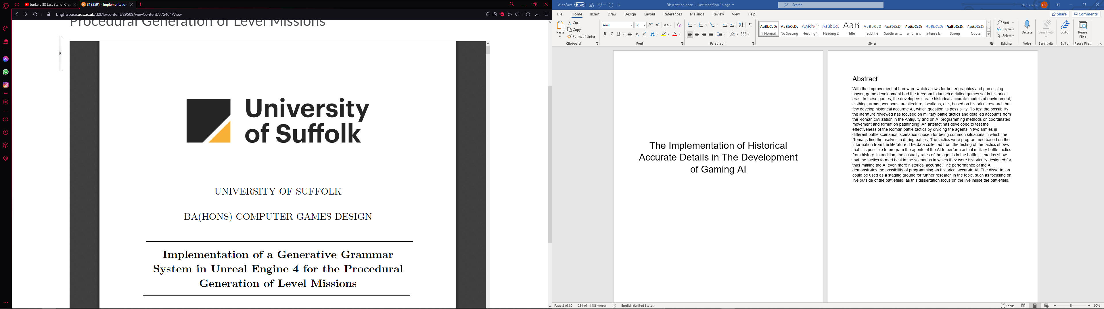

UNIVERSITY OF SUFFOLK

BSC(HONS) GAMES PROGRAMMING

The Implementation of Historical Accurate Details in the Development of Gaming AI

*Author:*

Denis Remo

*Supervisor:*

Steven Harris

May 5,2021

Abstract

With the improvement of hardware which allows for better graphics and processing power, game development had the freedom to launch detailed games set in historical eras. In these games, the developers create historical accurate models of environment, clothing, armor, weapons, architecture, locations, etc., based on historical research but few develop historical accurate AI, which questions its possibility. To test the possibility, the literature reviewed was focused on military battle tactics (Cowan, 2007a) and detailed accounts from the Roman civilization (Cowan, 2007b) in the Antiquity, and on AI programming methods on coordinated movement (Dawson, 2002) and formation pathfinding (Van Verth, et al., 2000). An artefact was developed to test the effectiveness of the Roman battle tactics by dividing the agents in two armies, the Romans (Cowan, 2007a) with their battle tactics, and the barbarians (Campbell, 2021), all with their historical accurate equipment, in different battle scenarios, scenarios chosen for being common situations in which the Romans find themselves in during battles. The tactics were programmed based on the information from the literature. The agents, for the most part, move around on the open field by using the game engine’s integrated pathfinding system. (Unity Technologies, 2019) The data collected from the testing of the tactics shows that it is possible to program the agents of the AI to perform actual military battle tactics from history. In addition, the casualty rates of the agents in the battle scenarios show that the tactics formed best in the scenarios in which they were historically designed for, thus making the AI even more historical accurate. Most of the casualties were produced at the points of contact. The weakest points of the formation, no matter the tactic, were at the rear and left side of the formation. The performance of the AI demonstrates the possibility of programming an historical accurate AI. The dissertation could be used as a staging ground for further research in the topic, such as focusing on live outside of the battlefield, as this dissertation focus on the live inside the battlefield.

Table of Contents

1. Introduction………………………………………………………….5

1.1 Rationale………………………………………………...………...5

1.2 Aims and Objectives…………………………………………….5

2. Literature review……………………………………………………6

2.1 Introduction……………………………………………………….6

2.1.1 Aim of the Review………………………………………………6

2.2 Historical literature……………………………………………….6

2.2.1 Taylor (2014) Roman Infantry Tactics in the Mid-Republic: A Reassessment…………………………………………………………6

2.2.2 Cowan (2007) Roman Battle Tactics 109BC-AD 313………………………………………………………………………8

2.2.2.1 Introduction……………………………………………………8

2.2.2.2 Testudo……………………………………………………….8

2.2.2.3 Orbis…………………………………………………………...9

2.2.2.4 Cuneus……………………………………………………….10

2.2.3 Cowan (2007) The Clashing of Weapons and Silent Advances in Roman Battles…………………………………………………………………11

2.3 AI literature……………………………………………………….13

2.3.1 Dawson (2002) Formations………………………………….13

2.3.2 Millington and Funge (2002) Artificial Inteligence for Games………………………………………………………………...13

2.3.3 Verth, et al. (2000) Formation-Based Pathfinding With Real-World Vehicles………………………………………………………14

2.3.4 Bjore (2013) Technics for Formation Movement Using Steering Circles………………………………………………….….15

2.3.5 Banino, et. al. (2018) Vector-based navigation using grid-like representations in artificial agents…………………….………16

2.3.6 Godoy, et. al. (2018) ALAN: adaptive learning for multi-agent navigation…………………………………………………….17

2.3.7 Godoy, et. al. (2020) C-Nav: Distributed coordination in crowded multi-agent navigation…………………………………….18

2.3.8 Rahmani & Pelechano A (2020) Multi-agent parallel hierarchical path finding in navigation meshes (MA-HNA*) …….18

3. Methodology………………………………………………………20

3.1 Introduction………………………………………………………20

3.2 Artefact overview……………………………………………….20

3.2.1 Stage 1: the design of the agents…………………………...20

3.2.1.1 Roman legionary……………………………………………20

3.2.1.2 Barbarians…………………………………………………...21

3.2.2 Stage 2: the design of the formations………………………22

3.2.2.1 Open order formation………………………………………22

3.2.2.2 Close order formation………………………………………23

3.2.2.3 Testudo………………………………………………………24

3.2.2.4 Orbis………………………………………………………….24

3.2.2.5 Cuneus……………………………………………………….25

3.2.3 Stage 3: the coding of the AI…………………………………26

4. Testing…………………………………………………………….28

4.1 Introduction………………………………………………………28

4.2 Arrow storm battle scenario……………………………………28

4.3 Barbarian frontal charge scenario…………………………….34

4.4 Encirclement scenario………………………………………….38

4.5 Roman frontal charge scenario……………………………….43

4.6 Roman frontal charge on weak point scenario………………47

5.Conclusion…………………………………………………………52

1. Introduction
   1. Rationale

Over the years, video games tend to focus on historical events, with empires across the human history fighting and trading with each other for power and glory. With improved graphics and processing power, game designers have the freedom to give the players the best experience in a historical game or simulation, from customizing the character in shiny medieval armor from High Middle Ages, to virtually walking through the streets of Athens during the Antiquity to even recreate the Alexander the Great’s conquers of the known world. However, the costumes, the architecture and the maps could be completed with an AI which thinks historically. This bring the question: is it possible to develop a historical accurate AI?

* 1. Aims and Objectives

In this project, the attention is focused on the battle simulations, where agents divided in two armies would fight each other until one remains. Most of the time the armies would attack each other head on with little to no tactics involved. However, if actual military tactics were involved, there could be a different outcome of the battle. Or would there be? Some games such as Total War: Rome 2 (Creative Assembly, 2013) and Mount & Blade II: Bannerlord (TaleWorlds Entertainment, 2020) introduced mechanics which let the player organize the units in simple formations like the line formation or the column. The project will go a step further and look for actual historical tactics which can be used in the development of gaming AI. The research will be focused on Roman battle tactics, due to the fact the Roman Empire is one of the most studied civilizations in history and their battle tactics helped them conquer territories around the Mediterranean Sea. In addition to Roman tactics, the research for this project will focus on formation movement and agent pathfinding.

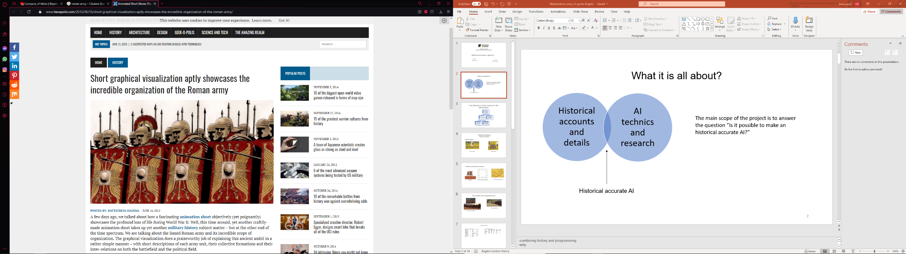

Fig.1 – Visual representation of the Roman army in battle

1. Literature review
   1. Introduction
      1. Aim of the Review

The purpose of this literature review is to assess and evaluate both historical and AI related literature in the search of useful information from these completely different fields of study. This can assist in the development of historical accurate AI that can be used in real strategy or simulation type games. The review contains two parts. The first part focuses on the historical literature in search of historical accurate details that can be imitated by an AI. The second part reviews the AI literature in search of methods which would help the AI simulate the details discovered in the first part.

2.2 Historical literature

2.2.1 Taylor (2014) *ROMAN INFANTRY TACTICS IN THE MID-REPUBLIC: A REASSESSMENT*

Most of the real strategy games that occur in a historical setting have battles in them. A good way to represent historical accuracy in the battle is to incorporate tactics used by civilizations throughout history. To represent properly the century (Roman unit, word coming from the Latin word centuria, which means 100, but the Romans form this unit from 80 soldiers, the rest being servants or slaves) in-game historically, the dimensions of the formation are needed and the exact dimension of the space a Roman legionary occupies in a century while in formation. Michael Taylor (Taylor, 2014) researched and calculated the space between soldiers, the frontage of the formations and the distance between formations during the Mid-Republic period, when the Roman army used the maniple system. His calculations were based on the written account of ancient historians such as Livy and Polybius, but it was also based on the structure of the Hellenistic armies (including Carthage), armies that fought against Rome during that period (Third to Second Century BC).

In calculating the personal space of a Roman soldier in a maniple formation, it is important to differentiate between “tactical space” and “file width”. Tactical space is “the total amount of space a soldier has before bumping into his comrades on his left or right” (Taylor, 2014, p. 306), while file width is “the amount of space a soldier has from the right shoulder of the man on his left to his own right shoulder” (Taylor, 2014, p. 306).

When discussing the tactical space of a Roman soldier, the author takes into account Polybius’ statement that the tactical space of a Macedonian soldier is half of a Roman soldier and since it is documented that the tactical space of a Macedonian soldier is 3 feet (0.9 meters), the Roman soldier has a tactical space of 6 feet (1.8 meters), which in turn makes the file width at around 4.5 feet, enough space to let the soldier go into sword dueling, but not so much to cause a breakthrough of the enemy. However, Polybius did not take into consideration the difference between tactical space and file width, because for the Greeks, the terms are identical. For the calculation of the frontage of the legion and the distance between the formations, the author used the depth of a formation and the Roman battles against the Hellenistic armies. To keep up with the topic of the dissertation, the agents in the century would have the same tactical space as the Romans had more than 2000 years ago.

Two formations presented by the author are the close order and open order formations. The close order formation is when the soldiers in a maniple close their ranks shoulder to shoulder, shield to shield, with no gap between them. This is used when the maniple is showered by enemy missiles, to avoid as many unnecessary casualties as possible. It is useful when on defensive. An open order formation is when the soldiers leave a wider gap between them for better mobility, and it is used more on the offensive. It allows the Romans to enter single combat and it gives them the opportunity to wield their swords more effectively in combat. The depth of the formation is situational and depends on different factors, from the type of formation to the source of information. Usually, the Roman commander order their troops to stay in a 4-man deep formation, when in close order, 8 when in open order. The author’s rule of thumb when calculating the space between formations is to make sure that the space is always smaller than the actual formations. According to the author, the Roman commanders tend to match the width of the enemy by moving as few maniples as possible in front line, to keep as many in reserve as possible. The open order would be the base formation for the AI in the application. Most of the tests on the AI’s coordination and movement would be conducted in open order, because historically, the Romans used it all the time, especially at the start of the battle and due to the possible extra space between agents, which will give them space to maneuver when the formation is moving around a corner.

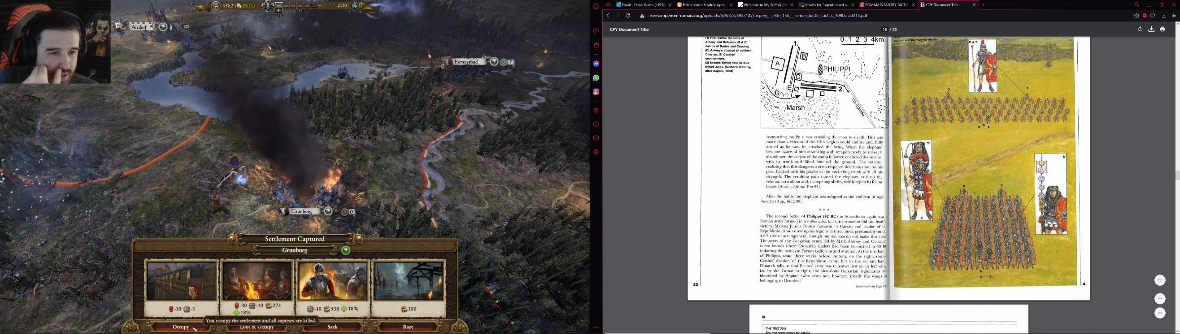

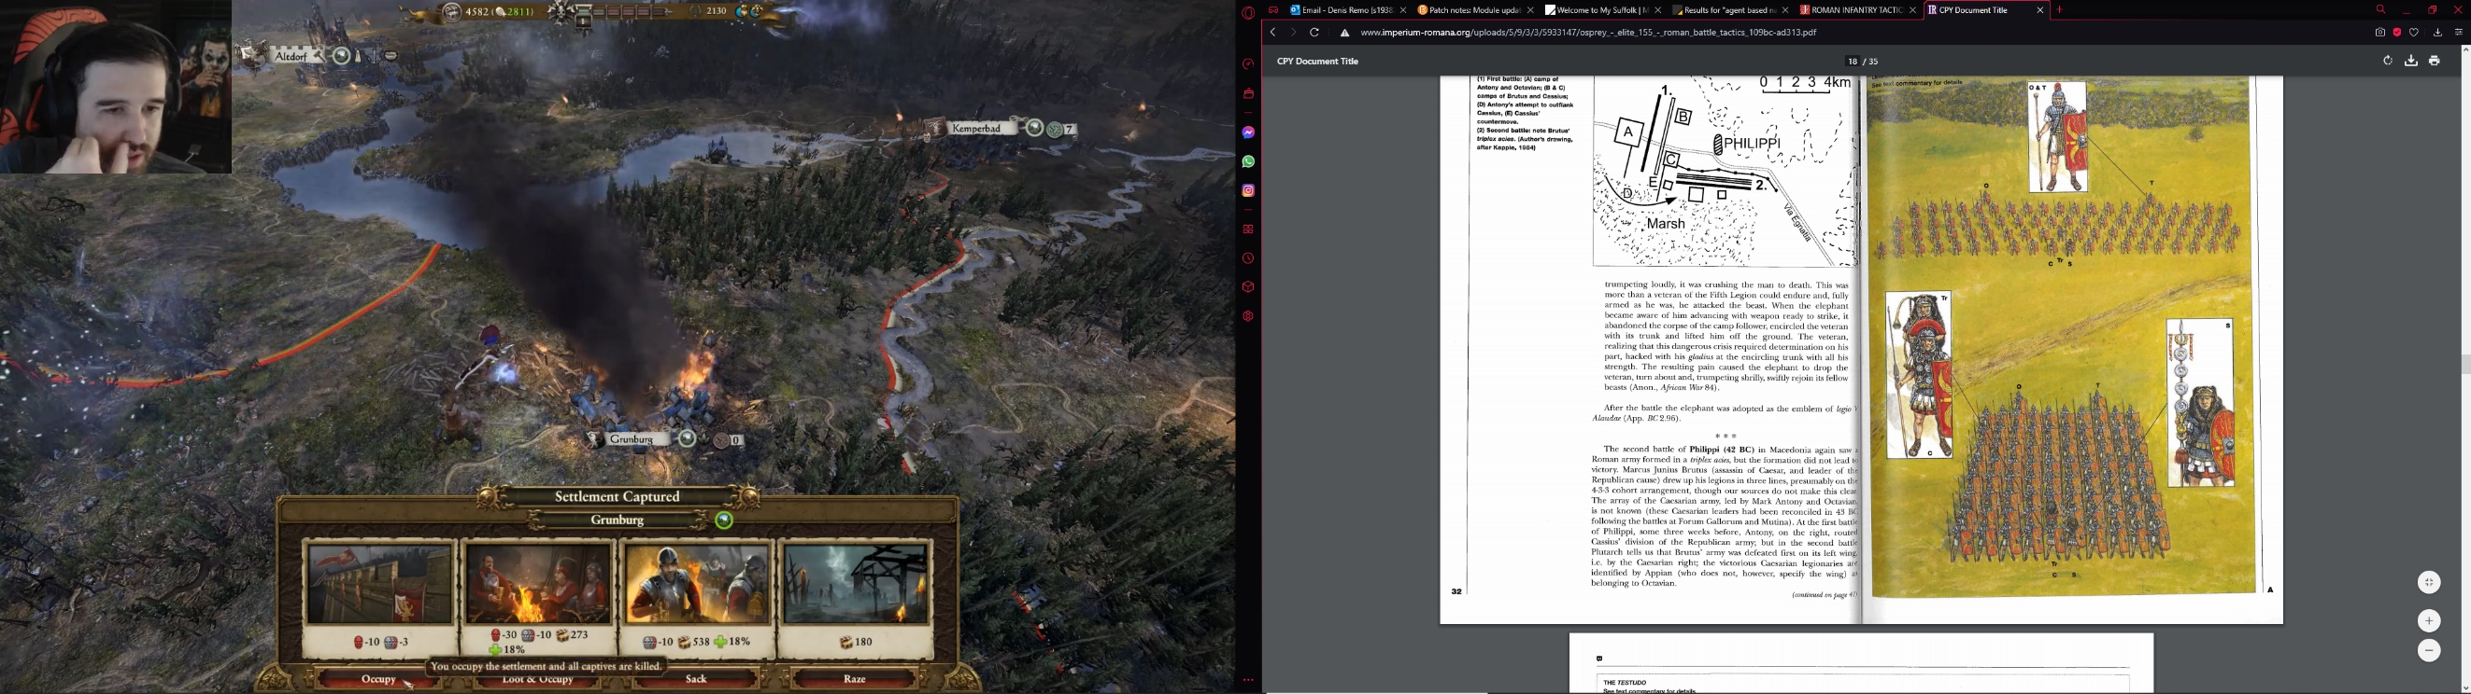

Fig.2&3 – Close and open order formations

2.2.2 Cowan (2007) *Roman Battle Tactics 109BC-AD 313*

2.2.2.1 Introduction

The two formations presented previously are the most common tactics the Romans used throughout their history and it will be used after they changed the military system from the manipular system to the cohort system in the Late Republic period, around the end of Second Century BC. In his book about the battle tactics of the late Republic and Imperial periods, Ross Cowan (Cowan, 2007a) talks about the how the Romans form their battle lines and what kind of formations they use in different scenarios. To cope with the dissertation topic, the chapter used on the research is the chapter about the Roman formations, both defensive and offensive type formations.

2.2.2.2 Testudo

A famous example of a Roman formation is the testudo. The testudo, which means tortoise in Latin, is a defensive formation used most of the times when the enemy has missile advantage over the Romans. In this formation, the legionaries use their shields, or scutum, to protect themselves from arrows or projectiles. In the application for this dissertation, the AI will use the testudo as a defensive formation. The formation would change form in later years of the Roman Empire. In the development of the application, the AI would use the Late Republic, Early Empire period testudo, due to the use of the iconic Roman shield and due to a better protection against projectiles. The testudo could be the primary focus of the development of the application, due to its popularity in community of historians. The agents would use two animations when getting into formation. An animation that makes the agents kneel, and a second animation that makes the agents put their shields above or in front of them, depending on the rank. The formation must be three ranks deep to work, so the century must move from n ranks deep to three ranks deep in formation. For this transition to work, every agent must know their position in the testudo and most importantly which rank they are assigned to. Being a century sized unit (80 agents) and for historical accuracy, two agents will be in fourth line, probably the optio (the centurion’s second-in command) and tesserarius (optio’s assistant). The centurion is the leader of the century. During the testing, in a simulated battle scenario, the century would be peppered by missiles while in testudo to see how effective it is.

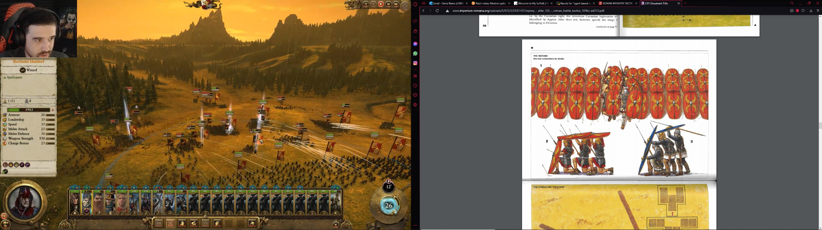

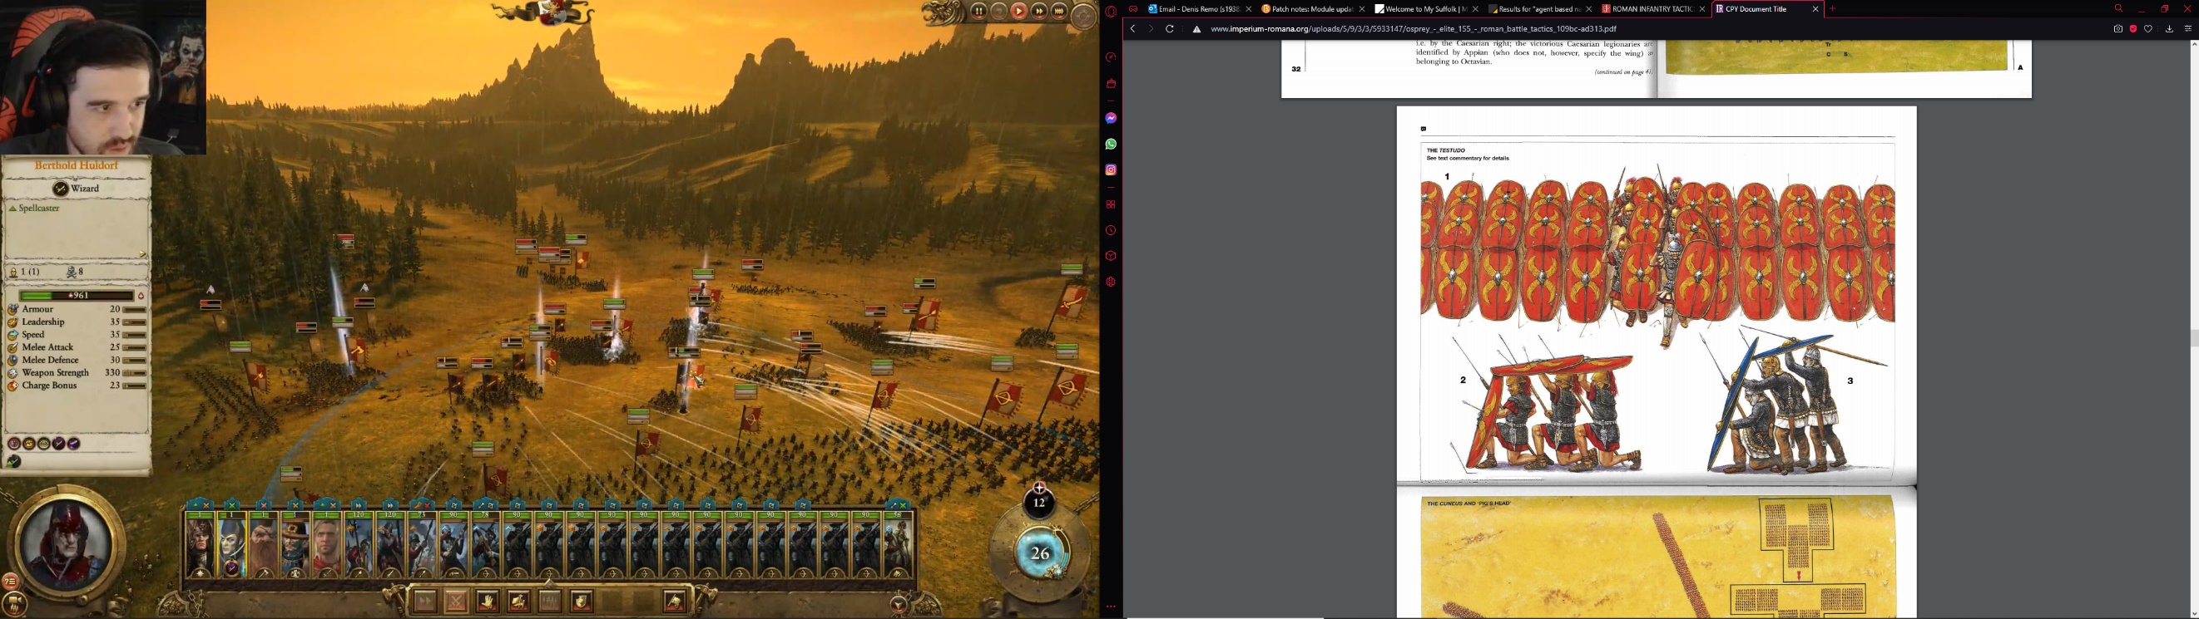

Fig.4&5- Testudo seen from the front and side

2.2.2.3 Orbis

Another formation used by the romans was the orbis. It means world or circular in Latin. As the name suggests, it was “designed for all-round defense” (Cowan, 2007a, p. 43). It was a defensive formation formed in an emergency, mostly during an encirclement or ambush. The author suggests that the formation does not have a specific shape, because it was formed on the spot, mainly centuries remaining in block formation with the legionaries on the edges rotate themselves towards the nearest danger. Some modern scholars believe that orbis was like another formation called *agmen quadratum*, or hollow square. While the orbis was used when a century was encircled, the hollow square was used when the whole army was encircled. This formation was useful in protecting the cavalry and light infantry in the middle of the square and use them for sally outs when the opportunity comes. The hollow square can be sustained during long retreats through enemy territory. In the program, the AI would use both the orbis and the hollow square formation. In the orbis, the AI will make the agents on the edges of the formation turn outwards, while in the hollow square formation, the century will be divided in 4 parts with each part dealing with a side of the square. The agents which are assigned the roles “officers”, “flag bearer” and “trumpeter” would stay inside of the square for historical accuracy. In two battle scenarios, each scenario in a different formation, the century would be surrounded and charged by the enemy from all directions. These scenarios would test the sturdiness of each formation in action.

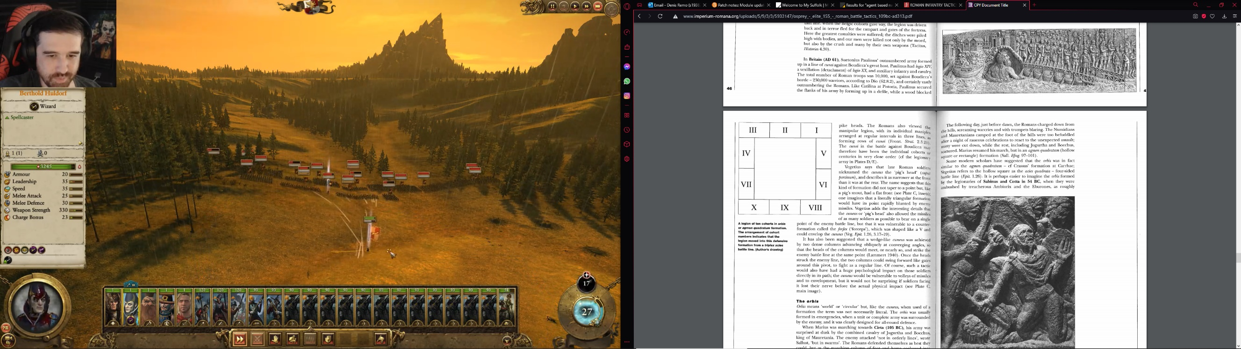

Fig.6- How the orbis would look like if all ten centuries of a cohort were forming it

2.2.2.4 Cuneus

The last formation that the author is presenting in his book is the *cuneus.* The cuneus, which means wedge in Latin, is an offensive formation used to penetrate the weakest point in the enemy’s line, sometimes with psychological effect. Ross Cowan suggests that the formation was not used in a triangular shape, but more a rectangular shape, like going in a thin column formulation towards the enemy in some situations, at least that is what is written in the ancient sources. In other situations, the ancient sources suggest that the Romans would use two columns that move diagonally towards the weakest point on the line and join meters in front of the line before charging. Those tactics were used against rebel armies in Early Empire Period, around 1st Century AD. Later, the legionaries changed the name of the tactic from cuneus to ‘pig’s head’. This time, the formation looks triangular, being narrower at the front and larger at the back, with a flat font, like a pig’s snout. This formation was also used to smash the enemy formation, but this time, the legionaries can throw their javelins more effectively at a single point before charging. In the development of the application, the AI will make the agents form a triangular shaped formation with a blunt tip. During the testing, in a simulated battle scenario, the agents in cuneus formation will charge the enemy line at the weakest point, trying to break the enemy battle line. In this scenario, the century would form be divided into small groups. These group would form a wedge and charge at the enemy.

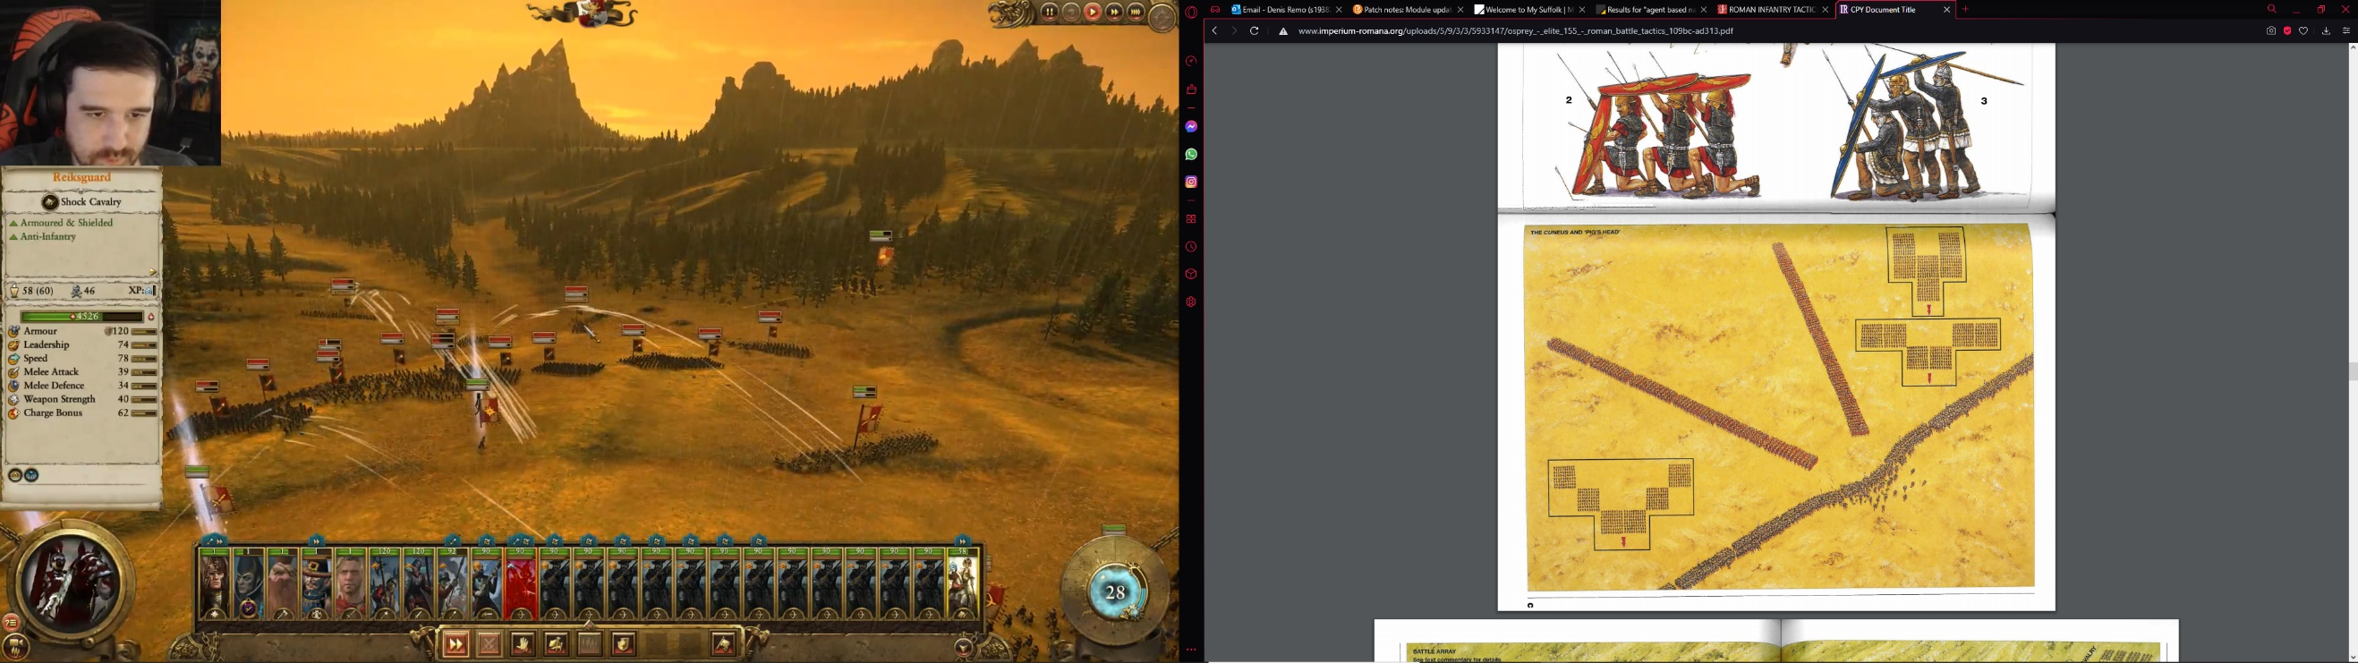

Fig .7- The cuneus in action

2.2.3 Cowan (2007) *The Clashing of Weapons and Silent Advances in Roman Battles*

When studying ancient battles and wars, the first thing that comes to mind are the generals, leaders, tactics, and equipment. Some aspects of the battles are not well documented and not saved. Besides the victories of the leaders of armies, it might be important to learn about those who fought the battles, the common soldier.  
In his article, Cowan (Cowan,2007) talks about some not so well-known aspects of Roman battles by studying ancient sources. Those aspects, as the title of his article suggests, are the clashing of weapons and the silent advances of the Roman legionaries into battle. In the mid-Republic period, especially while fighting the Carthaginians during the Punic Wars, the romans would clash the pila against the scuta while they charged the enemy, according to historian Polybius. There could be the possibility that most of the clashing arms were made by the rear ranks steadily following the front rankers. In late-Republic period, the Roman army became a more professional army, with the legionaries being highly trained and highly disciplined. This discipline is shown through their silence before battle. They would stay in formation and move towards the enemy in silence. This practice of silent movement gives the advantage of easily hearing the orders from the officers before the battle. However, some eyewitness accounts would state the opposite, with stories of raw recruits eagerly hurling their pila at anyone within range, contrary to a strangely quite battlefield. Dio’s accounts says that the legionaries kept their silence until the trumpet’s signals for battle, while Appian’s accounts say that the silence remains throughout the battle, with only the screams of the dying and the wounded can be heard. War cries and weapon clashing can also be used as a battle tactic in some situations. The clashing of weapons was used not only on the battlefield, but also outside if the battlefield. The legionaries would clash shields with their sword during celebrations. The clashing of weapons can be imitated with sound effects in the development of the AI. The agents would clash their weapons when they are stationary with simple animations and they would remain silent while moving to give the AI the opportunity to be more historical accurate, at least according to the historical accounts.

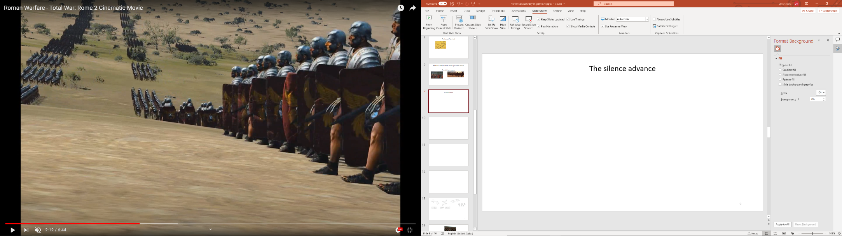

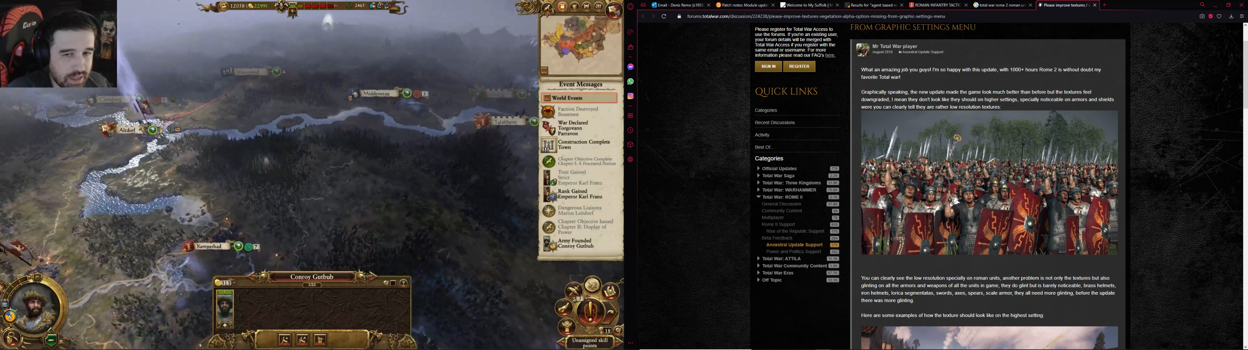

Fig.8&9 - The silent advance and the clashing of weapons

There could be many more details which would help the AI be more historically accurate, but the tactics and the rituals Romans used explained in the first part would be a good start for an AI that lets the player witness the way Romans fought their battles, from the view of their most famous generals and commanders, with features that brings life to the agents, making them look like the legionaries that fought and brought glory to their leaders. For the tactics and rituals to come life, the AI should incorporate methods of programming formations and group movement.

2.3 AI literature

2.3.1 Dawson (2002) *Formations*

In his chapter in the book AI Game Programming Wisdom, Chad Dawson (Dawson, 2002) explains in detail how a formation should work in a game, from the types of formations to the movement of the formations. When it comes to the types of formations that a game developer can use, the author specifies that the formations” will adhere to a 2D implementation, it should be straightforward to extend into 3D if required” (Dawson, 2002, p. 272).

An important aspect of coordinated movement is reforming the formation at the destination. Chad Dawson suggests three options which a developer can chose from. The first option is to keep the agents in formation all the way to the destination, but this might cause some agents to backtrack. The second option is to form the formation just ahead of the agent nearest to the destination. This might cause the lead agent to wait for other agents to form the formation. The third option is to make the agents go directly to the destination without delays and with faster movement. However, the agents will have big gaps in their lines, making the unit less effective. This option can be used in case of emergency for easy and quick retreats. The first option could be used when the agents are moving in testudo formation. Due to the defensive nature of the formation, the agents would move slow, which would limit the backtracking of them and then in turn would keep the formation intact in movement. The third option can be used in the development of the close and open order formation. In these formations, the distance between the agents does not matter, especially when charging or moving to another position. These formations were designed to give the Roman legionaries flexibility while moving on the battlefield, hence there is no concern for space between agents while moving.

2.3.2 Millington and Funge (2002) *Artificial Inteligence for Games*

A good method of organizing the formation was discussed by Ian Millington and John Funge (Millington & Funge, 2009) in their chapter. They think that it is easy to organize the structure of the unit based on the type of formation. In a fixed formation, a slot is marked the leader’s slot. The rest of the slots in the formation are defined relative to the leader’s slot. The leader would move through the world like any other character that is not in a formation, but the rest of the formation will move and in unison with the leader, while at the same time trying to stay in formation. The formation can increase its size with additional slots. A type of formation presented be the authors is the scalable formation. This formation would change its form every time a new slot is introduced in the formation. While fixed formations work based on the position and orientation of the leader, the emergent formations work by letting the characters in the formation select their target based on the position of other characters in the formation, not limiting themselves to the leader. This type of formation is useful when dealing with the scalability of the formation. Fixed formations are good for small groups, but without a character filling the leader’s slot, the formation cannot work properly, while emergent formations can work without a leader, with also gives the formation the ability to divide into small group to move independently throughout the game world.

2.3.3 Verth, et al. (2000) *Formation-Based Pathfinding With Real-World Vehicles*

A major part of coordinated movement is the group pathfinding. Unlike the traditional pathfinding where the agent finds a path to traverse a map as efficient as possible, in group pathfinding, only the agent that is assigned the role of leader can use singular pathfinding. The rest of the group must take into consideration not only the position of the leader, but also the position of their neighbors and the obstacles on the way. Jim Van Verth, et al. (Van Verth, et al., 2000) discuss in their paper a solution to the problem of controlling agents in formation. They used three classes of agents, inspired from real life vehicles, with their own unique speed and turning radius. The vehicles must traverse the map that is 3D in nature by using a pathfinding algorithm while being in a formation. The unit is a platoon-sized unit, which means there are no more than five vehicles in the unit.

The first step in programming the pathfinding is creating the visibility graph. The visibility graph is created inside a polygon called container of obstacles on map if there is at least one obstacle. All the obstacles in the visibility graph are represented as polygons. A map can contain multiple containers. These containers are larger polygons than the obstacles and they occupy a portion of the map. All the edges inside the graph are created by uniting all the vertices between the container’s vertices and the vertices of the obstacles. There is a path between the obstacles only if the visibility graph contains at least one edge between the vertices of the obstacles. The weight of an edge is equal to the distance between the edge’s vertices. After the visibility graph is created, the shortest path can be calculated based on the weight of the edges. In most cases, the path can be generated with the visibility graph, but sometimes the cost is too much. The heuristic is used in these situations. If between the start position and the end position there is a straight line, the visibility graph is useless. If the path intersects with at least one obstacle, then the heuristic is generated. The points of intersection will be included in the visibility graph. After that, the path is moved to the nearest vertices on the obstacles. The resulting path is used in the movement of the platoon. Depending on the obstacles and terrain, the path can be modified towards terrains that reduces the weight of the edges such as roads and away from obstacles that can increase the weight of the edges such as forests, buildings, and swamps. The application is planned to be developed in a game engine and one of the features of the game engine is the generation of the visibility graph and heuristic based on the game objects in the scene of the application. This implies that in the development of the application, there is no need for designing the visibility graph and calculating the heuristic for the programming of the pathfinding.

In a platoon, one vehicle is assigned as the leader. Only the leader can follow the generated path, while the rest of the platoon go towards a position that is offset of the leader’s position. The speed of the platoon must be the speed of the slowest vehicle. In case of vehicles left behind, the rest of the platoon must slow down or even stop to let the slow vehicles catch up. In case of encountering obstacles, the authors suggest changing the path of the vehicle that is about to collide from the offset positions to the leader’s path to the nearest point on the leader’s path. After that, the vehicle will follow the leader’s path until the whole platoon passes the obstacle. Then the vehicle will return to its original position in the formation. This method of obstacle avoidance works only on small formation. The formation in the application for the dissertation is 80 agents strong and the method does not work with a formation that big because the agents that will follow the path of the leader will collide with multiple agents and the agents in the formed column would wait a long time for the formation to reform, which is inefficient.

2.3.4 Bjore (2013) *Technics for Formation Movement Using Steering Circles*

Moving characters in a straight line in formation is easy. All that must be done is to make sure the characters have the same orientation and the same speed. But when it comes to turning the formation around a corner in unison, that is the real challenge. An easy solution to the problem might be by using Stephen Bjore’s (Bjore, 2013) method of using steering circles. The path is generated by calculating the center points of the two circles, the point of exiting the starting steering circle and the point of entering the ending circle. In this method it is known before generating the path the coordinates and the orientation of the formation’s current position and the formation’s target position, and the radius of the circles. Knowing the radius, it is possible to set how sharp the formation should turn. When it comes to navigating the path, the author suggests two ways. The first is marching the units towards the units in front of them while maintaining their distance, with the first row being in a straight line. The technique is useful when the formation in marching in a column. The second is making the units preserve their rows by staying next to the units to their left or right. Stephen’s method is useful when the formation is moving on open terrain or with small obstacles, for example when a formation is moving through a forest, but struggles with big obstacles, for example when a formation is moving through an urban environment. In the case of the application, the tests would be conducted on open ground, with few to no obstacles. Bjore’s method of formation movement would give the necessary flexibility for the century to move around the map.

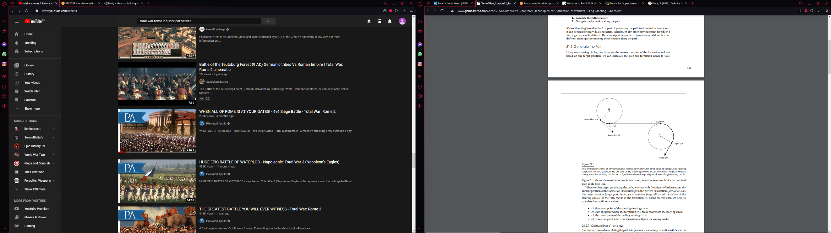

Fig.10 – The visualization of Bjore’s method

2.3.5 Banino, et. al. (2018) *Vector-based navigation using grid-like representations in artificial agents*

On the battlefield, the Romans used tens of centuries at the time, which means thousands of soldiers. To replicate this, the AI must need the most efficient navigation method so the formations can traverse safely through the map without setback. Banino, et al. (Banino, et al., 2018) experimented and evaluated the efficiency of using grid-like representations in vector-based navigation. Their hypothesis assumes that deep learning neural network fail “to rival the proficiency of mammalian spatial behavior”. (Banino, et al., 2018) Like the mammals, the agents tested in experiments use grid cells in their navigation. The agents also use a long short-term memory architecture to learn from past events. The experiment consists of agents reaching goals in” challenging, unfamiliar, and changeable environments”. (Banino, et al., 2018) Trained agents as expected perform better at finding goals than untrained agents, like mature rodents performed better than pup rodents. Like the mammals, the agents which used grid cells in their navigation would choose shortcuts and visit unknown area of the map. From the experiments, the authors also find out that agents which use grid cells perform better than controlled agents and human experts in traversing the map. In the topic of the dissertation, the vector-based navigation may use as an inspiration for developing an AI that has the role of a general in a scenario in which it leads its army through an unknown terrain based on its own experience. This method could be used to show how a general from history felt like when there is limited information about the terrain and the general’s army must go traverse blindly.

2.3.6 Godoy, et. al. (2018) *ALAN: adaptive learning for multi-agent navigation*

During battle, a formation stays strong if the morale is high. However, sometimes the battle is too costly, and the agents must retreat to safely, organized, or unorganized. In case of unorganized retreats, the agents break formation and run. In their run, there is no communication between them, and they must coordinate in some way so they would not collide with other. Godoy, et al. (Godoy, et al., 2018) have a solution for this called ALAN. ALAN (or adaptive learning for multi-agent navigation) is a framework designed to solve the problem of agents making decisions in real-time without communicating with each other. The agents must take into consideration all those factors while they are trying to avoid collisions, both with the static obstacles and with each other. ALAN was based upon other similar frameworks in multi-agent navigation. Unlike other frameworks, ALAN was designed to help the agents reach their goals as fast as possible, while at the same time they avoid slowing each other in the process. “ALAN is an action selection framework” (Godoy, et al., 2018) and is based on preferred velocities and a reward system. An agent selects from a set of velocities a preferred velocity based on the reward each of those generate. The reward function would choose the velocity with the best reward for the specific situation. With the preferred velocity, ALAN sent it to a collision avoidance system called ORCA (or Optimal Reciprocal Collision Avoidance framework). This avoidance system “produces a collision free velocity […], which is the velocity the agent will use during the next timestep”. (Godoy, et al., 2018) The reward system chooses the preferred velocities on two things: how much does the velocity decrease the distance between the agent and its goal and how much does the velocity interfere with other agents’ travel time. ALAN could include a politeness parameter, which would influence the agents more selfish or more selfless actions.

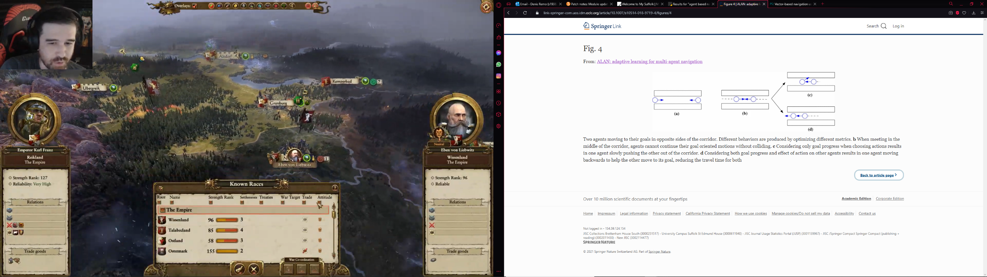

ORCA

ALAN

Fig.11 – The difference between ORCA and ALAN

2.3.7 Godoy,et. al. (2020) *C-Nav: Distributed coordination in crowded multi-agent navigation*

In case of organized retreats, the agents sometimes stay in ad-hoc formations to protect themselves from danger and they communicate with each other to organize their retreat. For this, Godoy, et al. (Godoy, et al., 2020) have a method called C-NAV. Unlike ALAN, C-NAV (short for Coordinated Navigation) allows the agents to broadcast their intended velocities to their nearby neighbors. This exchange of information helps the agents decide “how to move and coordinate with each other without the need for explicit negotiation”. (Godoy, et al., 2020) Like ALAN, in C-NAV the agents choose their velocities based on the reward system. The reward system should consider not only how the velocity could affect the agent in his task to reach its goal, but also how the velocity could affect the entire “neighborhood of agents”. (Godoy, et al., 2020) Besides using the broadcasted velocities, the agents use the observed velocities of the closest agents to see if their intended velocities is different to the observed velocities. With the preferred velocity, like ALAN, a collision avoidance framework analyzes the velocity and generates a collision-free velocity. In some scenarios, an agent avoids taking into consideration the information broadcasted from agents that are behind it and focuses its attention to “the neighbors that are closer to its goal”. (Godoy, et al., 2020) After testing the framework, the authors concluded that C-NAV agents are more polite “towards neighbors with similar intended velocities, than towards neighbors moving against them” (Godoy, et al., 2020) thus creating the possibility of coordinated movement in a group of C-NAV agents.

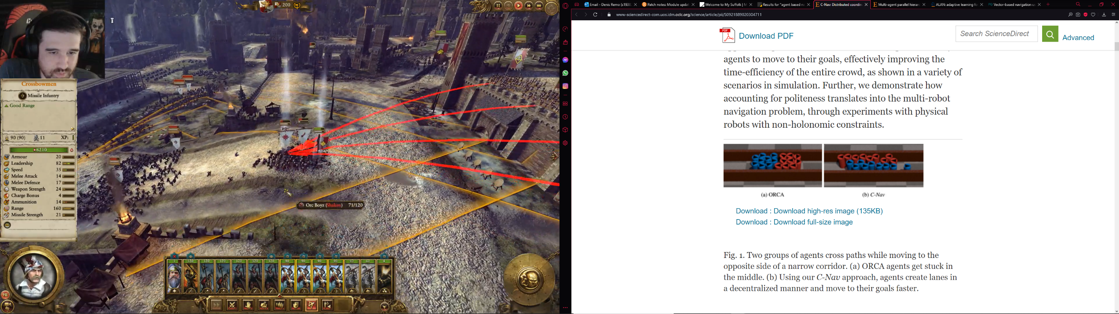

Fig.12 – The difference between ORCA and C-Nav

2.3.8 Rahmani & Pelechano A (2020) *Multi-agent parallel hierarchical path finding in navigation meshes (MA-HNA*)*

Thousands of agents finding their way around the battlefield, in formation, or on their own are fun to look at from a bird’s eye view. However, it might be a constraint to the CPU, especially when using hierarchical A* for large maps, maps which could give enough space for the agents to move around. In their article, Tahmani and Pelechano (Rahmani & Pelechano, 2020) proposed two solutions to remove the bottleneck by implementing HNA* (or Hierarchical A* for Navigation Meshes). The bottleneck is the result of consuming too much memory space and consuming too many resources in connecting the start position and the goal position to the inter-edges of the high-level graph in the abstraction graph. These solutions could increase the performance of the AI, especially when the game could contain thousands of agents moving around the map. The first solution is to store generated paths to be used when using A*. Those paths are created by connecting the center of all the polygons in the initial graph to the center of the inter-edges of the high-level graph. After that it is possible to calculate the A* path from a point p in each polygon at level 0 [..] to the inter-edges”. (Rahmani & Pelechano, 2020) The second method is to parallel search on the GPU instead on the CPU. Although the CPU is used for its more optimized cores, the GPU can be used here for its higher number of cores, which can be utilized by linking multiple nodes to the inter-edges of the former hierarchical graph in parallel. Furthermore, the GPU contains a shared memory, which “is much faster than local and global memory” (Rahmani & Pelechano, 2020) found in the CPU and “it is allocated per thread block, so all threads in the block have access to the same memory”. (Rahmani & Pelechano, 2020)

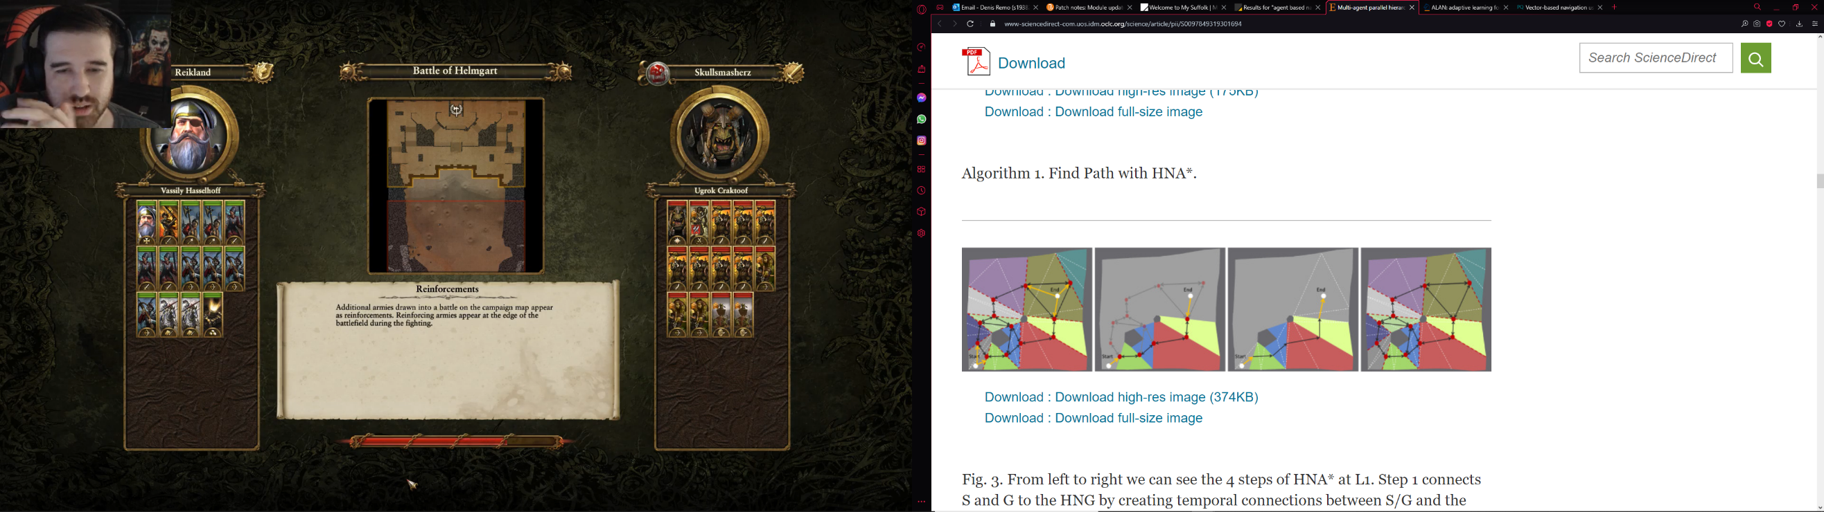

Fig.13 – The four main steps of MA-HNA*

1. Methodology
   1. Introduction

The artefact which accompanies this project is an app developed in the Unity game engine which shows the AI allowing its agents to think and fight like a Roman legionary around Late Republic-Early Empire period (late 1st Century BC to Late 1st Century AD) by using battle tactics from that period. The methodology chapter will look over the progress by exploring all the stages of development and the different challenges which come with programming an historical accurate AI. The version of the game engine used was 2019.4.13f1.

* 1. Artefact overview
     1. Stage 1: the design of the agents
        1. Roman legionary

The best way to show the Roman battle tactics is to design the agents as Roman legionary agents. The equipment and weapons chosen for the agents are inspired by the equipment and weapons used by the Roman army in the 1st Century AD. Since the project’s focus is on AI, the assets used for the artefact are not detailed, yet they help give a historical look to the AI. A Roman soldier is recognized from his shield, helmet, and weapons. The weapon of choice was a “short stabbing sword known as the gladius, but this is a misconception. For the Romans the word gladius simply meant ‘sword’, not specifically a short sword”. (Cowan, 2003)

The formation will be visualized from afar, hence not giving them armor. In the Roman army, the officers must be differentiated from the common soldier, so different helmets were given to them, so they are more recognizable on the battlefield. Each century has their own unique identity. The standard-bearer’s (or the signifier in Latin) main role is to show the century’s identity both on the battlefield and outside of the battlefield. If this century was the First Century of the First Cohort (a unit of 5 centuries), the standard-bearer would be called an aquifer and he would carry the Legion’s Eagle Standard, called “Aquilae, cast in silver, gold or gilded bronze, are usually represented on monuments standing on their wings either raised steeply erect or spread to the sides[…], in the former case sometimes encircled by a wreath or crown.” (D'Amato, 2018) The agent with the role of the trumpeter does not have a shield, but a trumpet used to transmit messages to different centuries or up the chain of command. Both the standard-bearer and the trumpeter wear animal skin (mostly wolf and bear skin) as a tradition which dates to the early days of Rome.

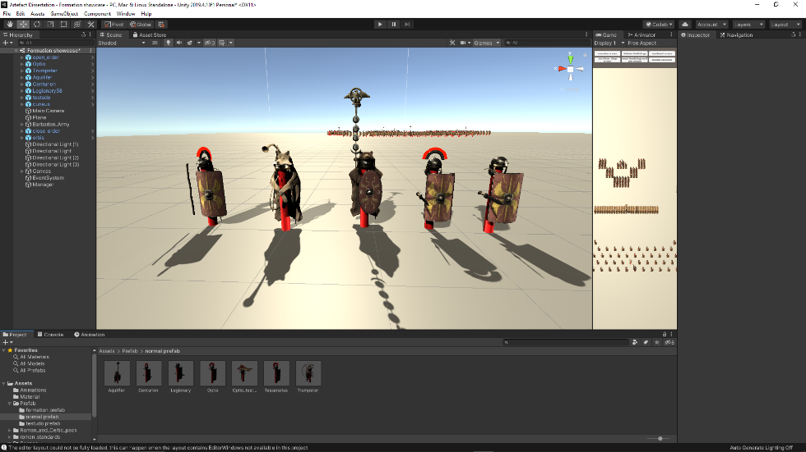

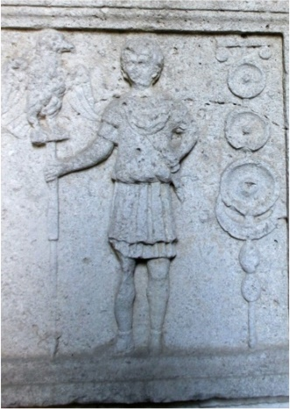

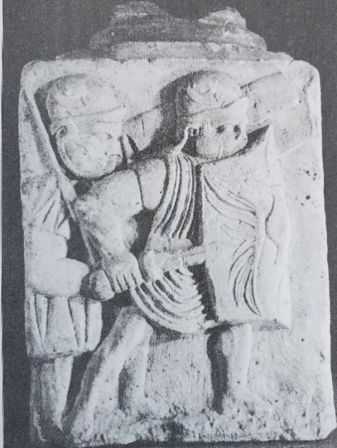

Fig.14,15&16 – A side-by-side comparison between the artefact’s Roman agents and the illustrations of legionaries on monuments and tombs

* + - 1. Barbarians

The enemy of Rome at the Northern Frontier were called barbarians by the Romans, no matter the civilization. From Iceni, Germanic, and Gallic tribes, to the Dacians, they were all barbarians. In the artefact, the barbarian army is composed of a combination of gallic and Celtic tribesmen with their chieftains as their field commanders. The equipment of the barbarians is a combination of Celtic armor and swords with gallic style “long shields, as high as a man, which are wrought in a manner peculiar to them, some of them even having the figures of animals embossed on them in bronze, and these are skillfully worked with an eye not only to beauty but also to protection”. (Diodorus, cited in Campbell, 2021, p. 34) The role of the barbarian army is to test the efficiency of the Roman tactics in different battle scenarios, to be an inconvenience for the Romans, like the barbarians were to the Romans in history for at least millennium and a half. Depending on the scenario, they can be a couple dozens, in other scenarios they can be a couple hundred agents attacking the century from different directions to test the Roman tactics to their limit.

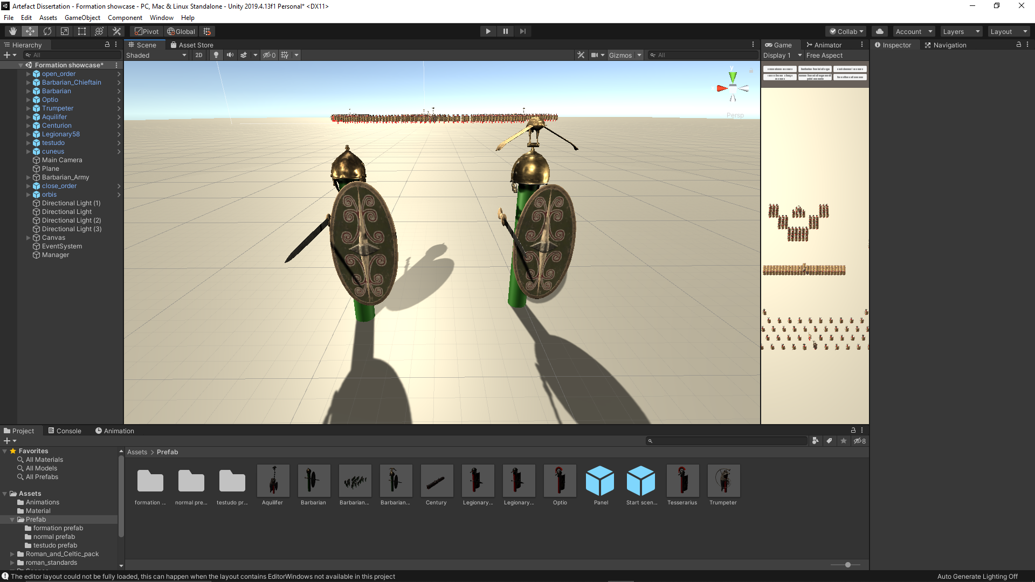

Fig.17 – Visual representation the artefact’s barbarian agent

3.2.2 Stage 2: the design of the formations

* + 1. .1 Open order formation

This formation is one of the two base formations used by the Roman army. It was used as an offensive formation due to the big space between the legionary agents, which allows them to use their weapons effectively in combat. In addition, it helps them became more maneuverable during charges. In the artefact, a prefab was created with the legionary in this formation for testing and presentation with enough space between the agents for better visualization of the tactic. The programming for this formation will be based on the location and rotation of the centurion (i.e., the leader of the formation)

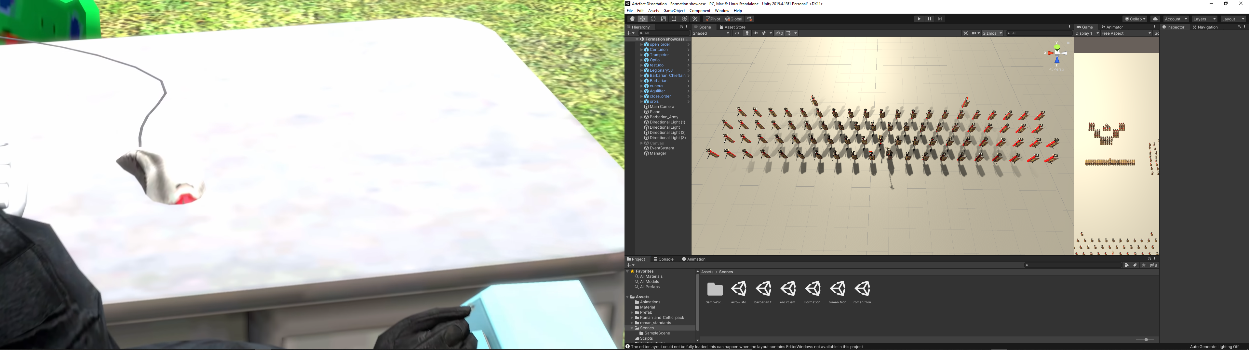

Fig.18 – Visual representation of the open order formation

3.2.2.2 Close order formation

This is another based formation used by the Roman army. It was used as a defensive formation, because legionary agents would be packed shoulder to shoulder and shield to shield, for better protection during combat, minimizing the chances of breakthrough of the enemy. Like the open order formation, a prefab was created with the legionary in this formation for testing and presentation with the agents packed together in an 8x10 tight formation. The programming of this formation will be based on the position and rotation of the centurion.

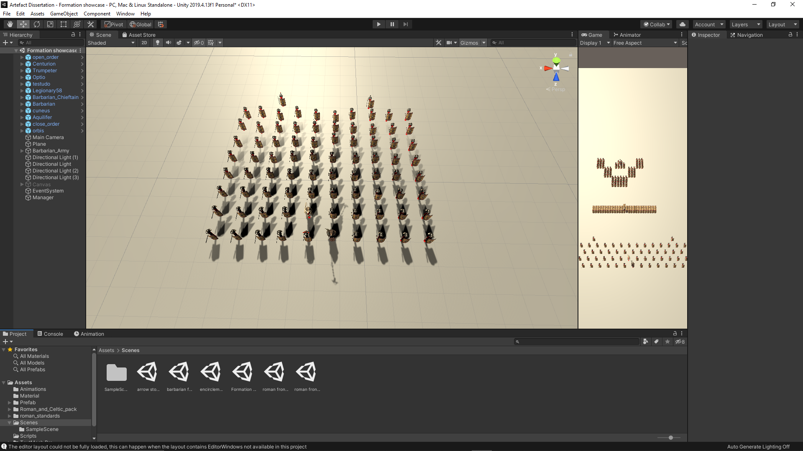

Fig.19 – Visual representation of the close order formation

3.2.2.3 Testudo

The most famous tactic the Romans used; the testudo is a defensive formation utilized for the sole purpose to protect the legionary agents from enemy missiles. In the artefact, the development of the formation included animations in combination with programming. The animations were included in the process due to the position of the shield. To limit the chance of the missiles hitting something vital, the Romans would stack their shields for better protection. Based on the rank of an agent in the formation, it must decide if its shield should be in front of him, below its comrades shield or above it.

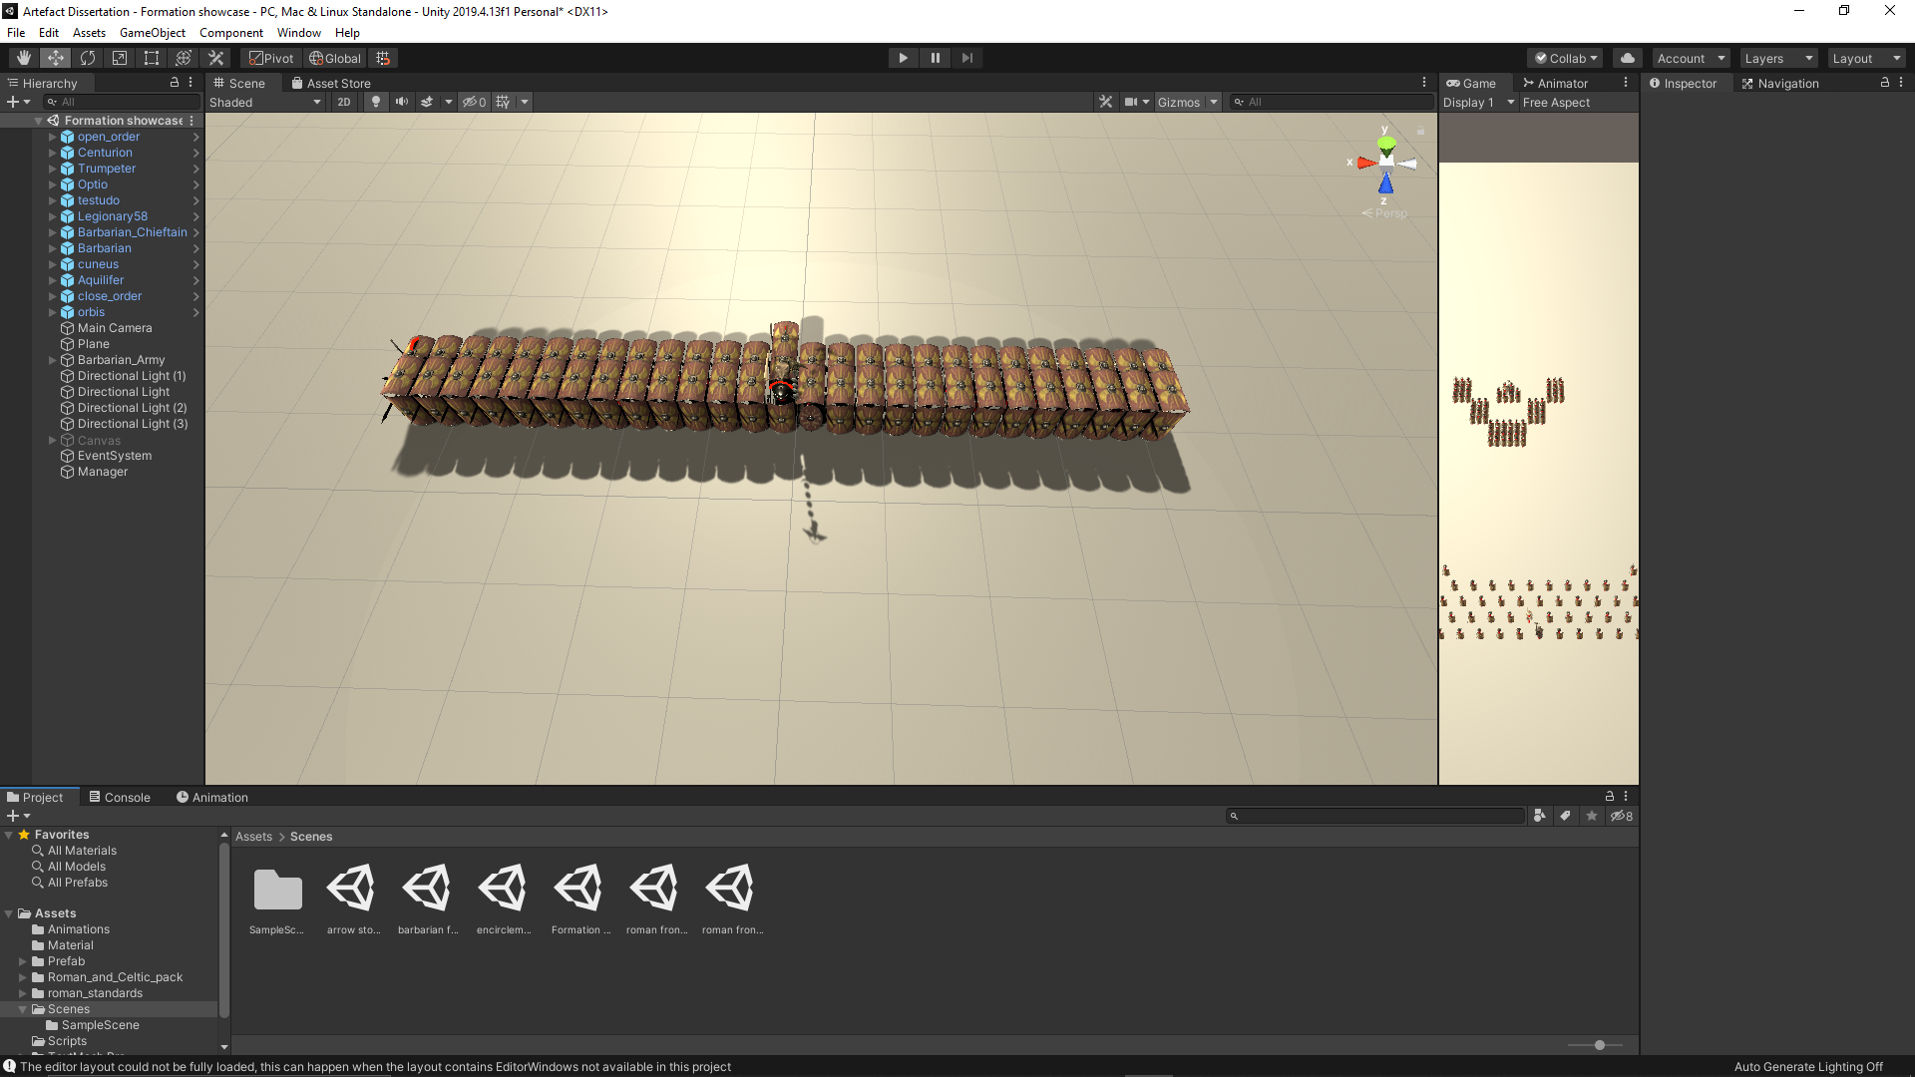

Fig.20 – Visual representation of the testudo formation

3.2.2.4 Orbis

The Orbis is a defensive formation utilized for the purpose of protecting the legionary agents from enemy encirclement. In the artefact, the agents which have the role of “officers” would stay in the middle of the formation, while the rest of the legionary agents form the defensive perimeter. The hard part is to distribute the legionary agents evenly throughout the perimeter and how many should be kept in reserve to reinforce a flank, because a defensive position is as strong as its weakest link.

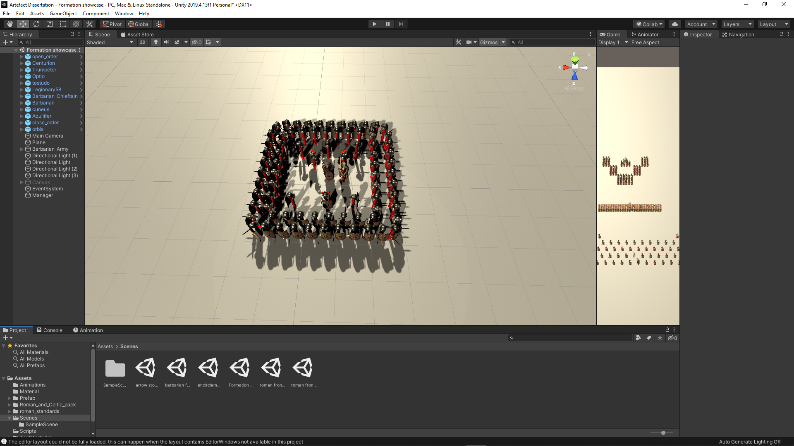

Fig.21 – Visual representation of the orbis formation

3.2.2.5 Cuneus

The Cuneus is the only offensive tactic presented and tested in the artefact. In the artefact, the legionary agents are divided in groups of 12. These groups form a “V” shape with the tip towards the enemy. Since the century cannot be divided equally by 12, some legionary agents were kept in reserve to protect the standard-bearer and the trumpeter and they stay behind the tip in case the formation needs a little more momentum in the charge.

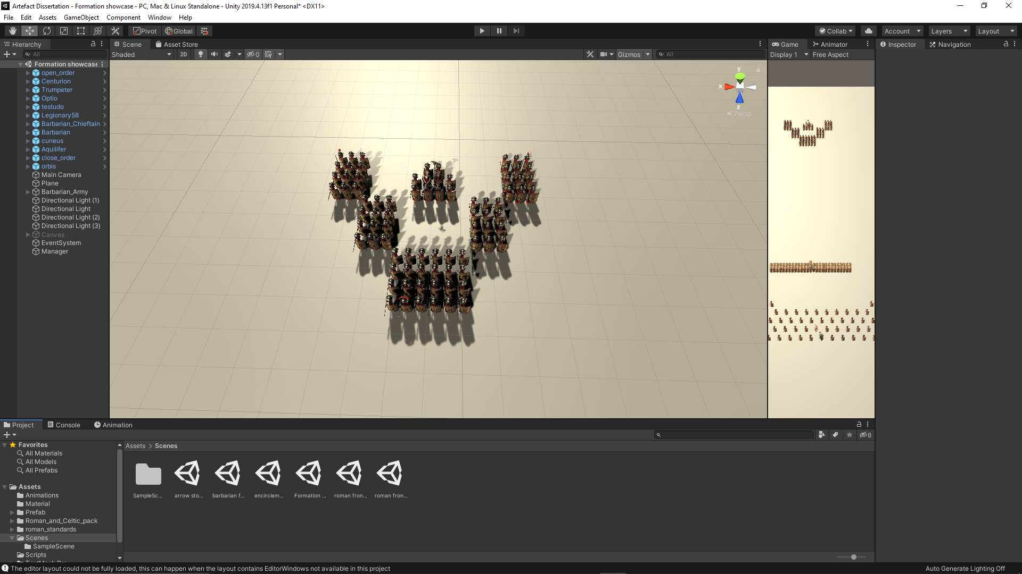

Fig.22 – Visual representation of the cuneus formation

3.2.3 Stage 3: the coding of the AI

With the design of the agents finished and the formations formed, the coding of the AI could begin. Firstly, the AI must receive some user input to move the century. This challenge was overcome by allowing the user to point, click and drag the position and rotation of the centurion on the map using the right mouse button, inspired form the point and command system in the Total War series (Creative Assembly, 2013). The artefact allows the user to look around the map by using the WASD buttons on the keyboard and zoom in and out by using the scroll wheel of the mouse.

The biggest challenge is to program the movement and coordination of the century. The position and rotation of each agent of the century is based on the position and rotation of the centurion (the leader of the century), and the offset on the x and z axis (the artefact is made in 3D with the use of Unity Game Engine) of the agent in the formation, sometimes even the rotation depending on the tactic. The movement was initially planned to be based on Bjore’s (Bjore, 2013) method of using steering circles in the development. However, since Bjore’s (Bjore, 2013) method is used for obstacle avoidance and the agents are primarily moving on a flat terrain with no obstacles, it was opted to the Unity’s agent Nav mesh (Unity Technologies, 2019) to be used for movement and pathfinding. The agents update their target every frame in case of defensive tactics (like the testudo or close order), where agents must stay in formation for a smooth movement of the agents, no matter the situation, or the destination as the target in case of offensive tactics (like the cuneus or the open order). The offset is easy to maintain if the formation maintains their rotation during their movement. However, everything changes when the leader rotates. The agents must update their offset by rotating their predefined offset around the leader by the angle of the leader’s rotation. This can be possible by transforming the coordinates into homogeneous coordinates. Since every agent has the same coordinate on the Y axis, the rotation is made in 2D on the X and Z axis. In the process of rotating the coordinates around a point, one of the steps is to move the point to the origin. Since in a formation everything evolves around the leader and the agent’s coordinates must rotate around the leader’ position, the leader can be considered the origin of the formation, thus skipping a step in the process.

$$future position.x = \left(centurion position.x + {offset}_{x}\right)*Cos\left(-angle rotation of centurion\right)- \left(centurion position.z + {offset}_{z}\right)* Sin\left(-angle rotation of centurion\right)- pos.x * Cos\left(angle rotation of centurion\right)+ centurion position.z * Sin\left(-angle rotation of centurion\right)+ centurion position.x;$$

$$future position.z= \left(centurion position.x + {offset}_{x}\right)*Sin\left(-angle rotation of centurion\right)+ \left(centurion position.z + {offset}_{z}\right)* Cos\left(-angle rotation of centurion\right)- pos.x * Sin\left(-angle rotation of centurion\right)- centurion position.z * Cos(-angle rotation of centurion) + centurion position.z;$$

Fig.23 - The equations used in calculating the target position of a legionary

The movement of the formation can be different depending on the tactics. For offensive tactics like cuneus and open order, the movement is impacted directly by the user input. During the forming stage of the tactic, the target for the agent is its position in that tactic based on the leader’s position and predefined offset. After the forming stage, the agent’s target is based on the user’s input and the predefined offset. Because the formation’s movement is based on the user’s input, it does not need smooth and synchronized movement, thus giving it a more aggressive attitude, attitude which allows the agents, like the Romans in history, to smash the enemy formation with their charge, hence forming the formation at the destination. (Dawson, 2002) As for defensive tactics like the testudo or orbis, the formation must stay compact and tight so there will not be any breakthrough of the enemy, hence why the agents must move slowly and smoothly on the battlefield to minimize the chances of forming gaps. (Dawson, 2002) For example, in testudo, the shields must be interlocked so no arrow can wound a legionary. This can be achieved by updating the target every frame based on the current position of the leader, no matter if the formation is forming or moving. Every agent has a unique list of offsets depending on the tactic, with the orbis including the orbis angle which allows the agent to rotate towards a direction depending on the face of the orbis and the testudo including the testudo rank which allows the agent to choose what animation should it use depending on the rank it is in in the formation. The testudo is unique as it requires animations for it to work properly. Animations reflects the rank of an agent. As discussed in the literature review, the first rank’s animation makes the agent crouch and puts the shield in front of it. The second rank’s animation makes the agent crouch and puts the shield over the first rank agent protecting both agents. And the third rank’s animation makes the agent crouch and puts the shield under the second rank’s shield protecting it with half of the shield protecting itself.

4.Testing

* 1. Introduction

In this chapter, the tactics will be presented in different battle scenarios with the purpose of testing the effectiveness in battle. There are five scenarios. These scenarios are chosen as they are the most common battle events in which the Romans found themselves in, hence why their battle tactics were influenced by these scenarios. Five battle tactics develop for five battle scenarios. These five scenarios are: arrow storm scenario, barbarian frontal charge scenario, encirclement scenario, Roman frontal charge scenario and Roman frontal charge weak spot scenario. In all those scenarios, the centurion cannot become a casualty, because the centurion is the designated leader of the formation and all the movement is based on the leader’s position and the leader’s target position.

* 1. Arrow storm battle scenario

In this scenario, the century is under enemy arrow fire and it is up to the tactic chosen by the user to decide the fate of the century and which legionary would become a casualty. The arrows in this scenario are programmed to be destroyed when they collide with the equipment of the legionary agents. Additionally, the enemy archers are positioned in front of the century, so all the arrows are fired directly to the front of the century. When fired, the arrows would land on an area with of 65 by 30 (it is measured in the unit of measurement for distance in the Unity game engine).

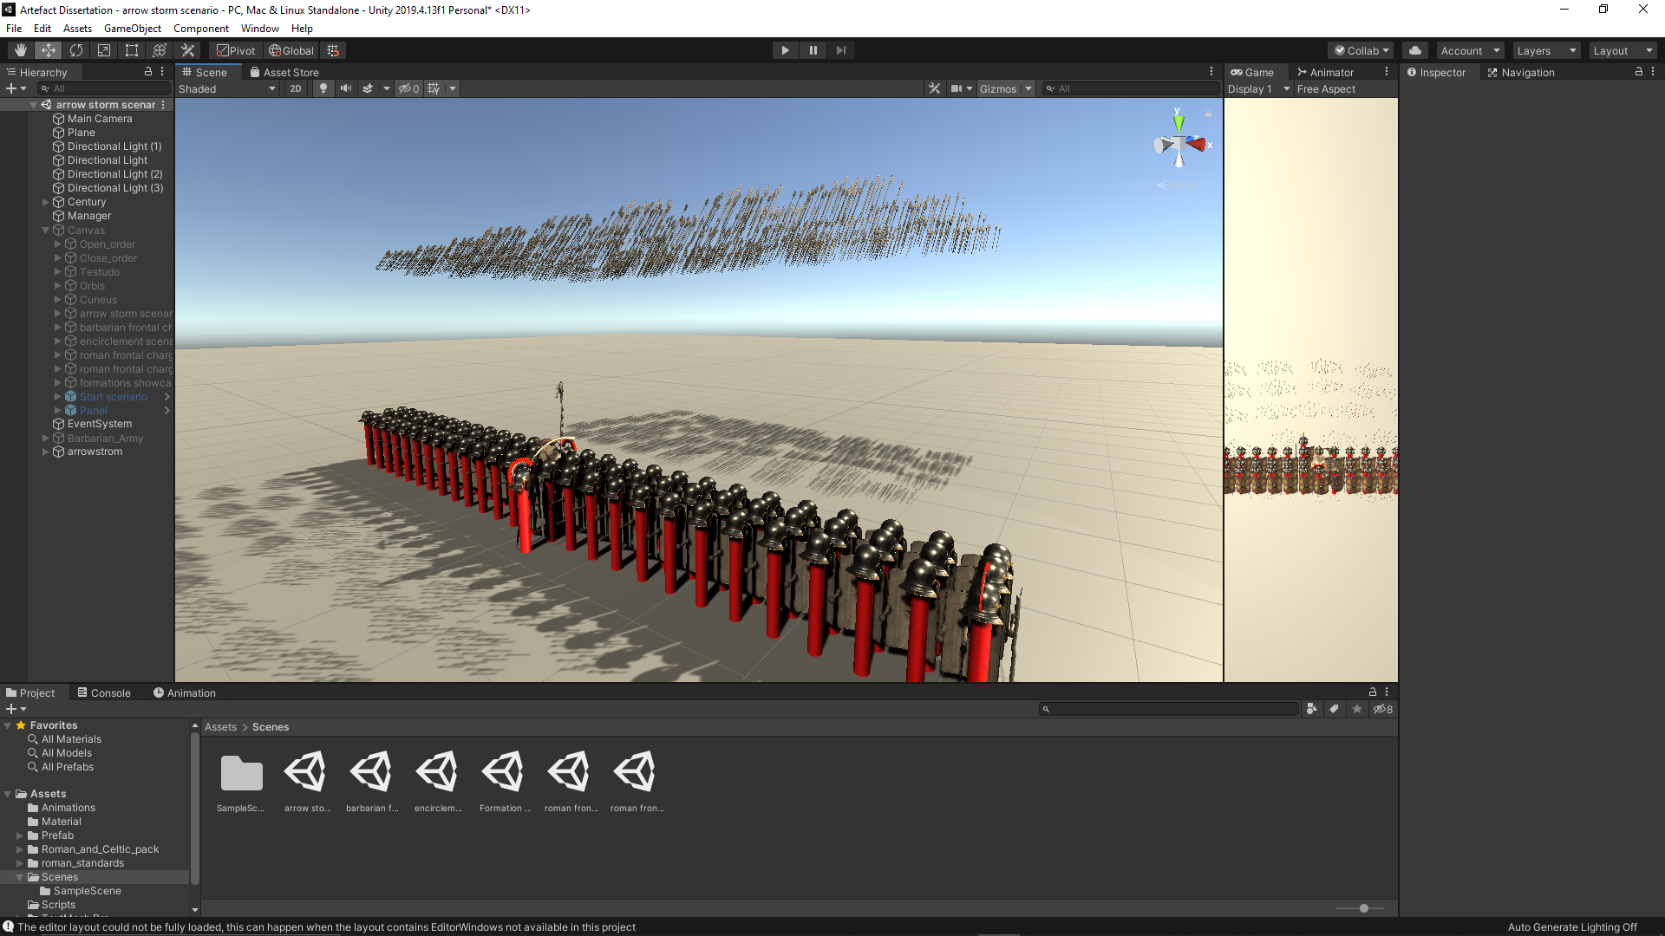

Fig.24 – The century under fire

When the century is in the open order formation, around 10% of the legionary agents became casualties. The casualty rate for this tactic is low due to the fact that the legionary agents are spaced out, hence decreasing the chance of getting hit by an arrow. Most of the casualties are in the first two to three ranks and around the center of the formation, where the arrow fire is mostly concentrated.

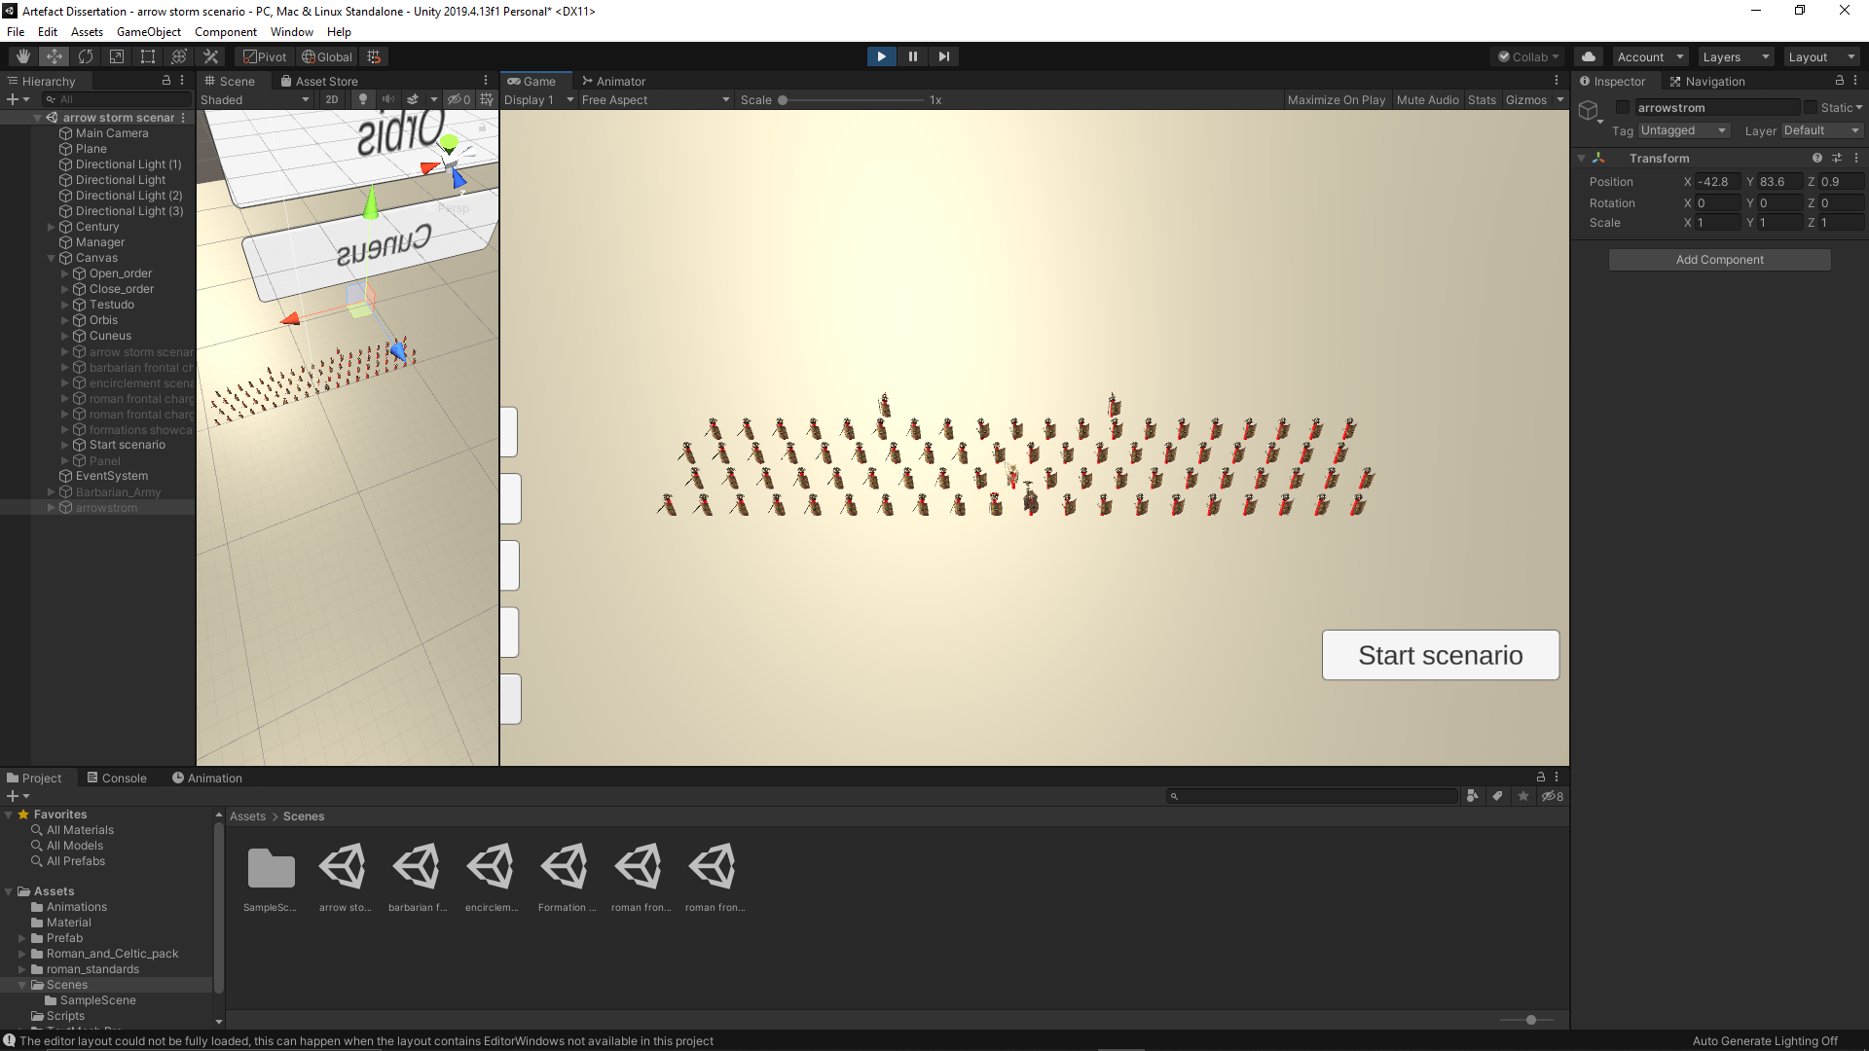

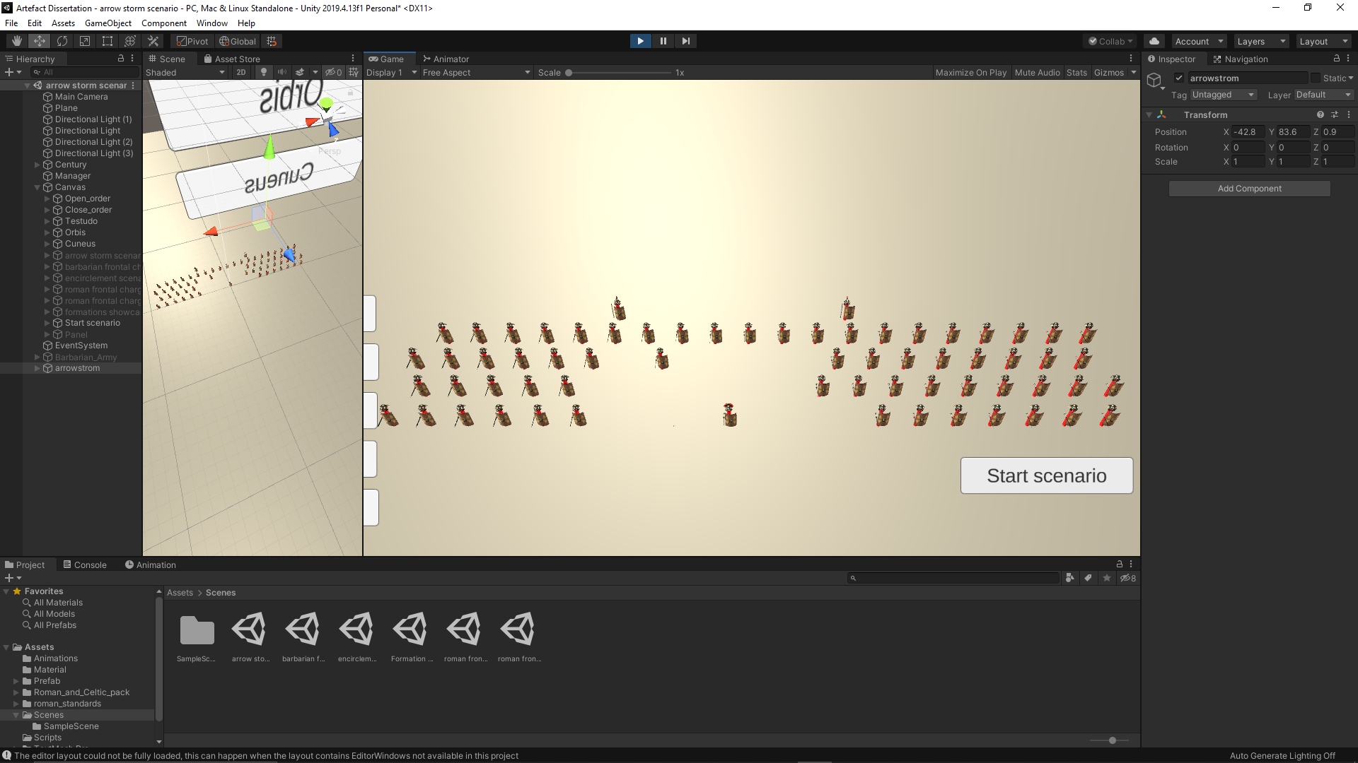

Fig.25&26 – Open order before and after the battle scenario

In close order, the casualty rate was higher compared to the open order, around 25%, more than double the number of casualties when the century was in open order. This is possible because the formation is more compact, with eight ranks deep, compared to four and there is not enough space between the legionary agents for an arrow to go harmlessly through them. Those factors combined increases the chances of a legionary to be hit by an arrow.

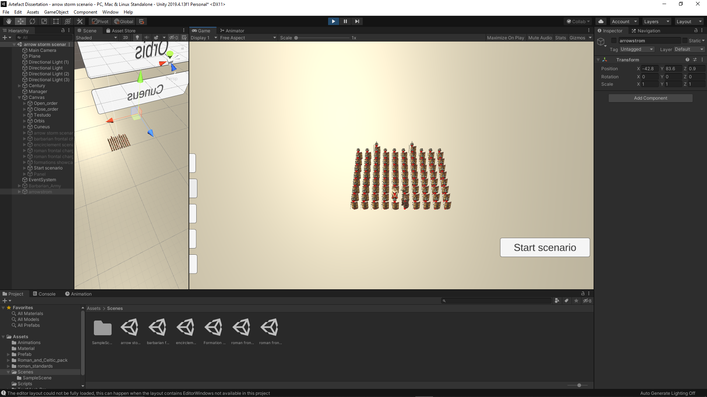

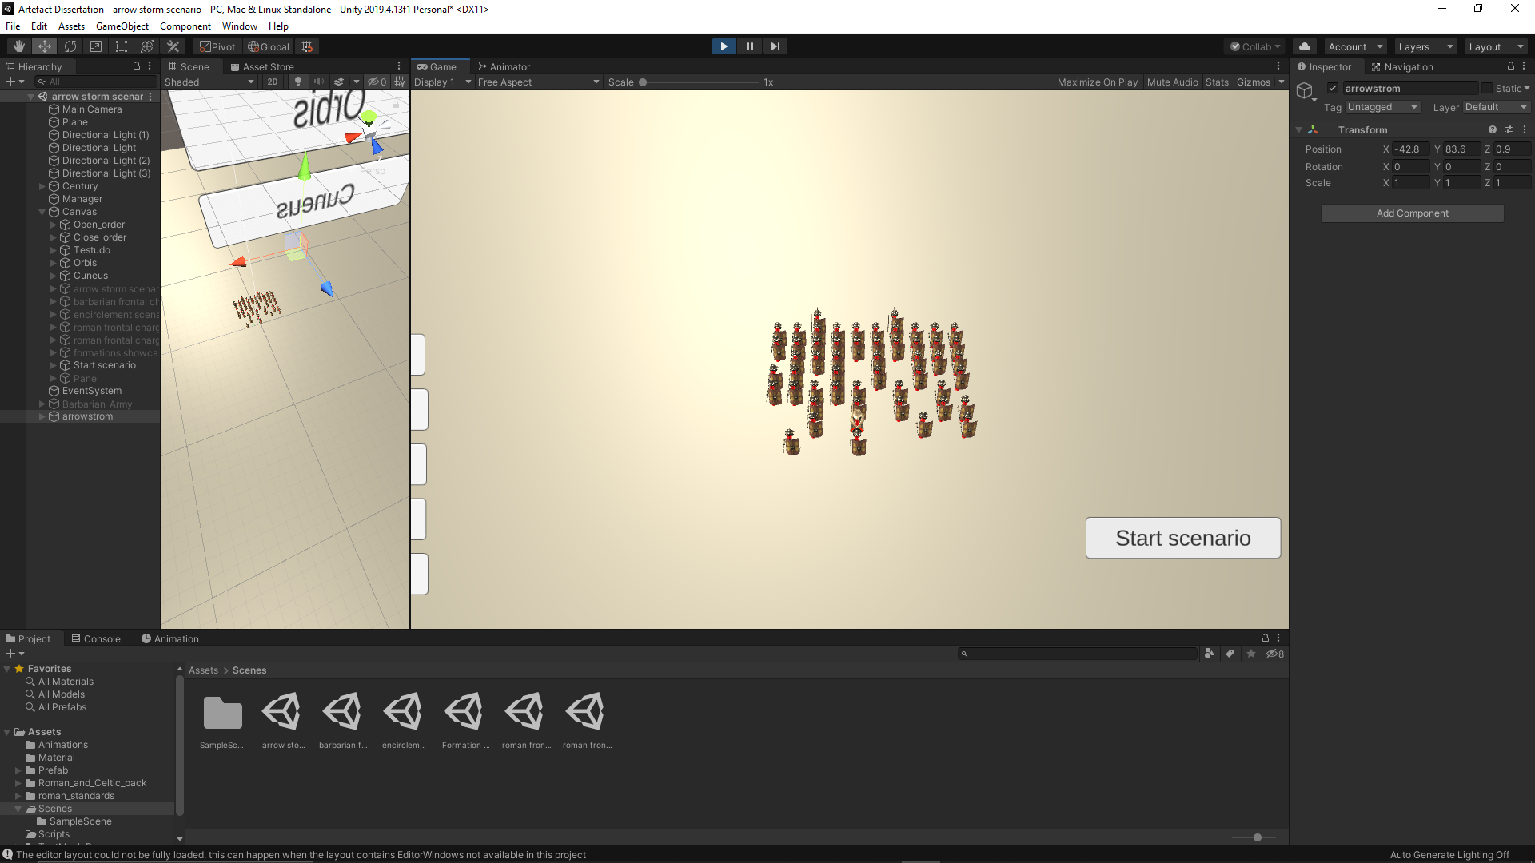

Fig.27&28 – Close order before and after the battle scenario

In testudo, the casualty rate was relatively zero. In this formation, every legionary raises their shields over their head to protect themselves. Even the legionary agents in the front rank which have their shields in front of them are protected by the shields of the legionary agents in the second rank.

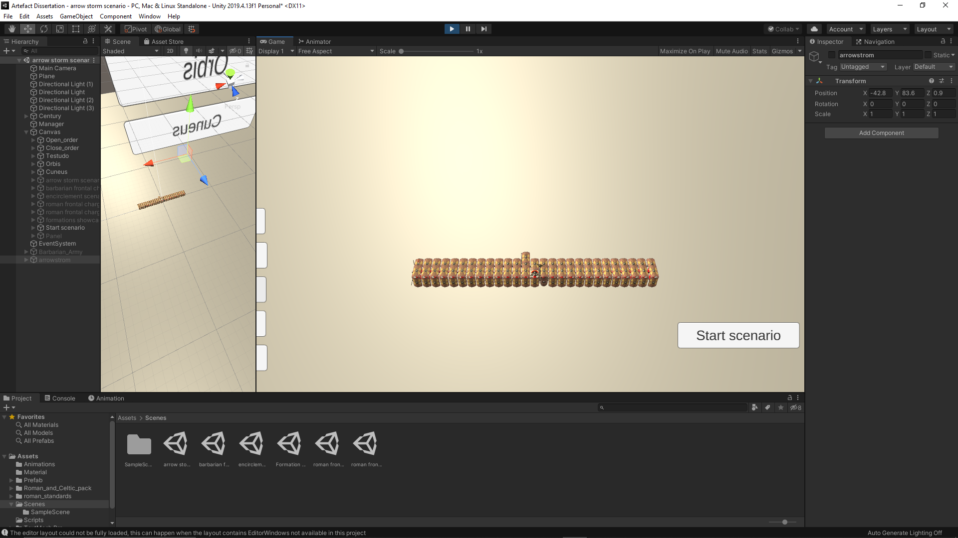

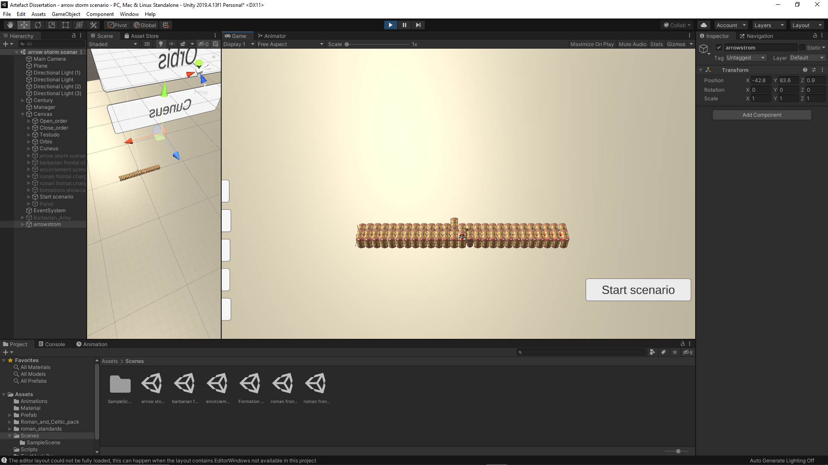

Fig.29&30 – Testudo before and after the battle scenario

In orbis, the casualty rate was around 60%, the biggest casualty rate out of all formations. In this formation, most of the legionary agents have their sides or their backs exposed to the arrow fire. The officers are in the middle of the formation, where the concentration of arrow fire is located. Most of the casualties are in the lateral sides of the orbis, where the sides of the legionary agents are exposed. The back side of the orbis has fewer casualties as the arrows did not reach them. There would be more casualties if the arrow fire covered the whole formation.

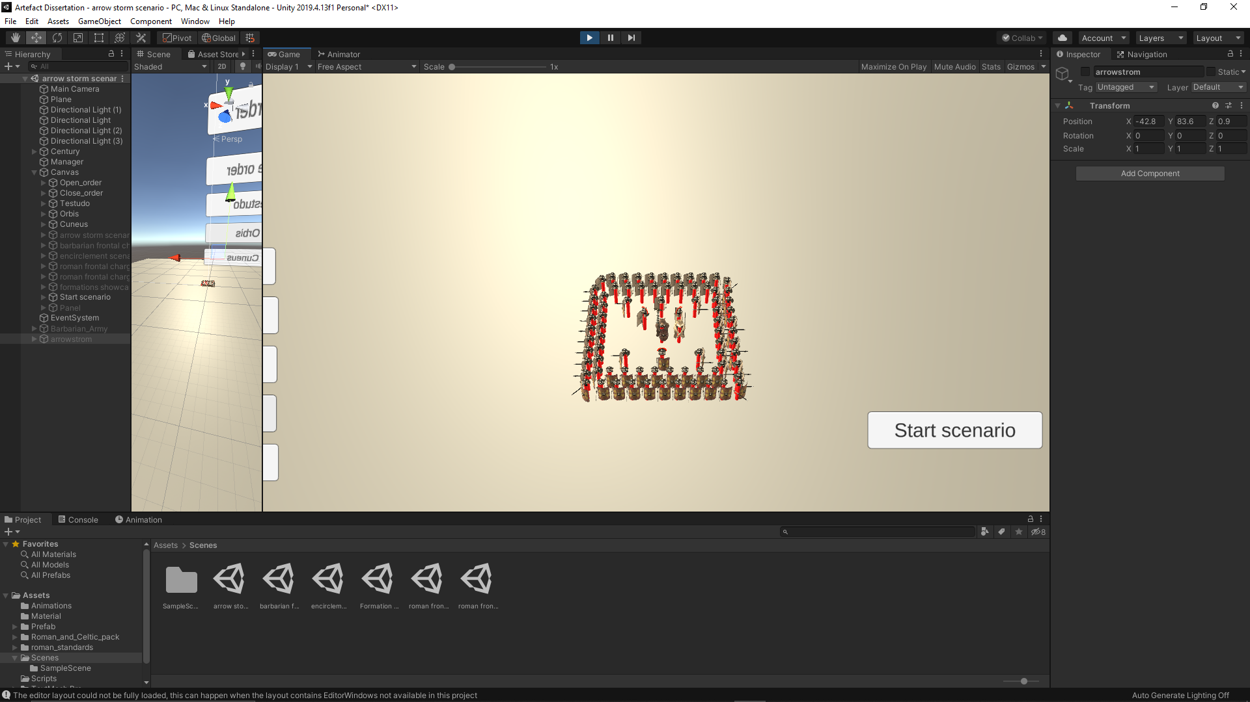

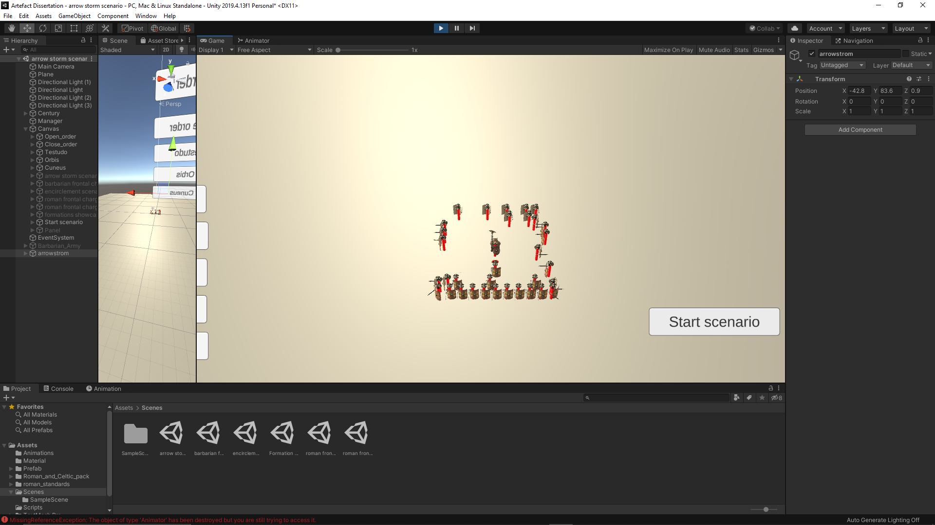

Fig.31&32 – Orbis before and after the battle scenario

In cuneus, the casualty rate was 10%, the same rate as open order. Although the number of casualties is the same, the shape of the formations is not. The open order has fewer ranks, but the spacing between the legionary agents is bigger. However, in cuneus the frontage is smaller, and they are divided in small groups. This tactic of dividing the legionary agents in small groups limits the damage of the arrow fire by effecting the groups which are nearest to the tip of the formation.

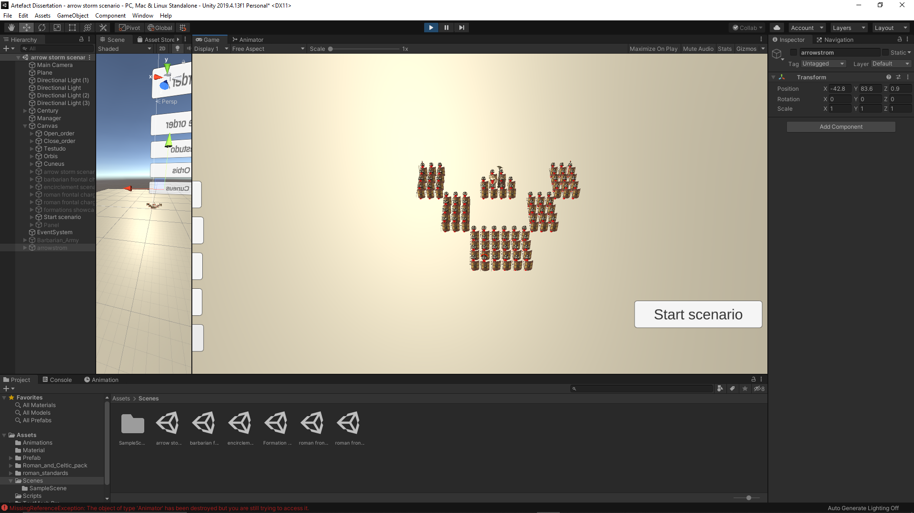

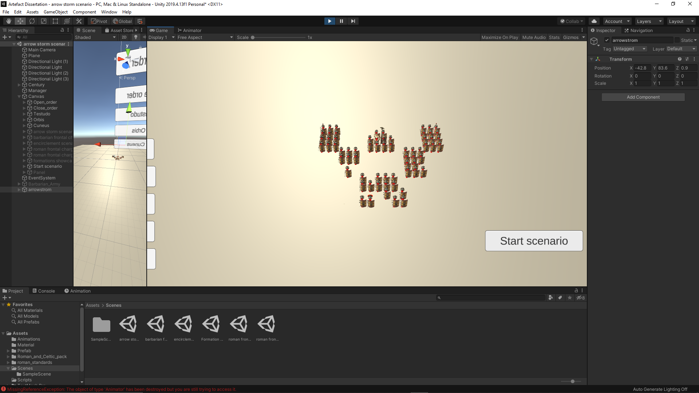

Fig.33&34 – Cuneus before and after the battle scenario

Based on the performance of the formations in this battle scenario, it has been concluded that the testudo is the most effective tactic. Historically, it has developed for the sole purpose of protecting the century from arrow fire and it demonstrated in the artefact the reasons why it was adopted by the Romans.

* 1. Barbarian frontal charge scenario

In this scenario, the century is attacked head on by a barbarian horde with a frontal charge. The casualty rate of the century depends mainly on the tactic used, the gaps between the legionary agents in the chosen tactic and the ability of the barbarians to squeeze through the gaps in the Roman formation. The purpose of a frontal charge is to break through the battle line of the enemy. In this case the purpose of the barbarians’ frontal charge is to break through the Roman battle line. The barbarian horde consists of a small group of 20 barbarians. This group’s attack is focused on a point of the frontage for maximum breakthrough. The century is tested in the survivability of a frontal charge.

In the open order formation, the casualty rate was around 5%. Although low casualty rate, the barbarians manage to squeeze through the formation, some of them even to the back of the formation. Most of the casualties are located in the first rank of the tactic, around the center of the frontage of the formation, where the point of contact between the two armies is located.

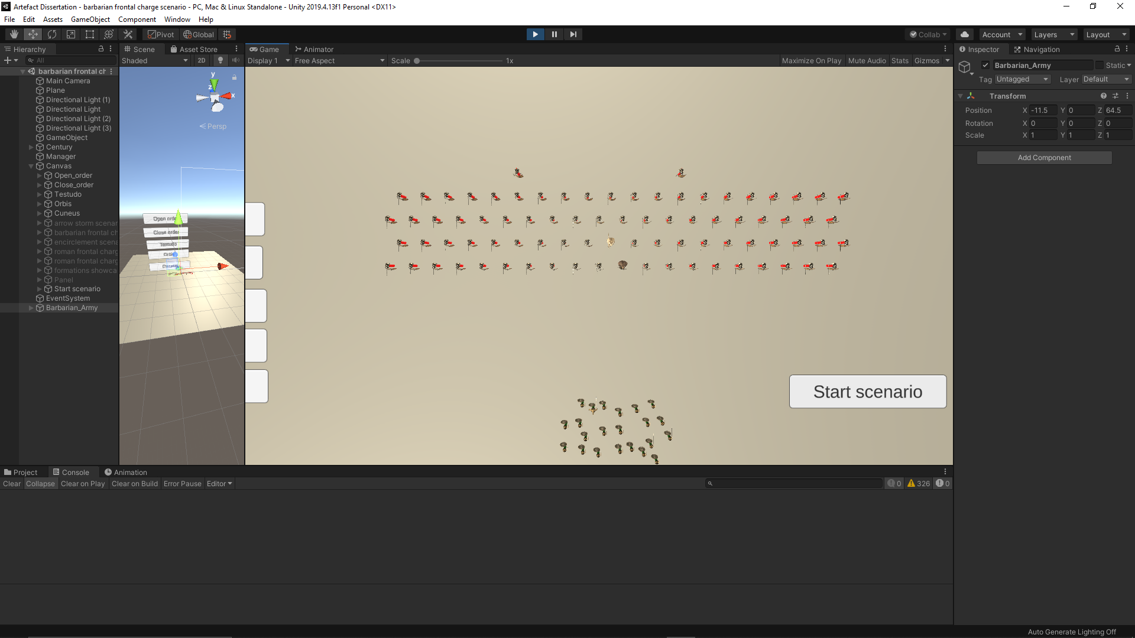

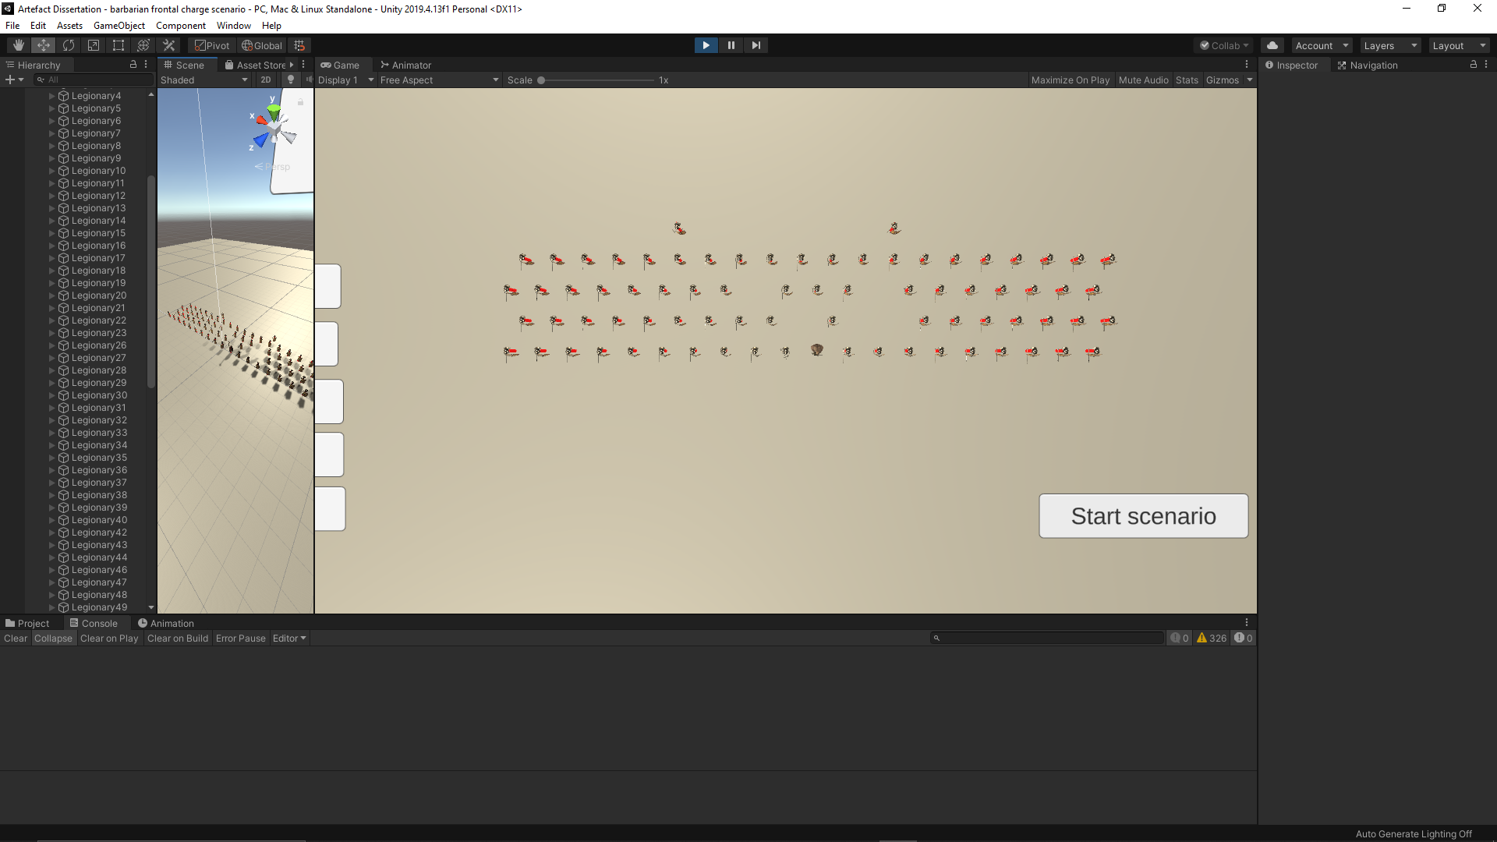

Fig.35&36 – Open order before and after the battle scenario

In the close order formation, the casualty rate was lower than 5%, a lower rate than in open order tactic. Fewer barbarians manage to squeeze through the formation. Because of the tactic’s focus on the defense, the shields are closer together, which makes the barbarians turn towards the swords of the legionary agents for the kill. More barbarian agents were destroyed by the legionary agents in this formation than in open order. The casualties were mostly made by the barbarians which managed to squeeze through.

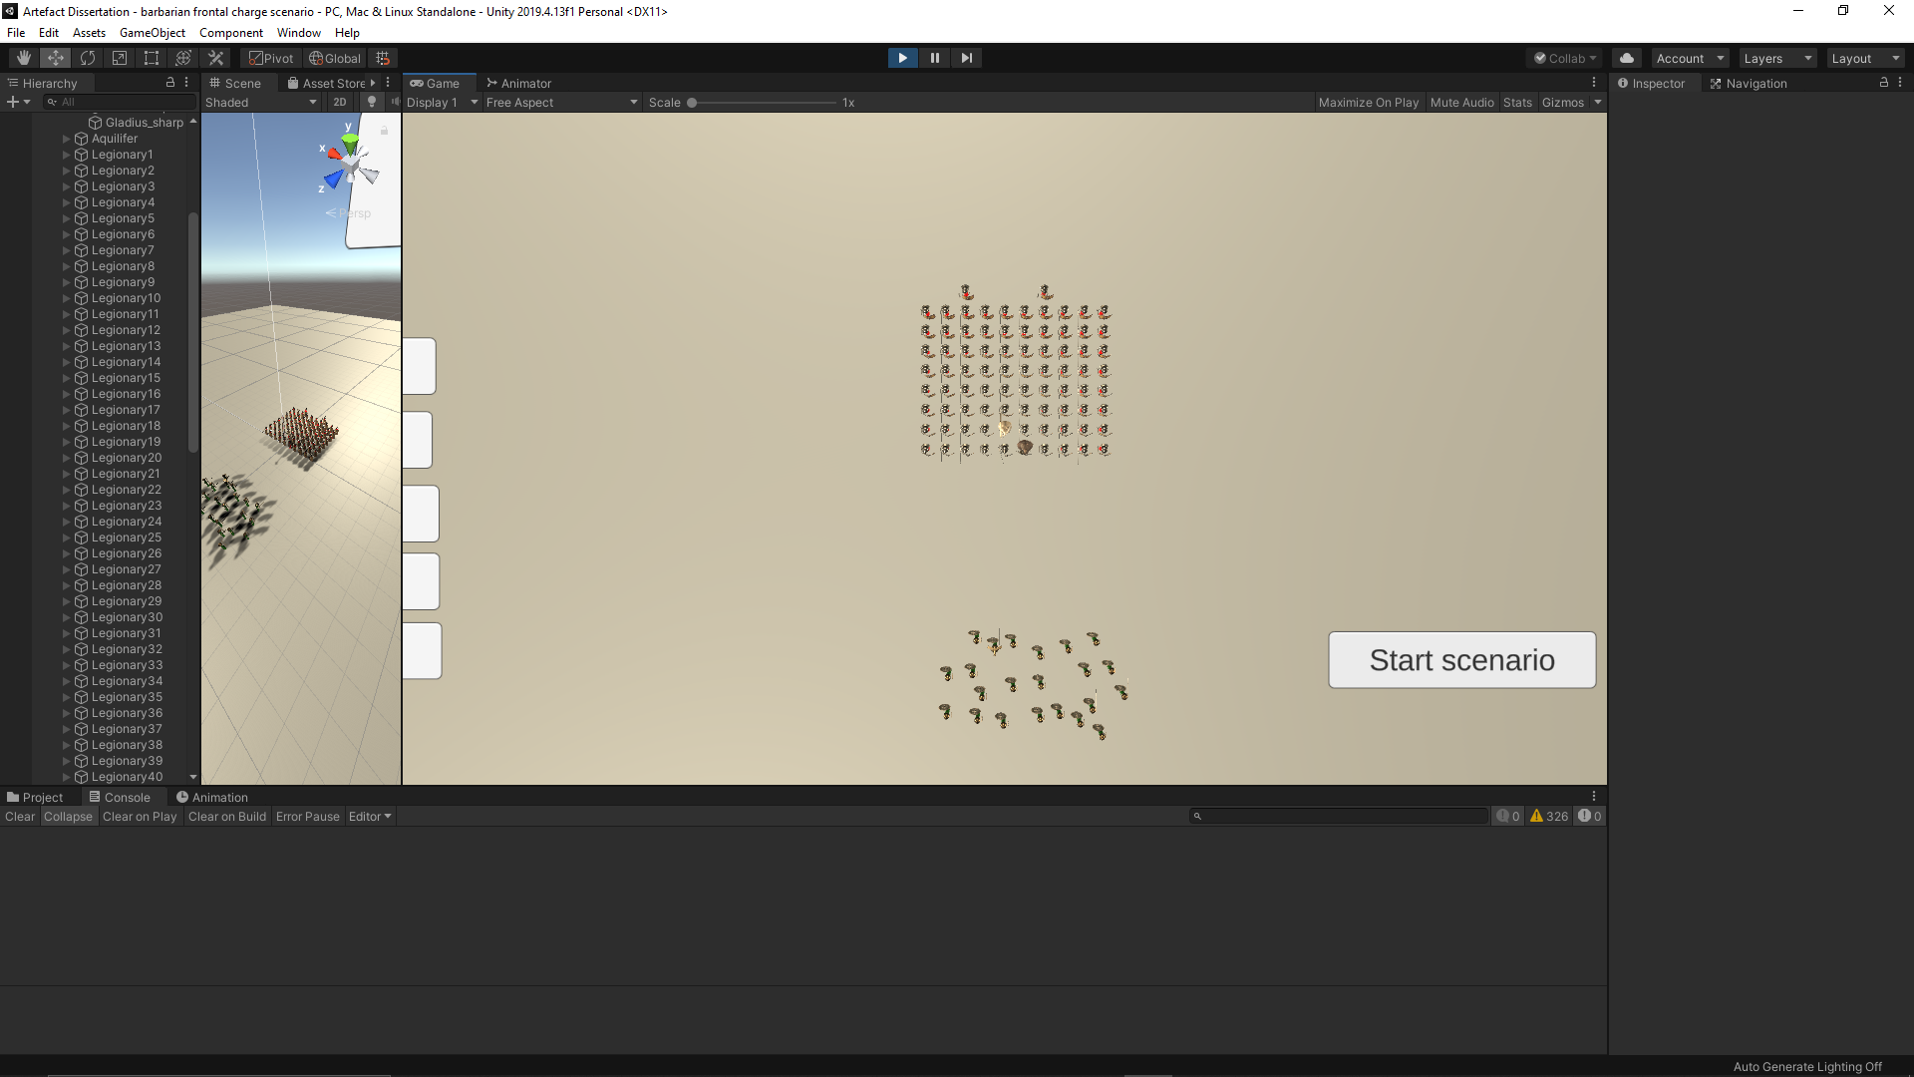

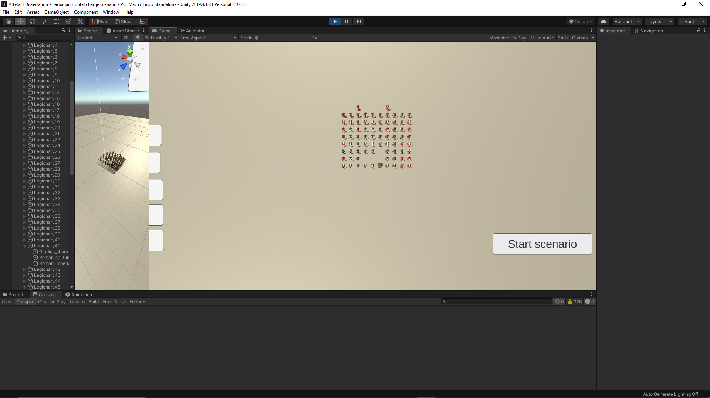

Fig.37&238 –Close order before and after the battle scenario

In the testudo and orbis formations, there are no casualties. The main reason is the how compact the tactics are. In orbis and testudo, both defensive tactics, the shields are interlocked and there are almost no instances of barbarian breakthrough. In addition to that, the swords are pointed forwards between the shields, which allows the legionary agents to destroy the barbarian agents, while being safe from the slashes of the barbarian swords.

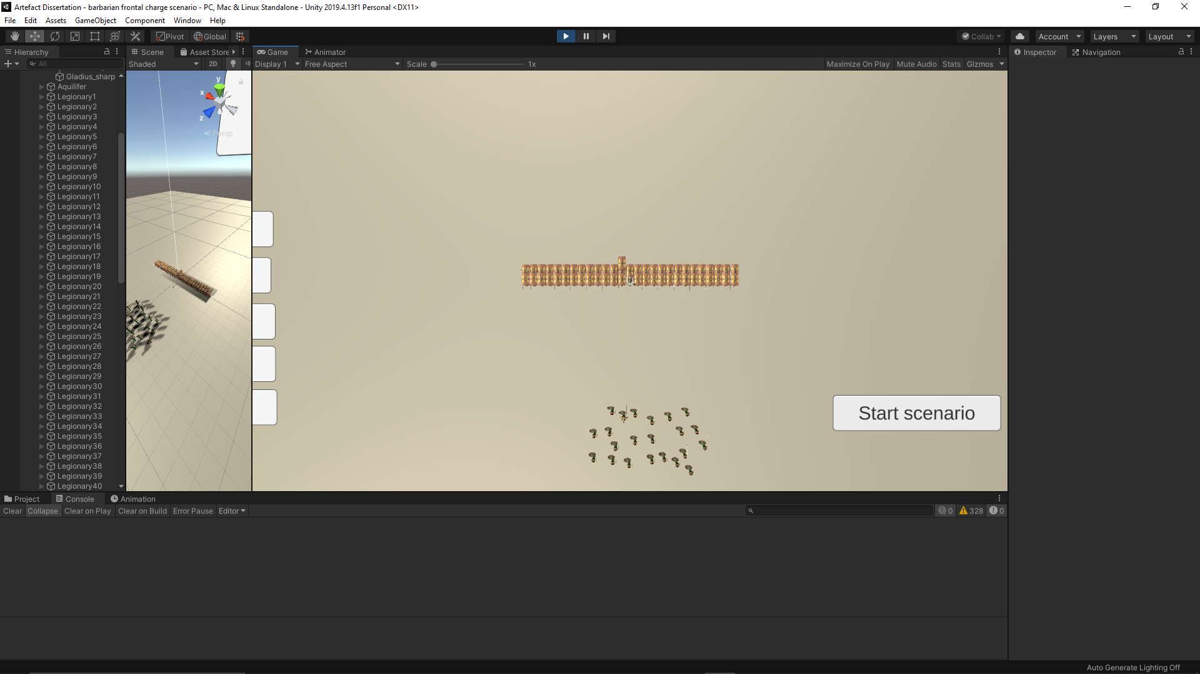

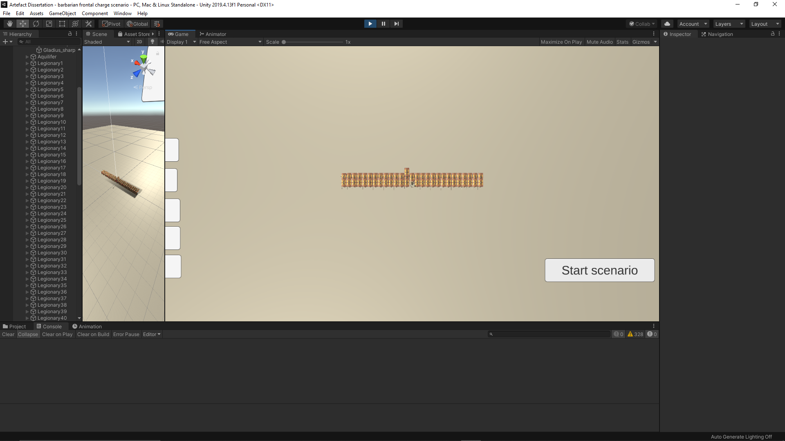

Fig.39&40 – Testudo before and after the battle scenario

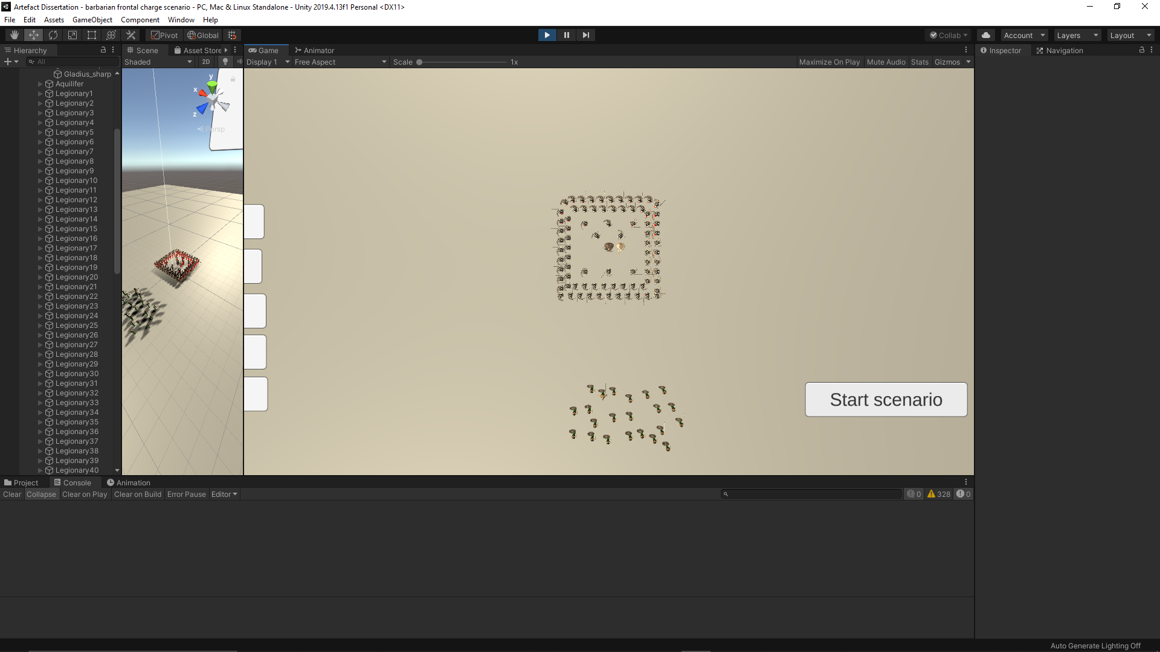

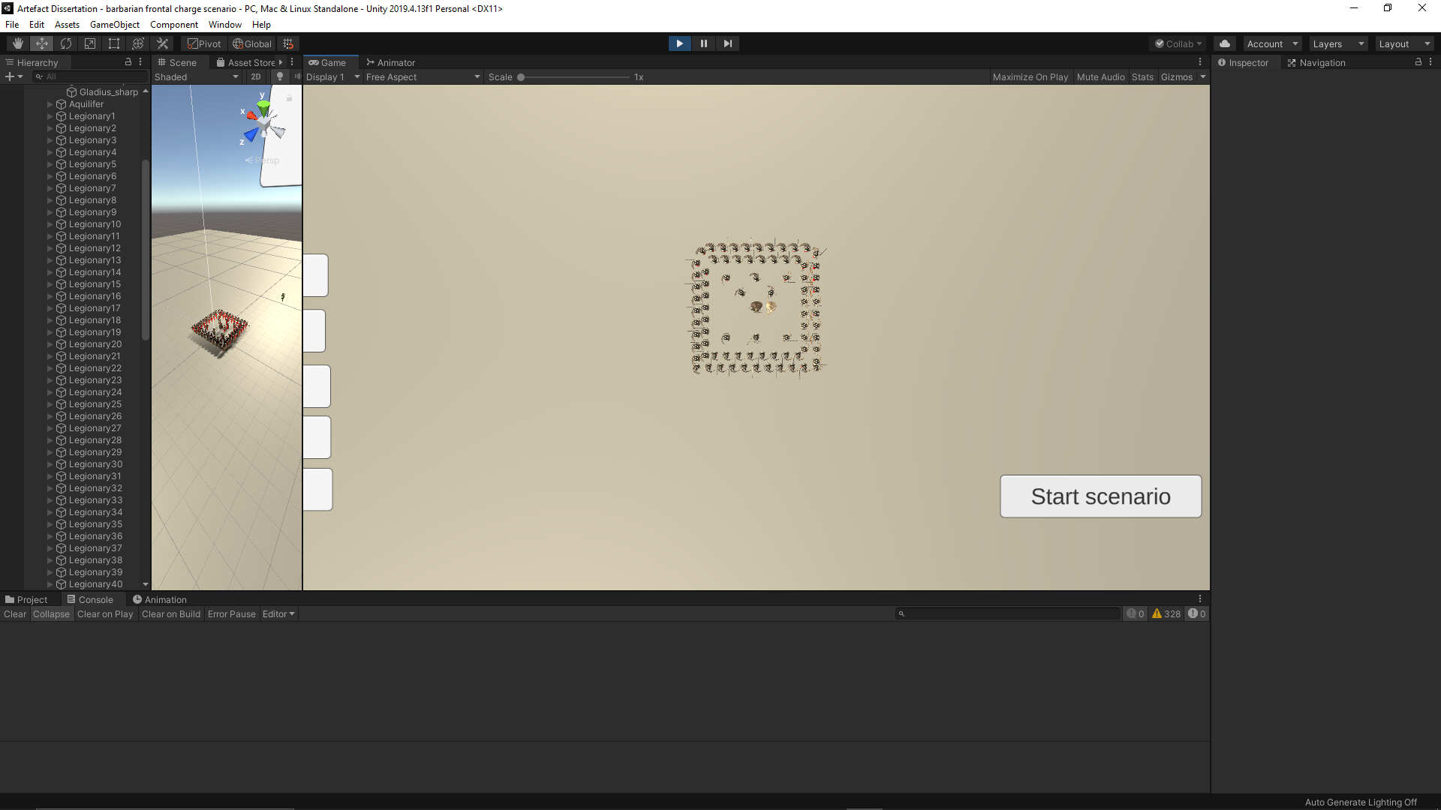

Fig.41&42 – Orbis before and after the battle scenario

In the cuneus formation, the casualty rate was less than 5%. Although it is designed as an offensive tactic, while stationary, the legionary agents are well protected from the front, which helps them absorb the brunt of the attack. The casualties are mainly from the sides of groups, because some barbarians managed to squeeze through the groups and attack them from the sides and rear.

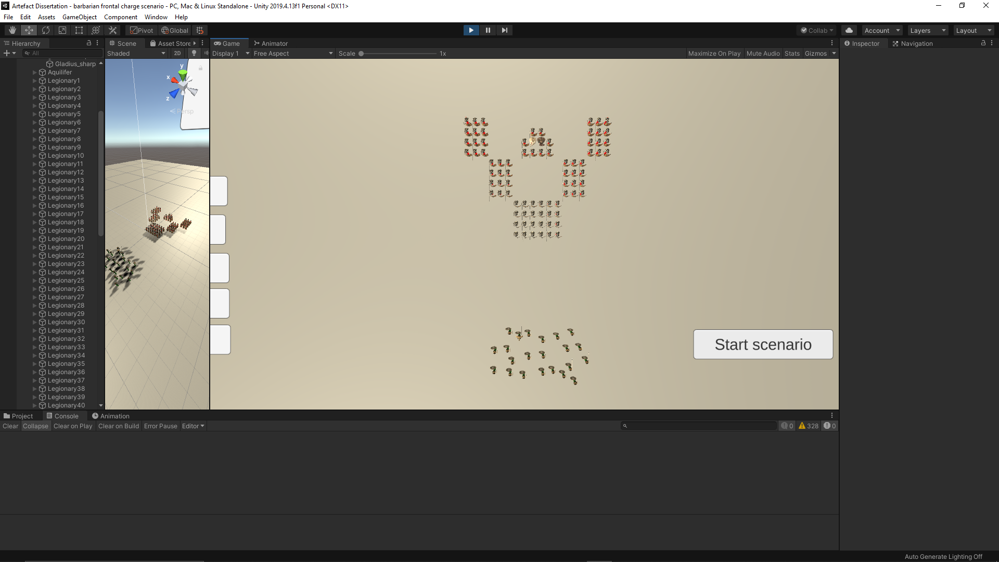

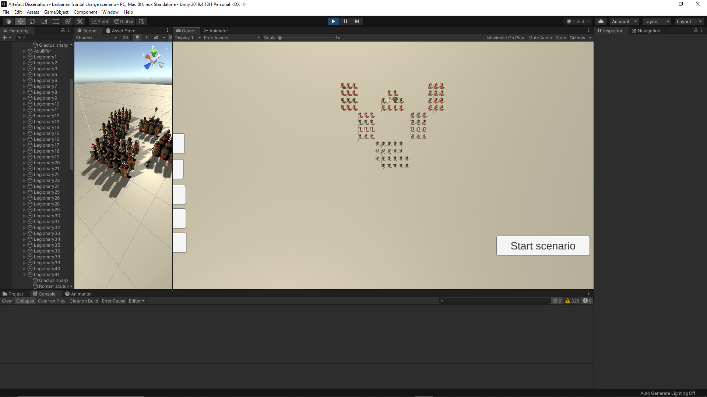

Fig.43&44 – Cuneus before and after the battle scenario

Based on the performance of the formations in this battle scenario, it has been concluded that the defensive tactics (orbis, testudo and close order) are effective at stopping an enemy charge. Although, when in offensive formations (open order and cuneus) the legionary agents suffered casualties, those were due to the gaps between the agents, which allows the barbarians to squeeze through. The equipment of the Romans increased the chances of survival in this battle scenario, which can be proven in the low casualty rate when using offensive tactics.

* 1. Encirclement scenario

In this scenario, the century is surrounded by the barbarian horde. The tactic chosen determines the survivability of the legionary agents. Unlike the last scenario, the barbarians are charging the from all sides. Most of the tactics are designed for battle scenarios in which the barbarians are coming from the front, but in this scenario, the barbarians are charging from the sides and back, so in most of the formations, the sides and back are exposed to an enemy attack. The barbarian horde consists of a couple hundred agents divided in small barbarian warbands placed in a circle facing inwards around the century.

In open order formation, the casualty rate was around 15%. Most of the casualties are located around the middle of the formation. There are less casualties at the end sides of the formations because the legionary agents managed to escape from the encirclement by slipping through the barbarian warbands. The spacing between the legionary agents allows the barbarian agent to destroy legionary agents one by one, in some instances around 5 barbarian agents attacking one legionary agent.

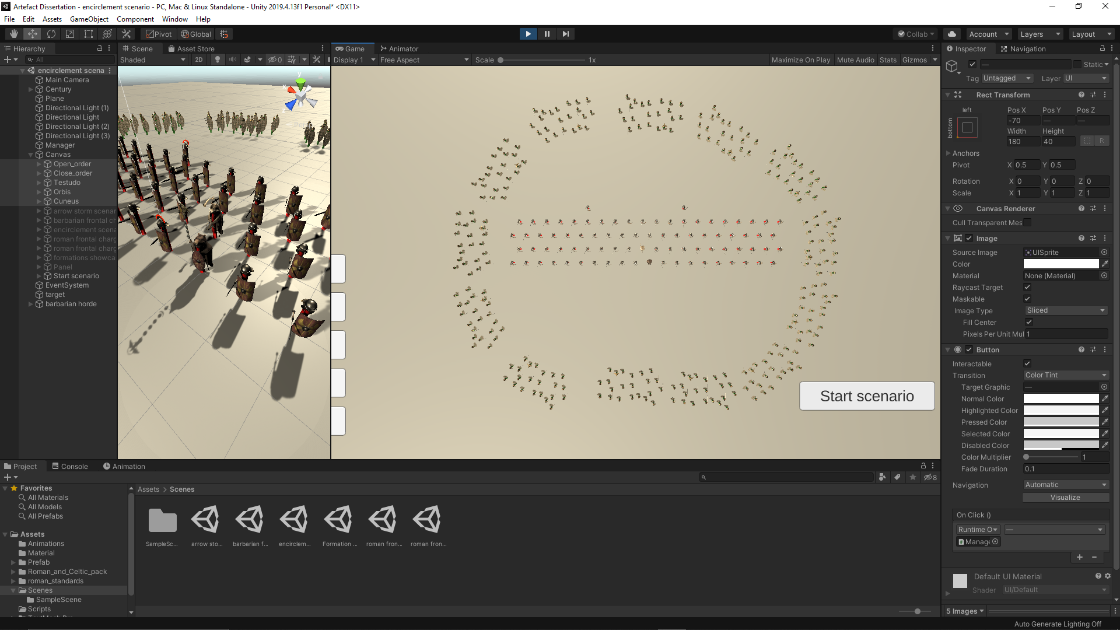

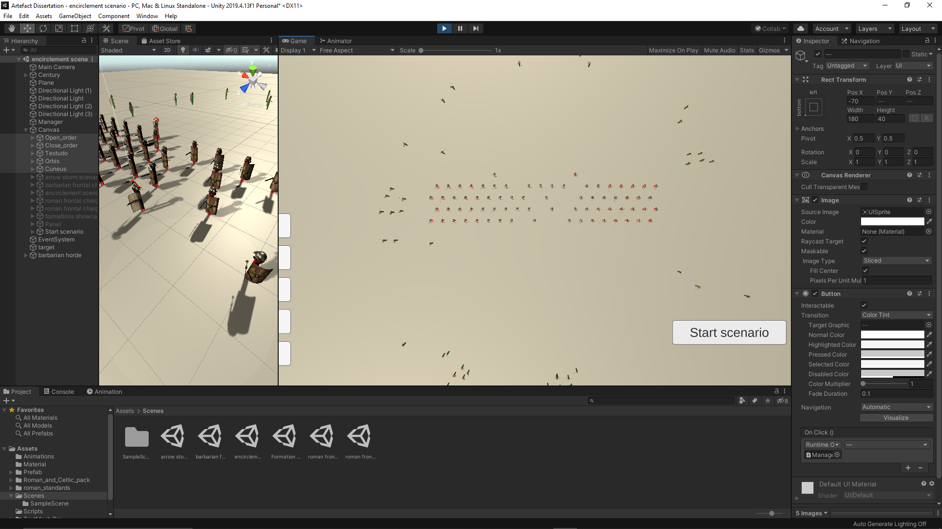

Fig.45&46 – Open order before and after the battle scenario

In close order formation, the casualty rate was around 20%. Most of the casualties are located on the right and back side of the formation. There are more casualties in this formation than in open order because all the legionary agents are trapped inside the encirclement. The barbarian agents chip away the century one column at a time.

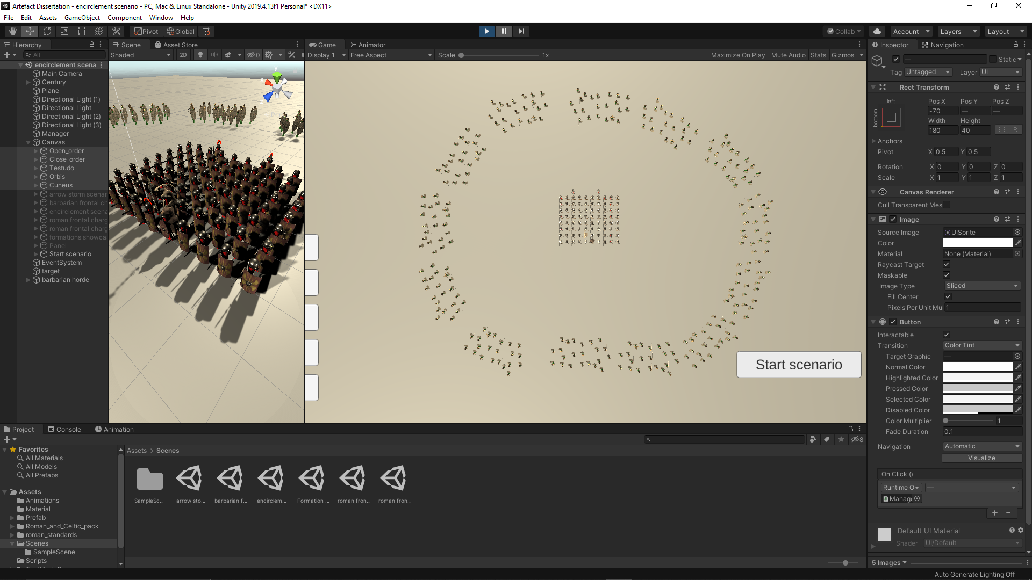

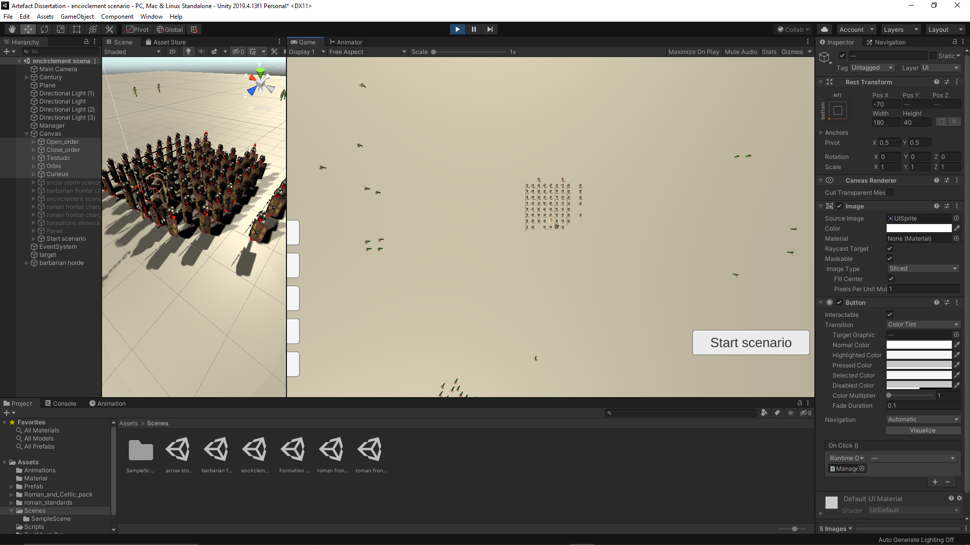

Fig.47&48 – Close order before and after the battle scenario

In testudo formation, the casualty rate was around 15%. Most of the casualties are in the last rank as they are the only ones not protected by their comrades shields or their backs protected by their comrades’ bodies.

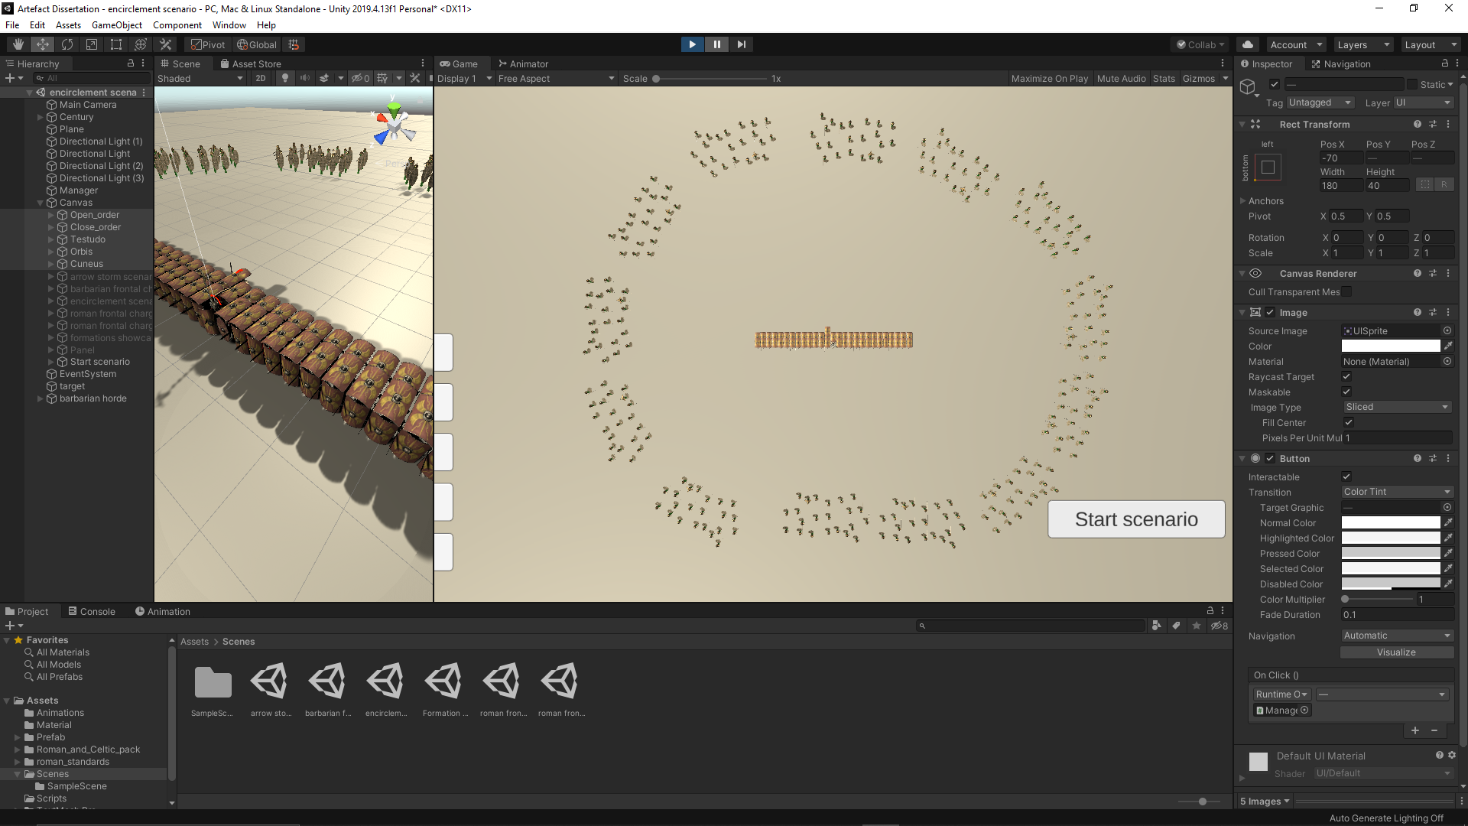

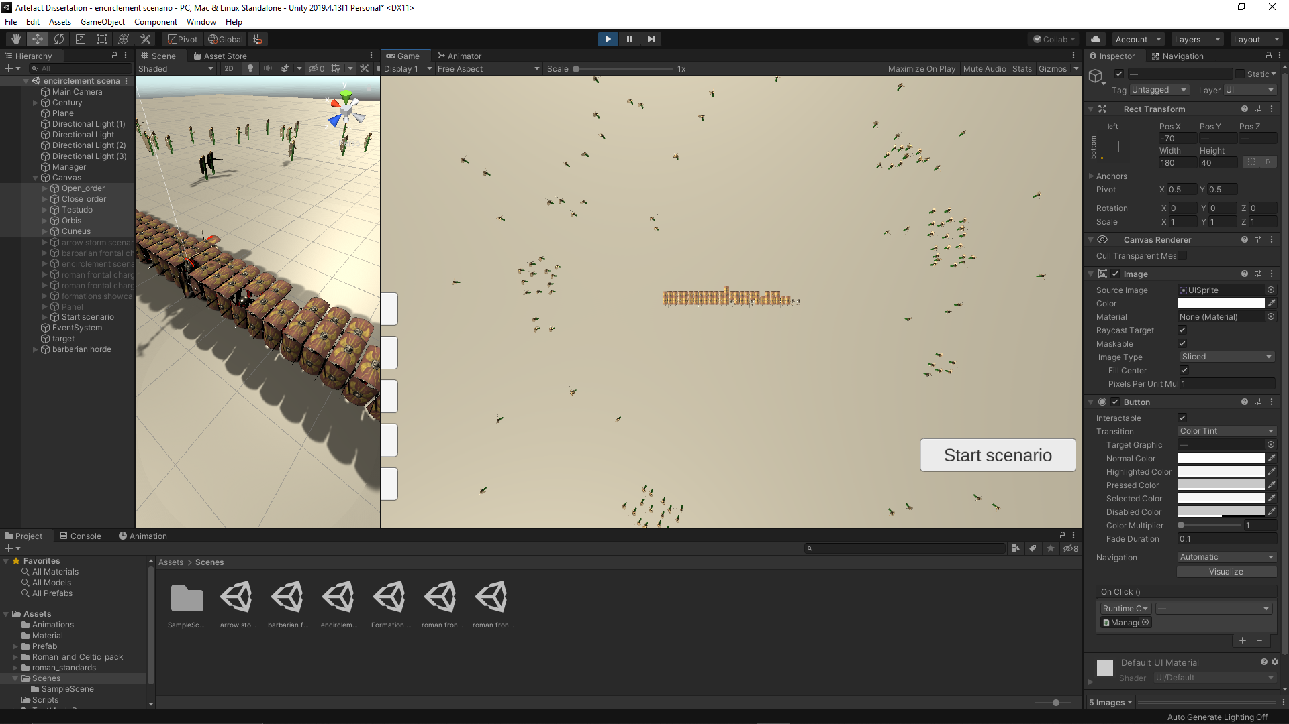

Fig.49&50 – Testudo before and after the battle scenario

In orbis formation, the casualty rate was relatively non-existent. The reason for no casualties is since there is no exposed sides or back. The square shape of the tactic allows the century to have legionary agents facing in all directions bracing the enemy charge.

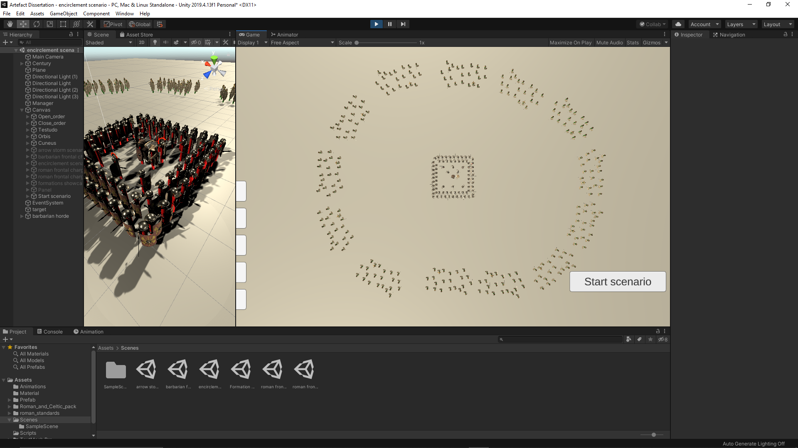

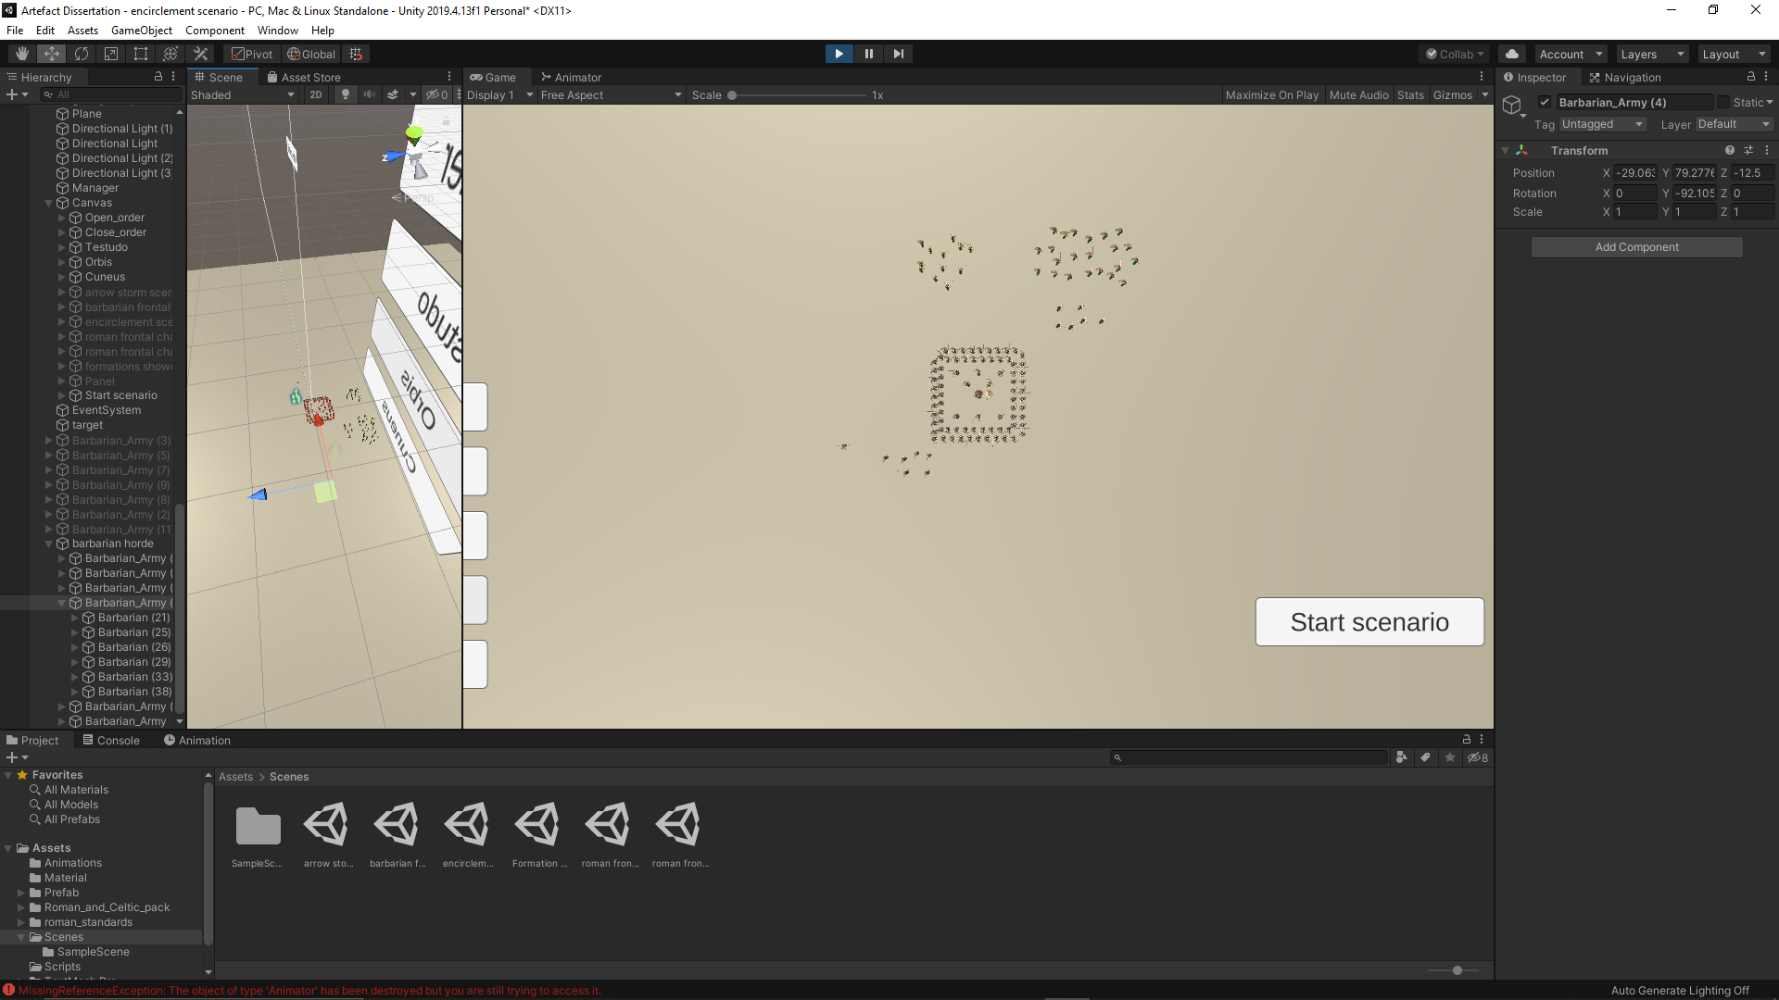

Fig.51&52 – Orbis before and after the battle scenario

In cuneus formation, the casualty rate was around 15%. Like in open formation, the barbarian agents destroyed the legionary agents by separating the small groups in the formation and attacking them individually.

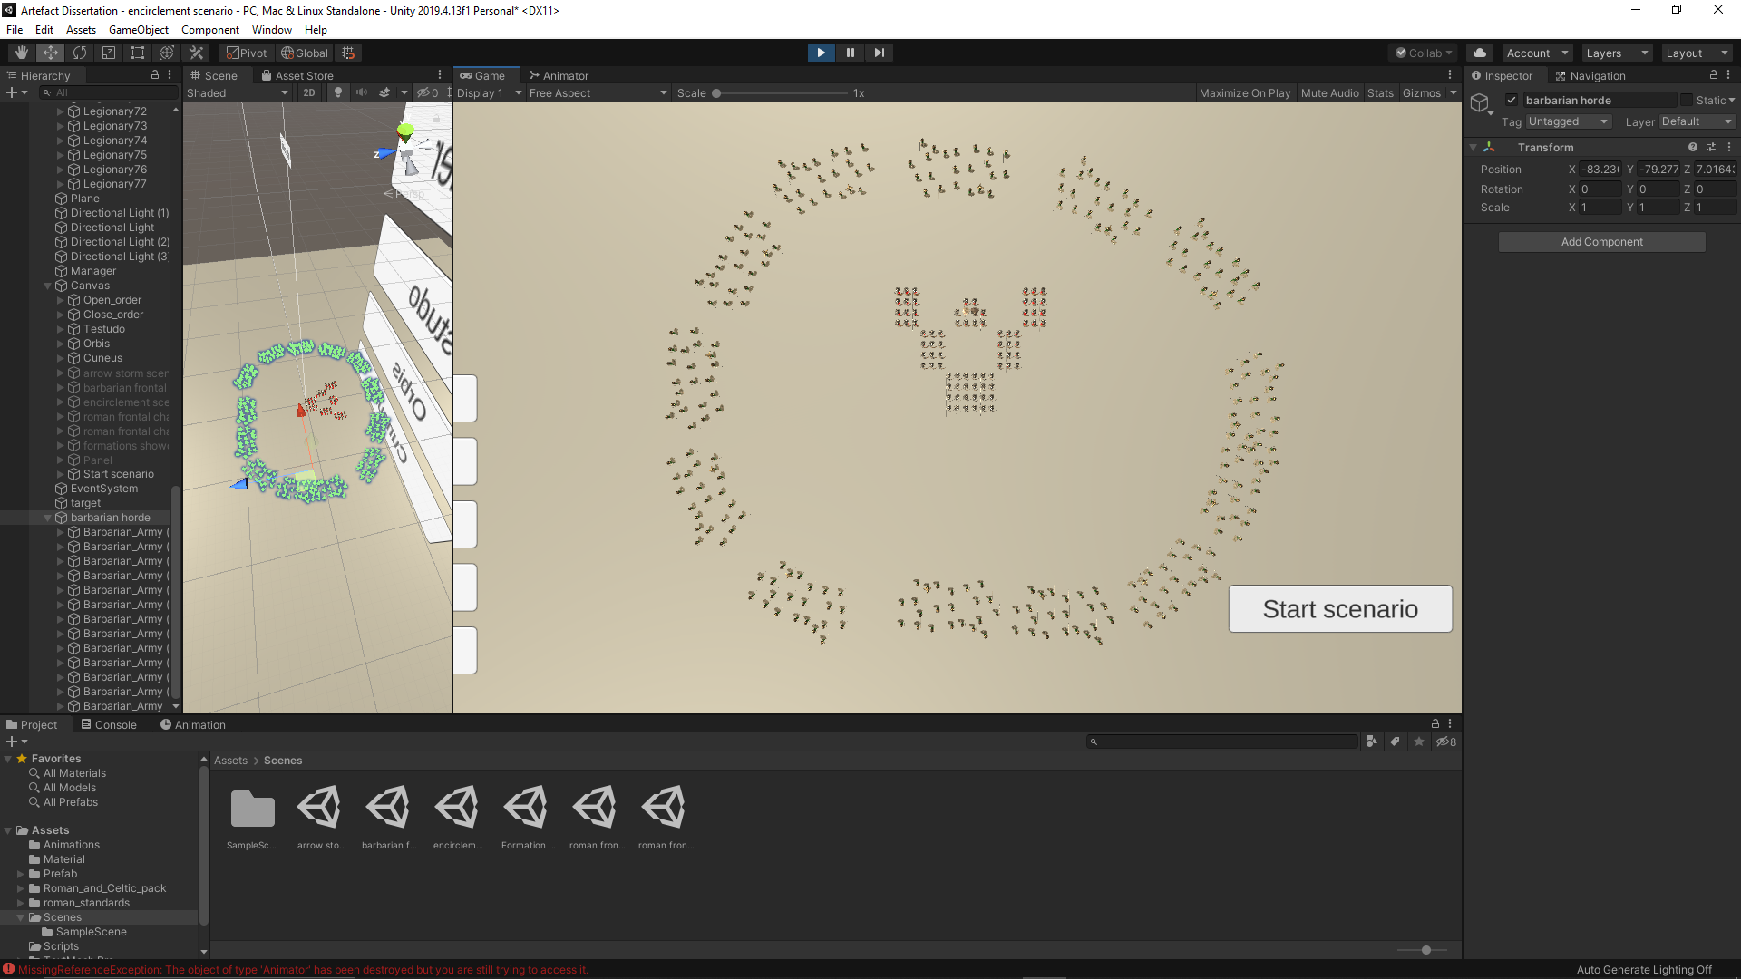

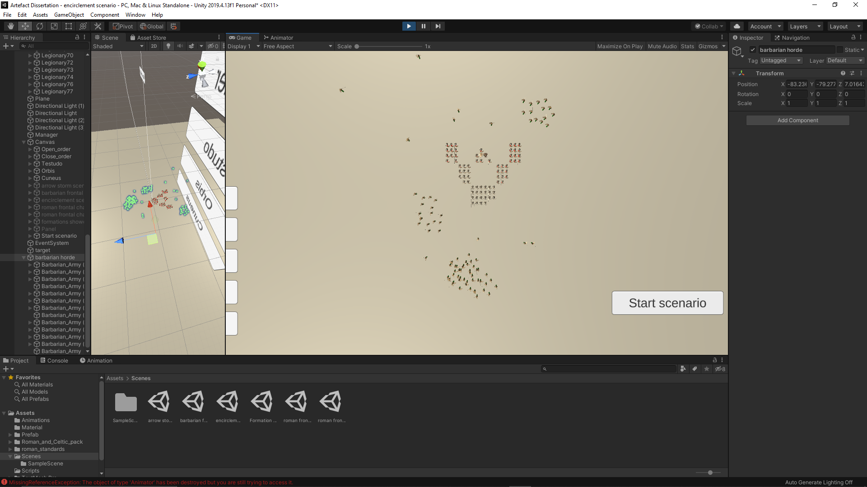

Fig.53&54 – Cuneus before and after the battle scenario

Based on the performance of the formations in this battle scenario, it has been concluded that the orbis is the most effective tactic. Historically it has developed for the sole purpose of protecting the century from encirclement and it is demonstrated in the artefact the reasons why it was adopted by the Romans. It has been discovered during testing that most of the casualties are located at the right side and back. There are fewer casualties on the left side, due to the fact that on the left side, the legionary agents have their right arms with their weapons in hand and the barbarian agents are programmed to be destroyed by having their bodies collide with the roman swords. If barbarians are focusing the charge on the right side and back, the number of casualties on the century side would increase dramatically.

* 1. Roman frontal charge scenario

In this scenario, it is the turn of the century’s turn to attack in a frontal charge. It attacks a barbarian army head on to destroy it. The tactic chosen in this scenario would affect the speed of the charge, the weight of the charge and the number of legionary agents who enter in combat when the two armies collide. The number of barbarian agents destroyed depends entirely on the breakthrough of the century. Both defensive and offensive tactics are tested in this scenario. The barbarian army is composed of small warbands positioned in such the way that the depth of the barbarian army has a chance to stop the Roman charge.

In the open order formation, the casualty rate was around 5%. However, the legionary agents manage to break through the barbarian battle line. Although the barbarian casualties are low, there are more barbarian agents destroyed than legionary agents. The weight of the charge was increase by the speed of the charge as it was programmed to be double than the defensive tactics.

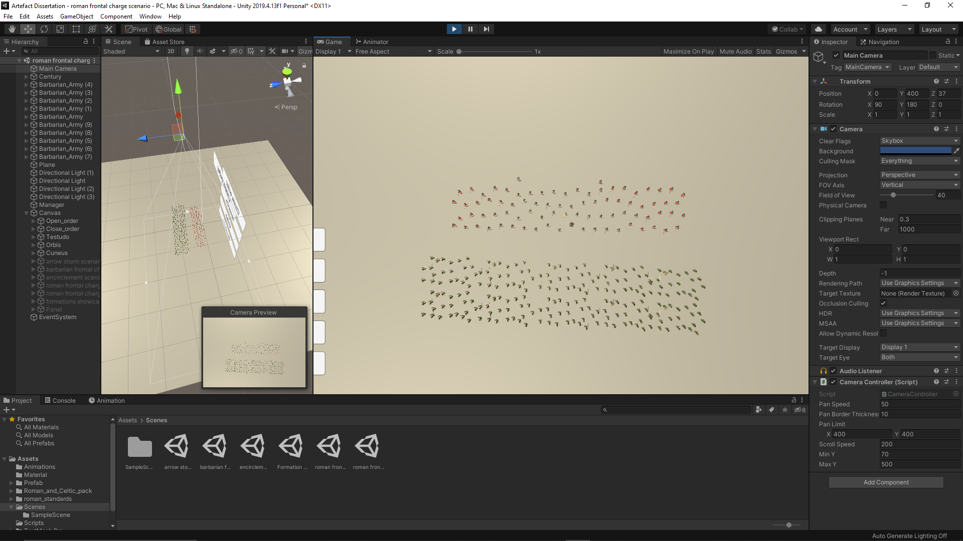

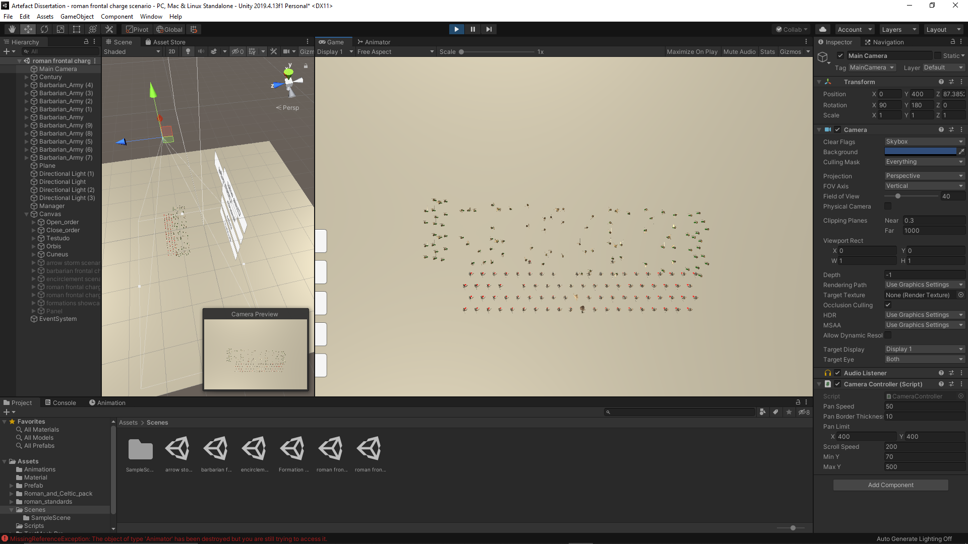

Fig.55&56 – Open order before and after the battle scenario

In the close order formation, the casualty rate is zero. Although the speed of the charge is slower, the power of the charge is supplemented by the weight of it. Since the depth of the formation is double then the open order, the pressure of the barbarian battle line is so big, the century went through it like a hot knife through butter.

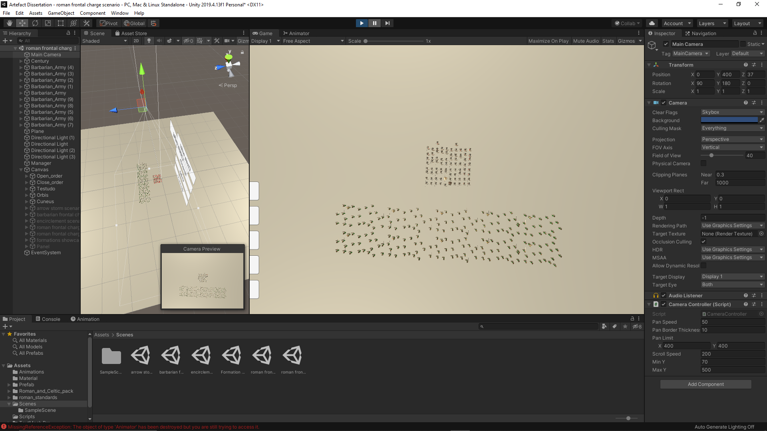

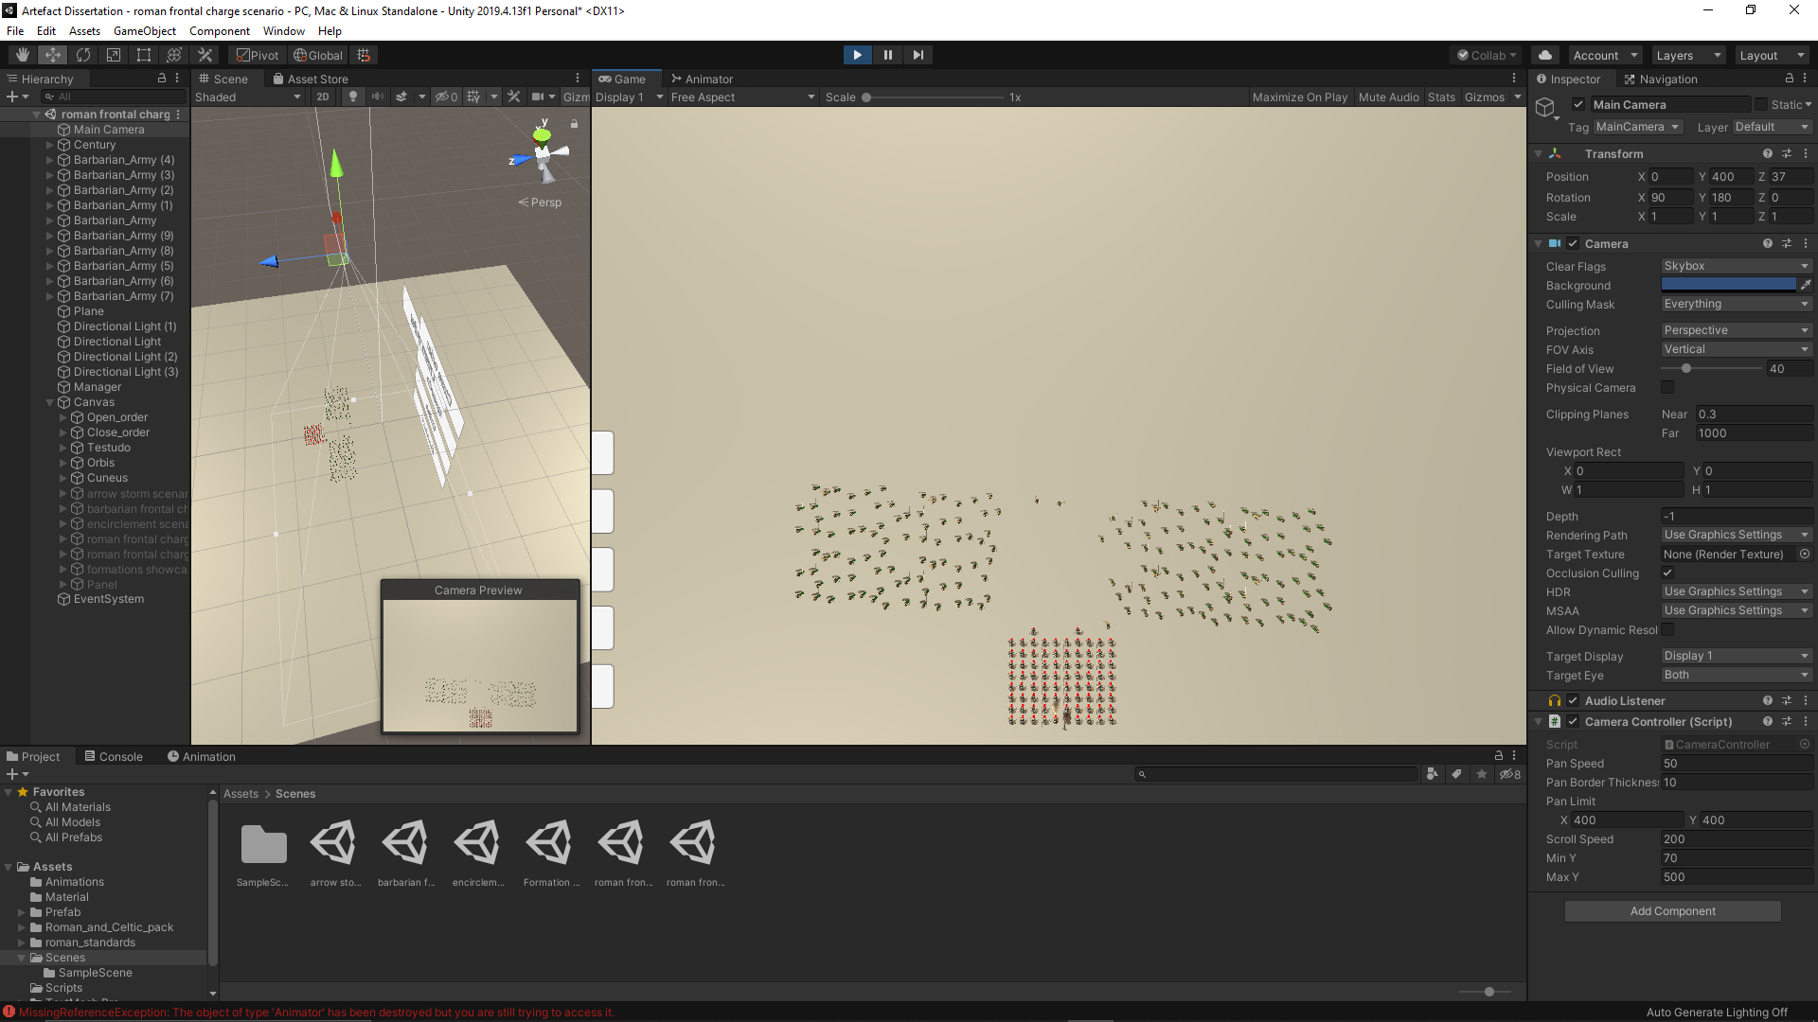

Fig.57&58 – Close order before and after the battle scenario

In the testudo formation, the casualty rate was zero. It had the same effect as the close order. It went through the barbarian battle line easily. Unlike the close formation, in testudo the century advances even slower and the frontage is bigger. However, the usage of the shields for protection helped to decrease the casualties on the Roman side, but a high casualty rate on the barbarian side.

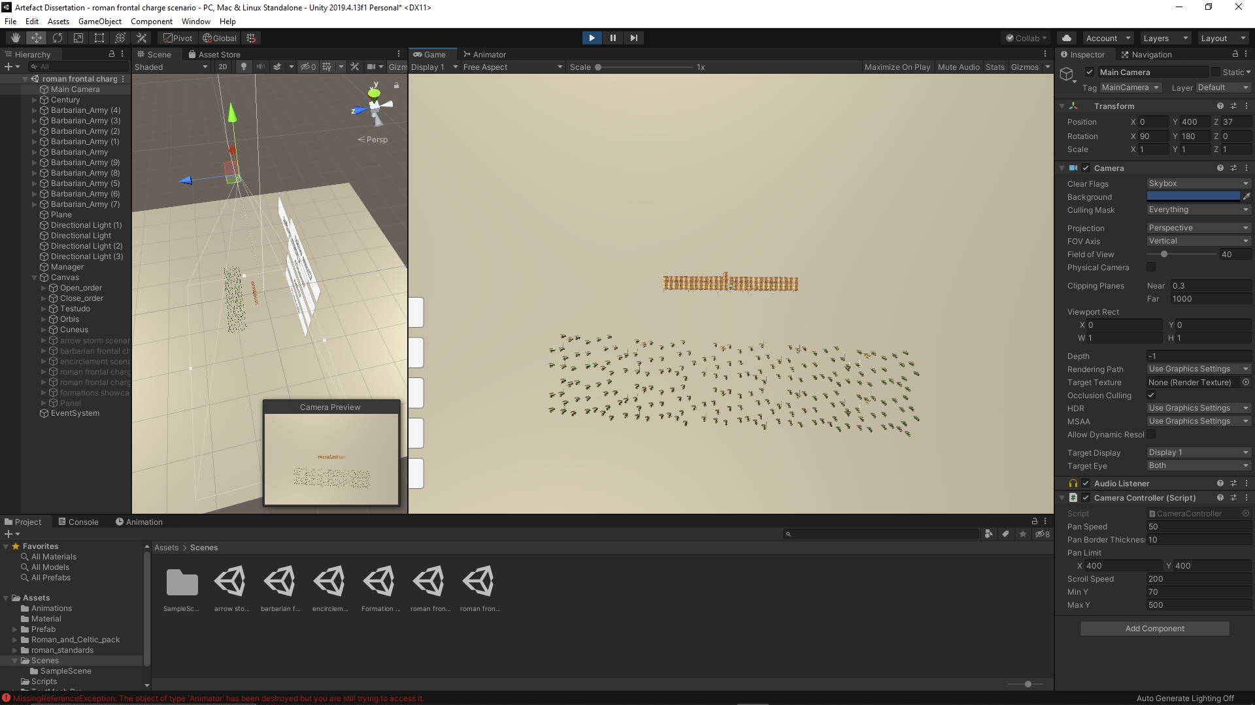

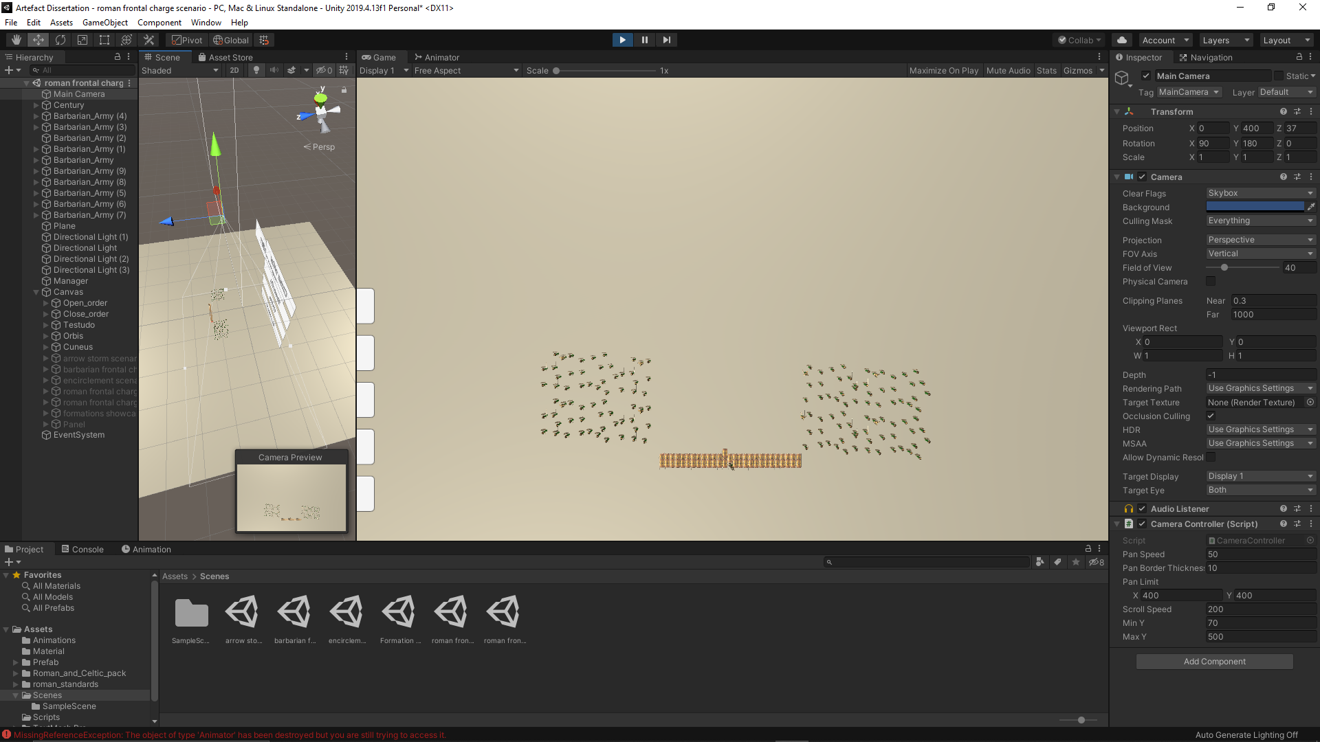

Fig.59&60 – Testudo before and after the battle scenario

In the orbis formation, the casualty rate was around 3%. The few casualties are cause on the initial contact between the two armies. The small depth of a side of the formation may give the chance for the barbarian agents to break it and destroy some legionary agents. The power of the charge is not as powerful as the close order; however, it is strong enough to break through the enemy battle line.

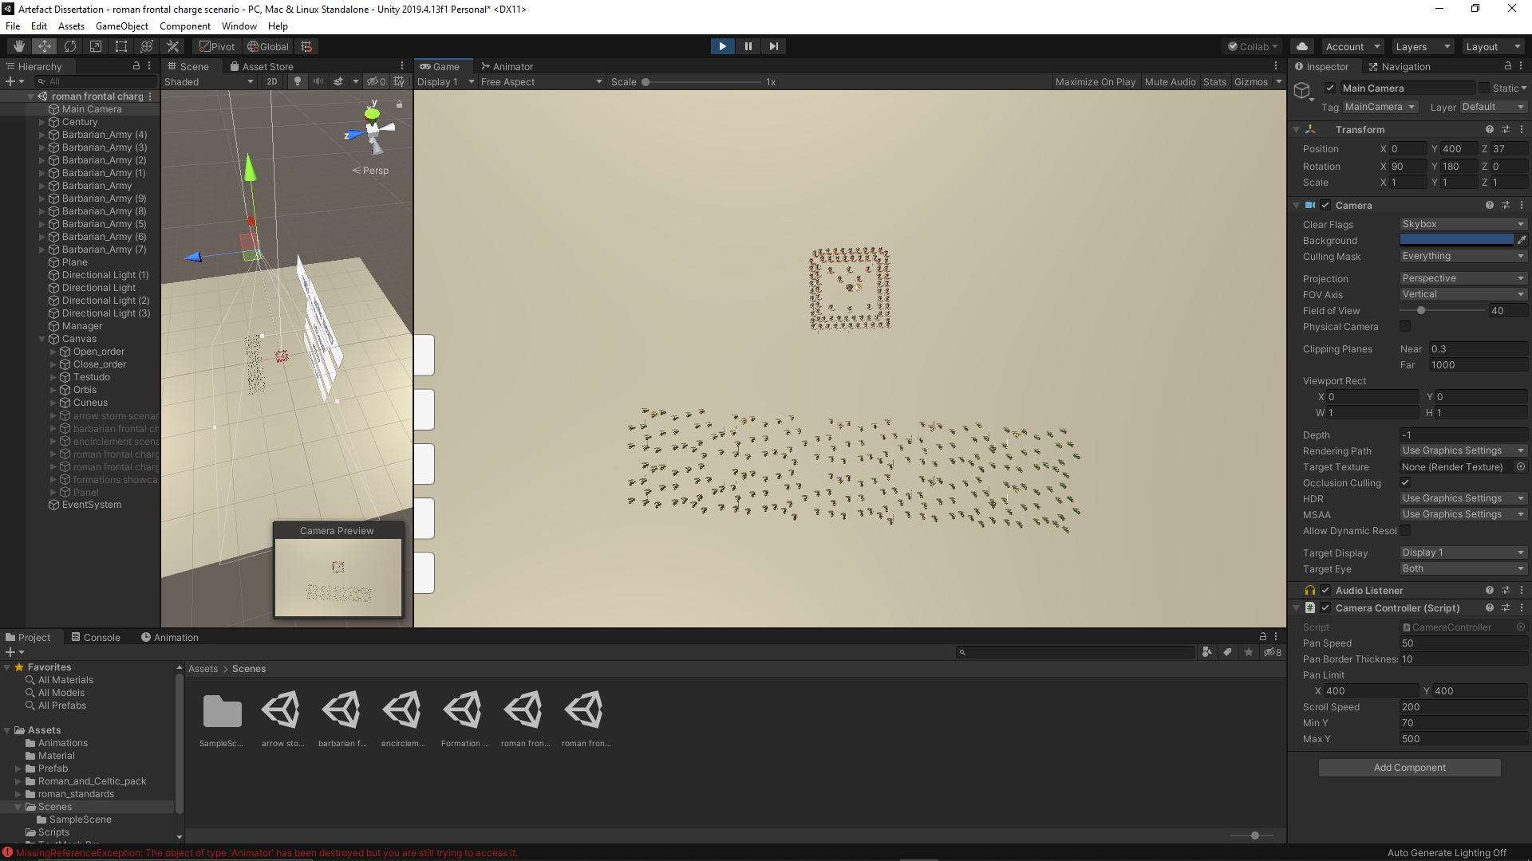

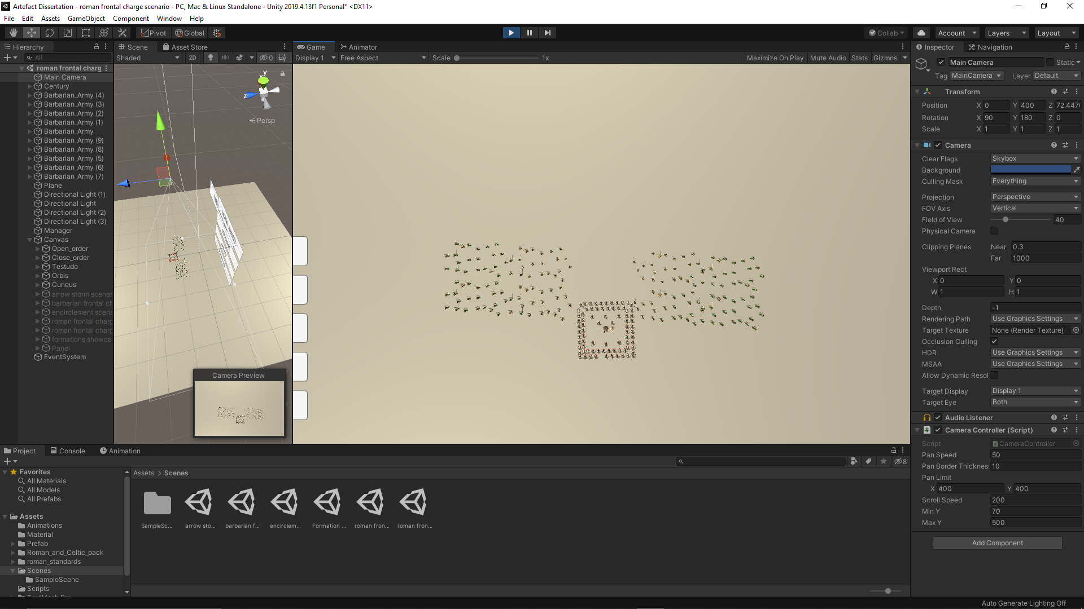

Fig.61&62 – Orbis before and after the battle scenario

In the cuneus formation, the casualty rate was around 5%. The casualties are caused on the initial contact. Due to the shape of the formation, it breaks the barbarian battle line almost in half, destroying everything in their path, but the charge was not strong enough to pushed through the entire battle line. If a moral variable were implemented on barbarian agents, there would be a possibility of the nearby agents running away.

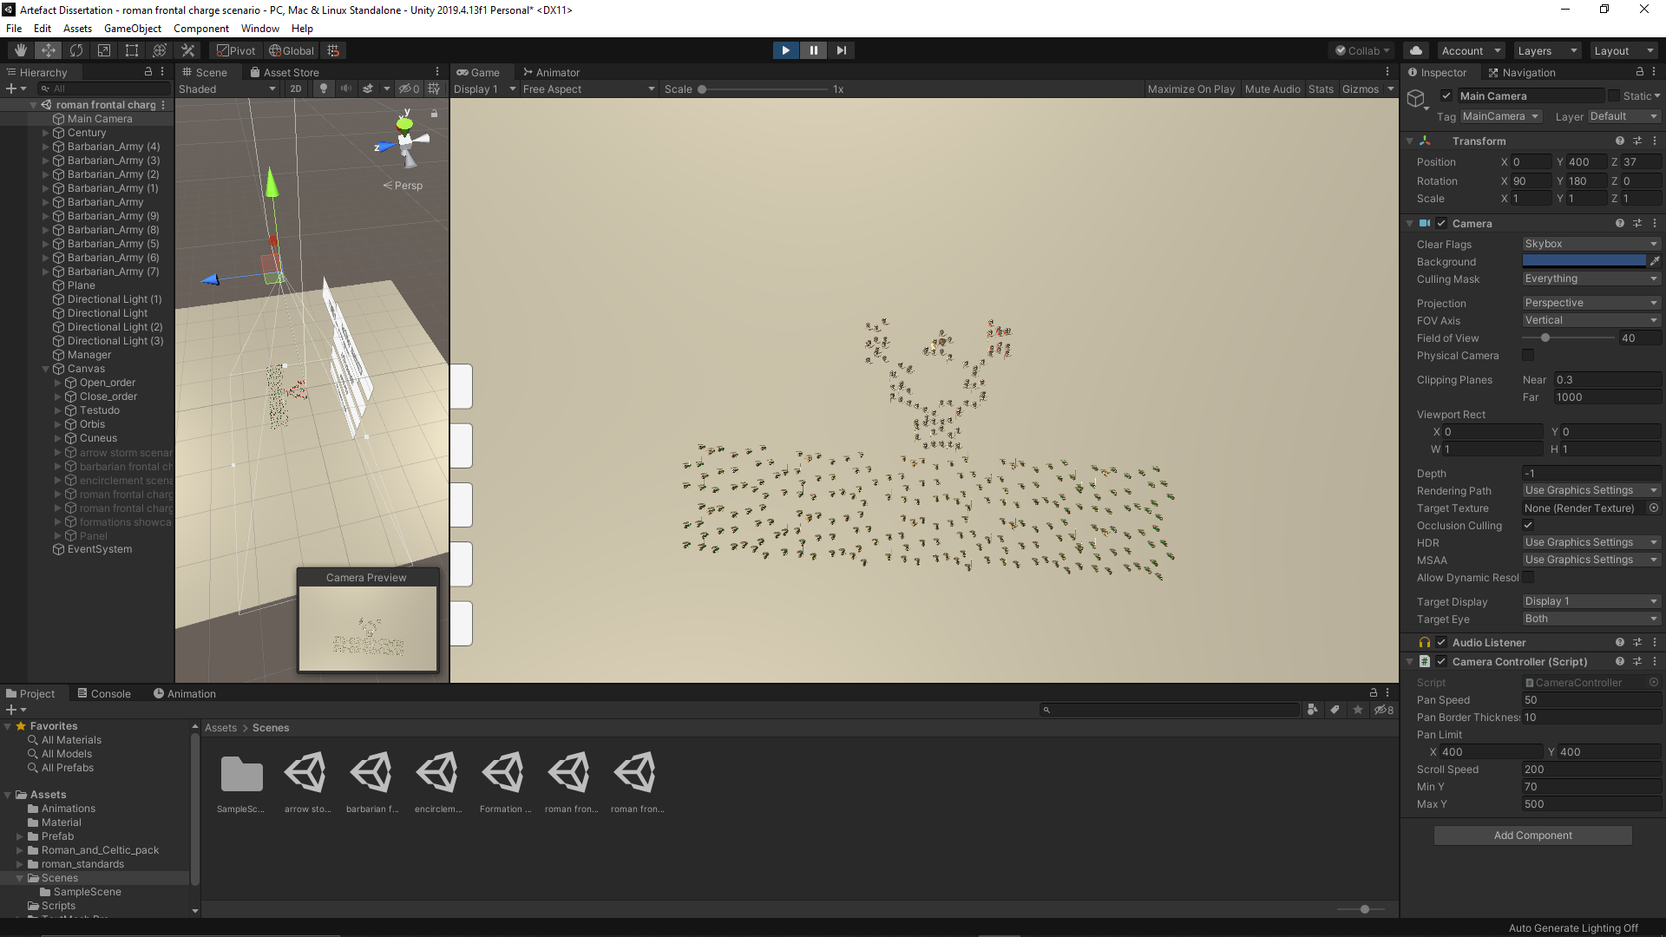

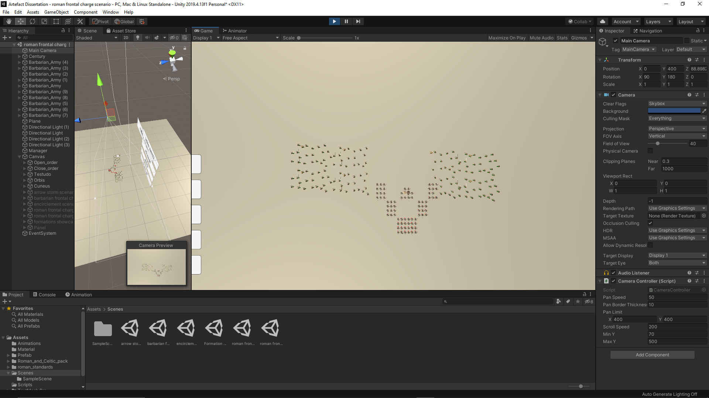

Fig.63&64 – Cuneus before and after the battle scenario

Based on the performance of the formations in this battle scenario, the offensive formations have a better chance to break through the barbarian battle line if the lines are thin and the defensive formations went through the battle line without struggle.

4.6 Roman frontal charge on weak point scenario

In this scenario, the century is attacking the barbarian army head on in a frontal charge. The difference between this scenario and the last one is how the barbarian army is formed. In the previous scenario, the barbarian agents were spread out equally throughout the battle line, with no weak points. In this scenario, the barbarian battle line has a weak point in the center. The focus of the scenario is to test the tactics and identify the best formation which would exploit the weak point in the barbarian line effectively.

In the open order formation, the casualty rate was around 2%. The frontage of the tactic was wider than the weak point, which made approximately half of the legionary to miss the target and attack around in a normal frontal charge. The rest who did manage to attack the weak point broke through the barbarian army and destroyed a couple of barbarian agents.

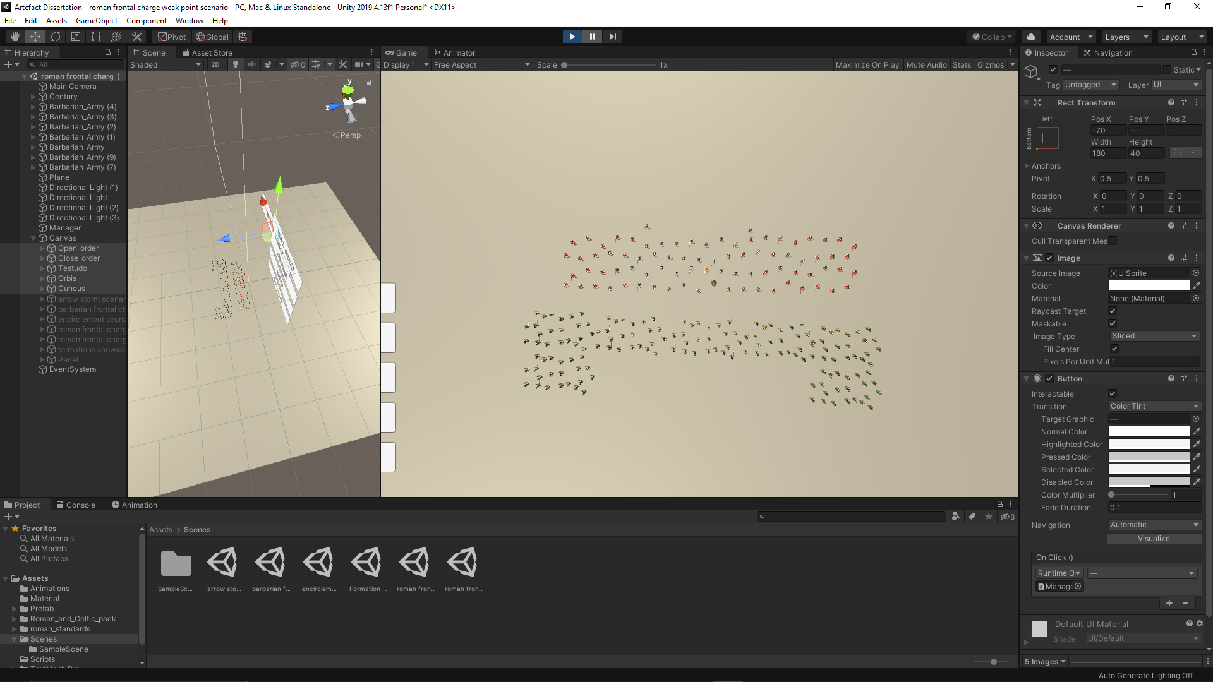

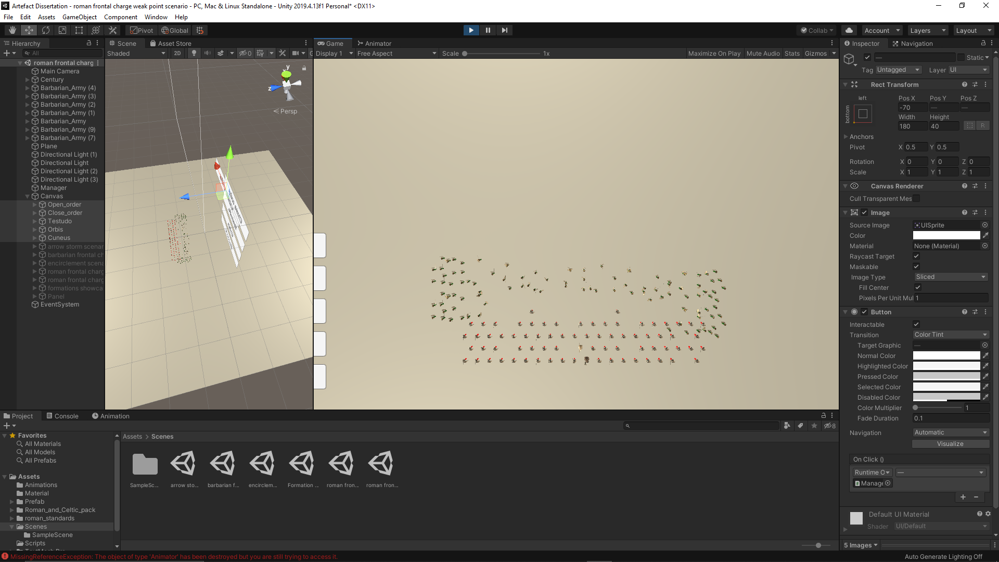

Fig.65&66 – Open order before and after the battle scenario

In the defensive formations (close order, testudo and orbis), the casualty rates are relatively zero, with the orbis formation having a couple of casualties on the initial contact. Besides the testudo, the weak point was wider than the frontage of the tactics. All the formations went through the barbarian army without problem, with a lesser effort than in the previous scenario, due to the fact there were fewer barbarian agents stopping the century’s advance.



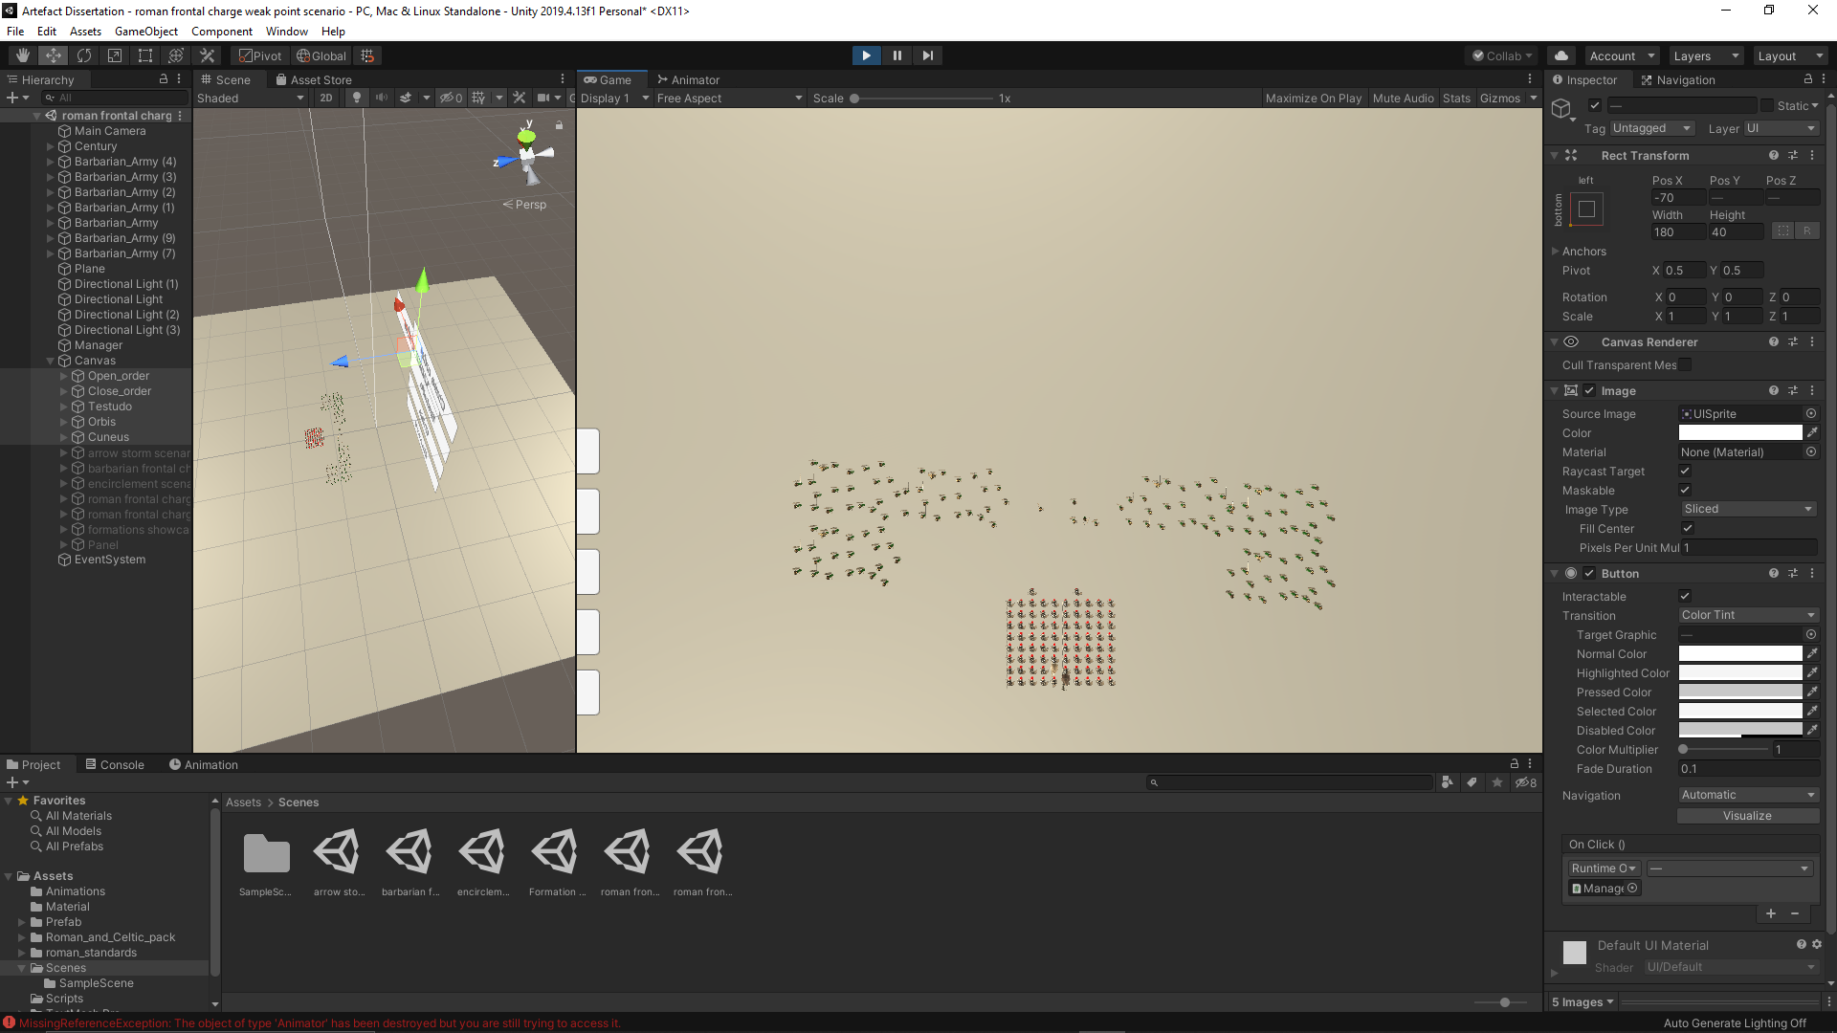

Fig.67&68 – Close order before and after the battle scenario

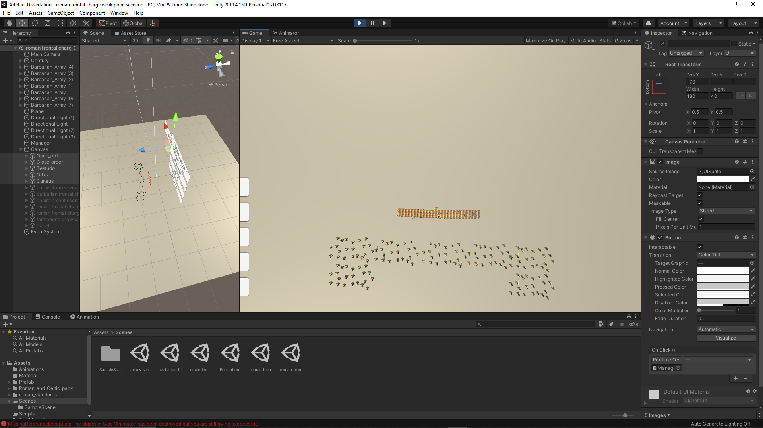

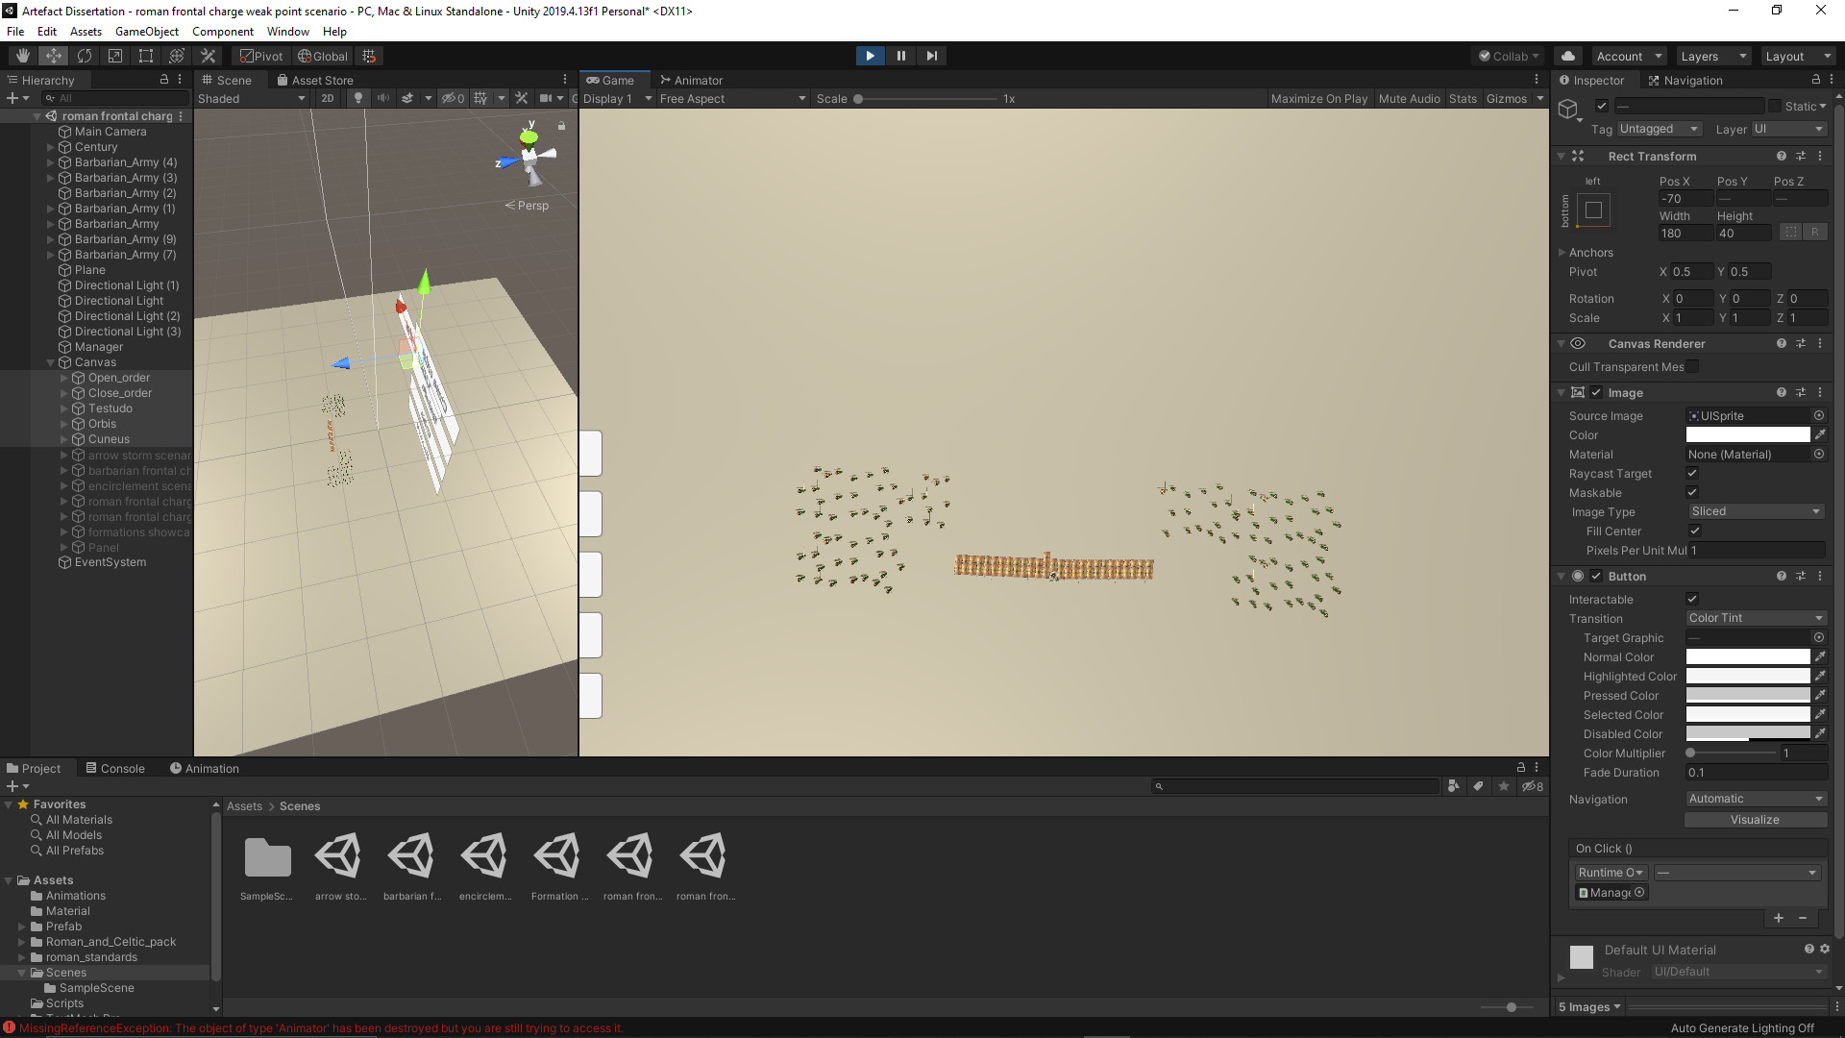

Fig.69&70 – Testudo before and after the battle scenario

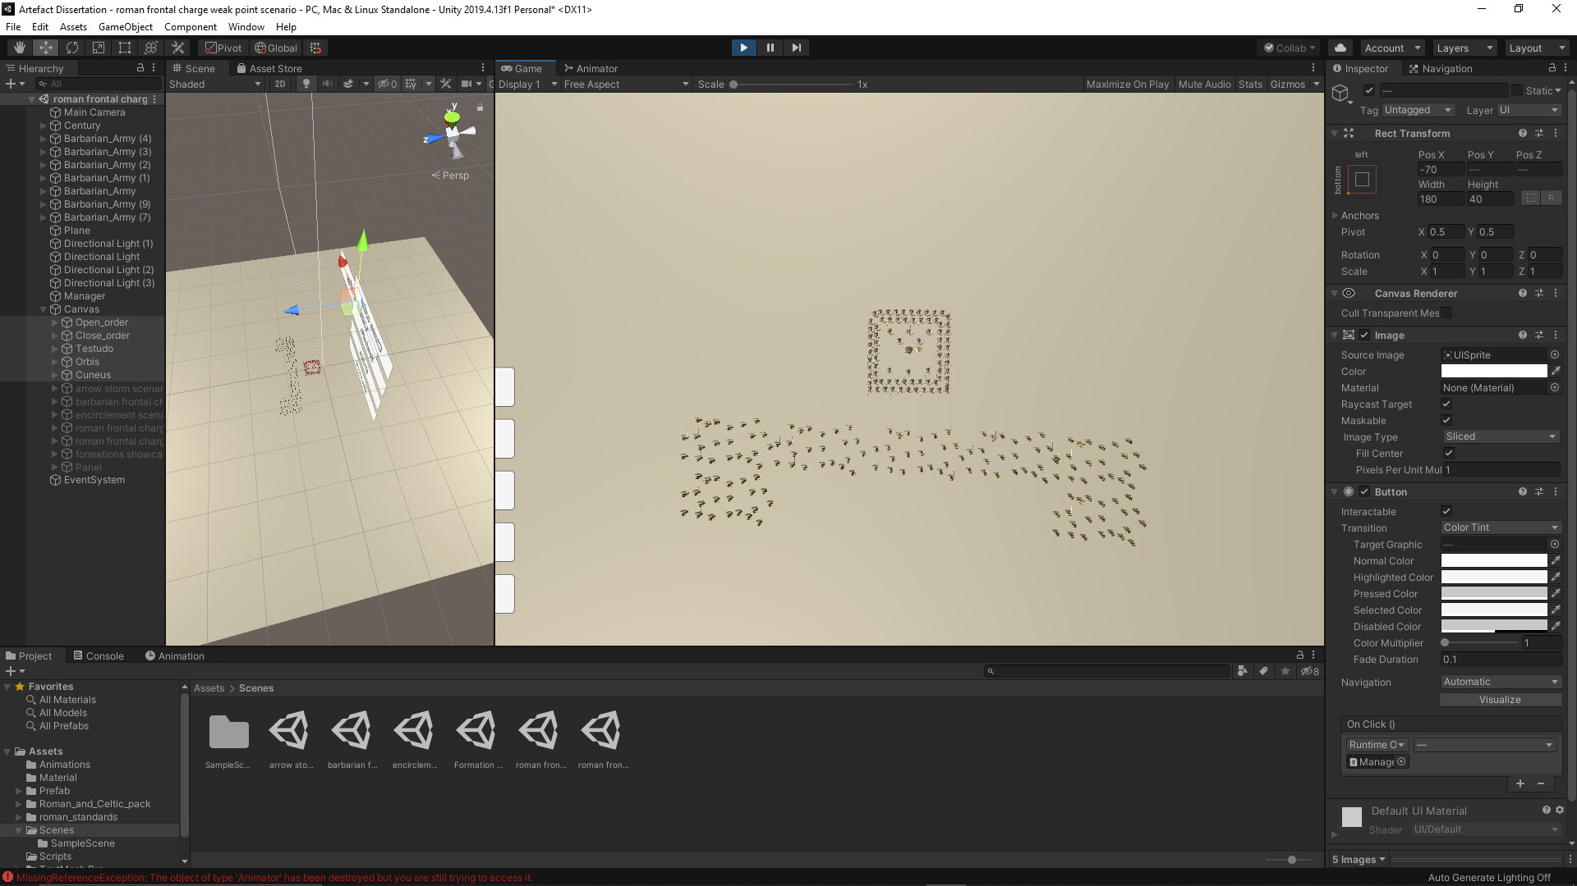

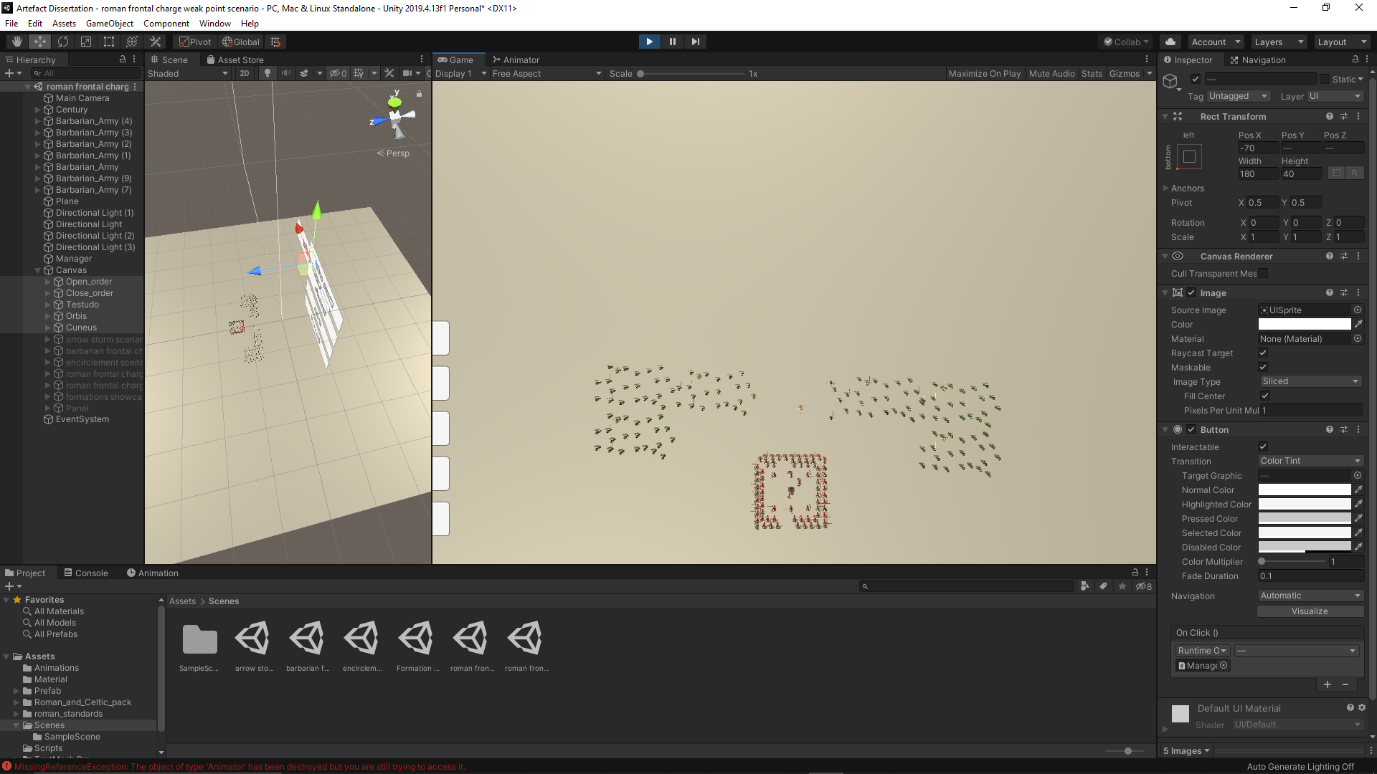

Fig.71&72 – Orbis before and after the battle scenario

In the cuneus formation, the casualty rate was around 5%. Because of the triangle shape of the tactic, the century went through the weak point without effort. In addition to punching through the enemy weak point, the century formed a gap in the enemy battle line as wide as the frontage of the formation.

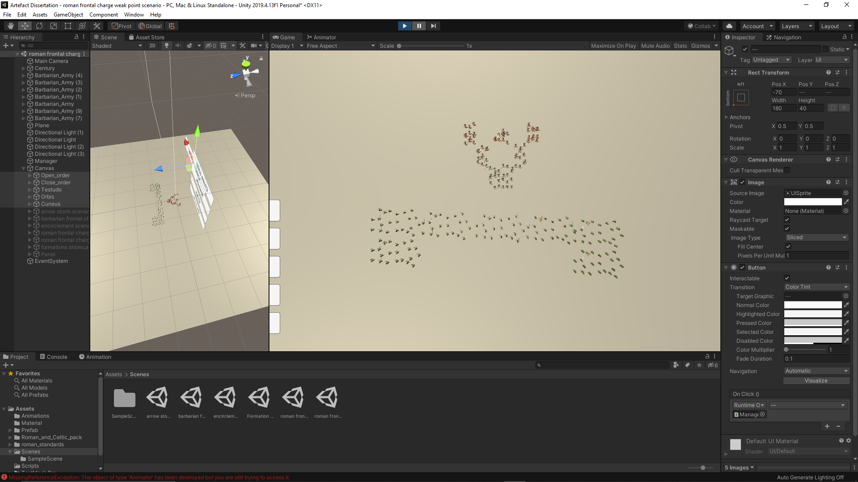

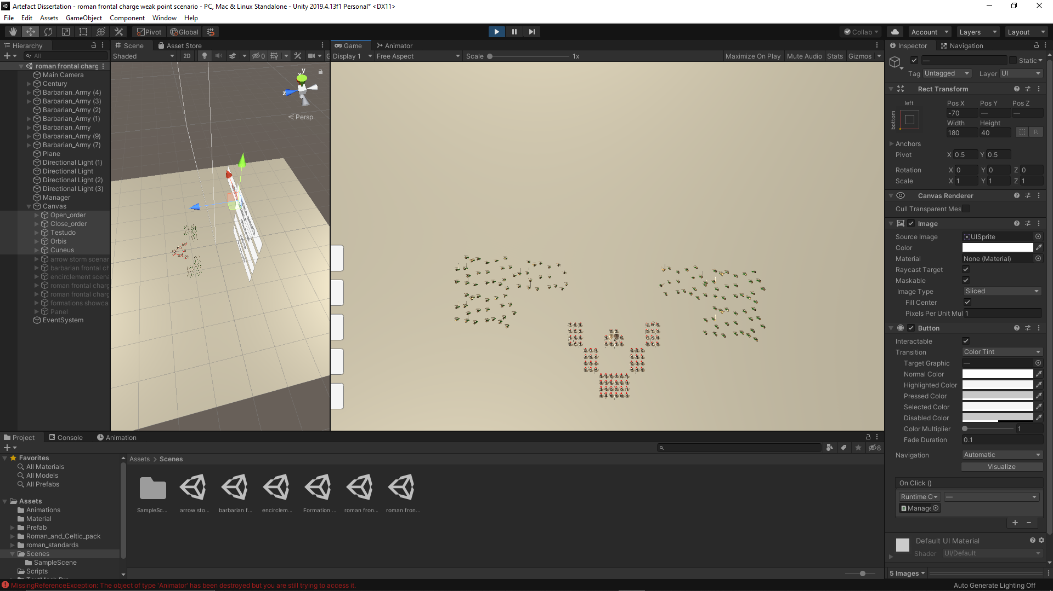

Fig.73&74 – Cuneus before and after the battle scenario

Based on the performance of the formations in this battle scenario, it has been concluded that the cuneus is the most effective tactic, even though it caused some casualties on the Roman side in the process. Historically it has developed for the sole purpose of exploiting a weak point in the enemy battle line. During the testing, it has been noticed that the gap produced by the cuneus was wide enough for another century, if following the attacking century, to go through the gap and be behind the enemy, which give the opportunity for the said century to attack the backs of the enemy.

5.Conclusion

The main purpose of the project was to demonstrate the possibility of developing a historical accurate gaming AI. To do that, historical military battle tactics were studied and combined with AI developing techniques, the agents could replicate those tactics in action. In the artefact which accompanies the project, the agents are programmed to use Roman battle tactics from around late 1st Century BC. In the artefact, the tactics were tested in different battle scenarios. These scenarios were chosen in the first place due to the fact the Romans had often fought in open fields and the tactics were designed specifically to increase both the lethality and survivability of the century in these battle scenarios. The data collected from the testing of the tactics shows not only how it can demonstrate the effectiveness of the formations, but also proves why the tactics were historically designed for a specific battle scenario in mind, thus proving the possibility of developing a true historical accurate gaming AI. As for transitioning between tactics, historically it was very difficult for a unit to change formations mid-battle, due to the stress of combat, even for highly trained or highly experienced unit. In the artefact, the agents can change the tactics without difficulty due to the fact every agent was programmed with a unique offset and position in each tactic, making it easier for them to transition.

When it comes to proving the relevancy of a project, the best way to do it is by giving examples where it might be useful. It might be used as a starting point in further research into the topic, without limiting to the Roman civilization and how they conducted war. It might include other civilizations and other aspects of their life. History is not about just war and battles. It is the story of humanity. The project might be used by game developers who are creating real time strategy or simulation games in which the action occurs in a historical setting. It might also be considered as a step further into the development of historical accurate games.

# References

Banino, A. et al. (2018) Vector-based navigation using grid-like representations in artificial agents. *Nature,* 557(7705), pp. 429-433,433A-433P.

Bjore, S. (2013) Technics for Formation Movement Using Steering Circles. In: *Game AI Pro.* Boca Raton: CRC Press, pp. 289-295.

Campbell, D. (2021) Roman Legionary vs Gallic Warrior: 58-52BC (Combat). In: Oxford: Osprey Publishing, pp. 34-39.

Cowan, R. (2003) Roman Legionary 58BC-AD69. In: Oxford: Osprey Publising, pp. 25-44.

Cowan, R. (2007a) Roman Battle Tactics 109BC-AD 313. In: Oxford: Osprey Publising, pp. 40-46.

Cowan, R. (2007b) The Clashing of Weapons and Silent Advances in Roman Battles. *Historia: Zeitschrift für Alte Geschichte,* 56(1), pp. 114-117.

D'Amato, R. (2018) Roman Standards & Standard-Bearers (1): 112 BC-AD 192. In: Oxford: Osprey Publishing, pp. 28-59,86-99.

Dawson, C. (2002) Formations. In: S. Rabin, ed. *AI Game Programming Wisdom.* Hingham: Charles River Media Inc, pp. 272-281.

Godoy, J. et al. (2018) ALAN: adaptive learning for multi-agent navigation. *Autonomous Robots volume,* 42(8), p. 1543–1562.

Godoy, J., Guy, S. J., Gini, M. & Karamouzas, I. (2020) C-Nav: Distributed coordination in crowded multi-agent navigation. *Robotics and Autonomous Systems,* Volume 133.

Mandal, D. (2015) *Short graphical visualization aptly showcases the incredible organization of the Roman army.* [Online]   
Available at: https://www.hexapolis.com/2015/06/16/short-graphical-visualization-aptly-showcases-the-incredible-organization-of-the-roman-army/  
[Accessed 6 January 2021].

Millington, I. & Funge, J. (2009) *Artificial Inteligence for Games.* Burlington: Elsevier.

Rahmani, V. & Pelechano, N. (2020) Multi-agent parallel hierarchical path finding in navigation meshes (MA-HNA*). *Computers & Graphics,* Volume 86, pp. 1-14.

TaleWorlds Entertainment (2020) *Mount & Blade II: Bannerlord [Computer game]*. Available at https://store.steampowered.com/app/261550/Mount__Blade_II_Bannerlord/ (Downloaded:30 March 2020)

Taylor, M. J. (2014) ROMAN INFANTRY TACTICS IN THE MID-REPUBLIC: A REASSESSMENT. *Historia: Zeitschrift Für Alte Geschichte,* 63(3), pp. 301-322.

The Creative Assembly (2013) *Total War: Rome II* [Computer game]. Available at <https://www.totalwar.com/games/rome-ii/> (Downloaded:20 February 2017)

Unity Technologies (2019) *NavMeshAgent.* [Online]   
Available at: https://docs.unity3d.com/2019.4/Documentation/ScriptReference/AI.NavMeshAgent.html  
[Accessed 2 March 2021].

Van Verth, J., Brueggermann, V., Owen, J. & McMurry, P. (2000) *Formation-Based Pathfinding With Real-World Vehicles.* Morrisville, Game Developers Conference Proceedings.

Appendix I

|  |  |  |  |  |  |
| --- | --- | --- | --- | --- | --- |
| Casualty rate | | | | | |
|  | Open order | Close order | Testudo | Orbis | Cuneus |
| arrow storm scenario | 10% | 25% | 0% | 60% | 10% |
| barbarian frontal charge scenario | 5% | >5% | 0% | 0% | >5% |
| encirclement scenario | 15% | 20% | 15% | 0% | 15% |
| roman frontal charge scenario | 5% | 0% | 0% | 3% | 5% |
| roman frontal charge weak point scenario | 3% | 0% | 0% | 3% | 5% |

Appendix II

Appendix III

Arrow storm scenario



Open order before scenario

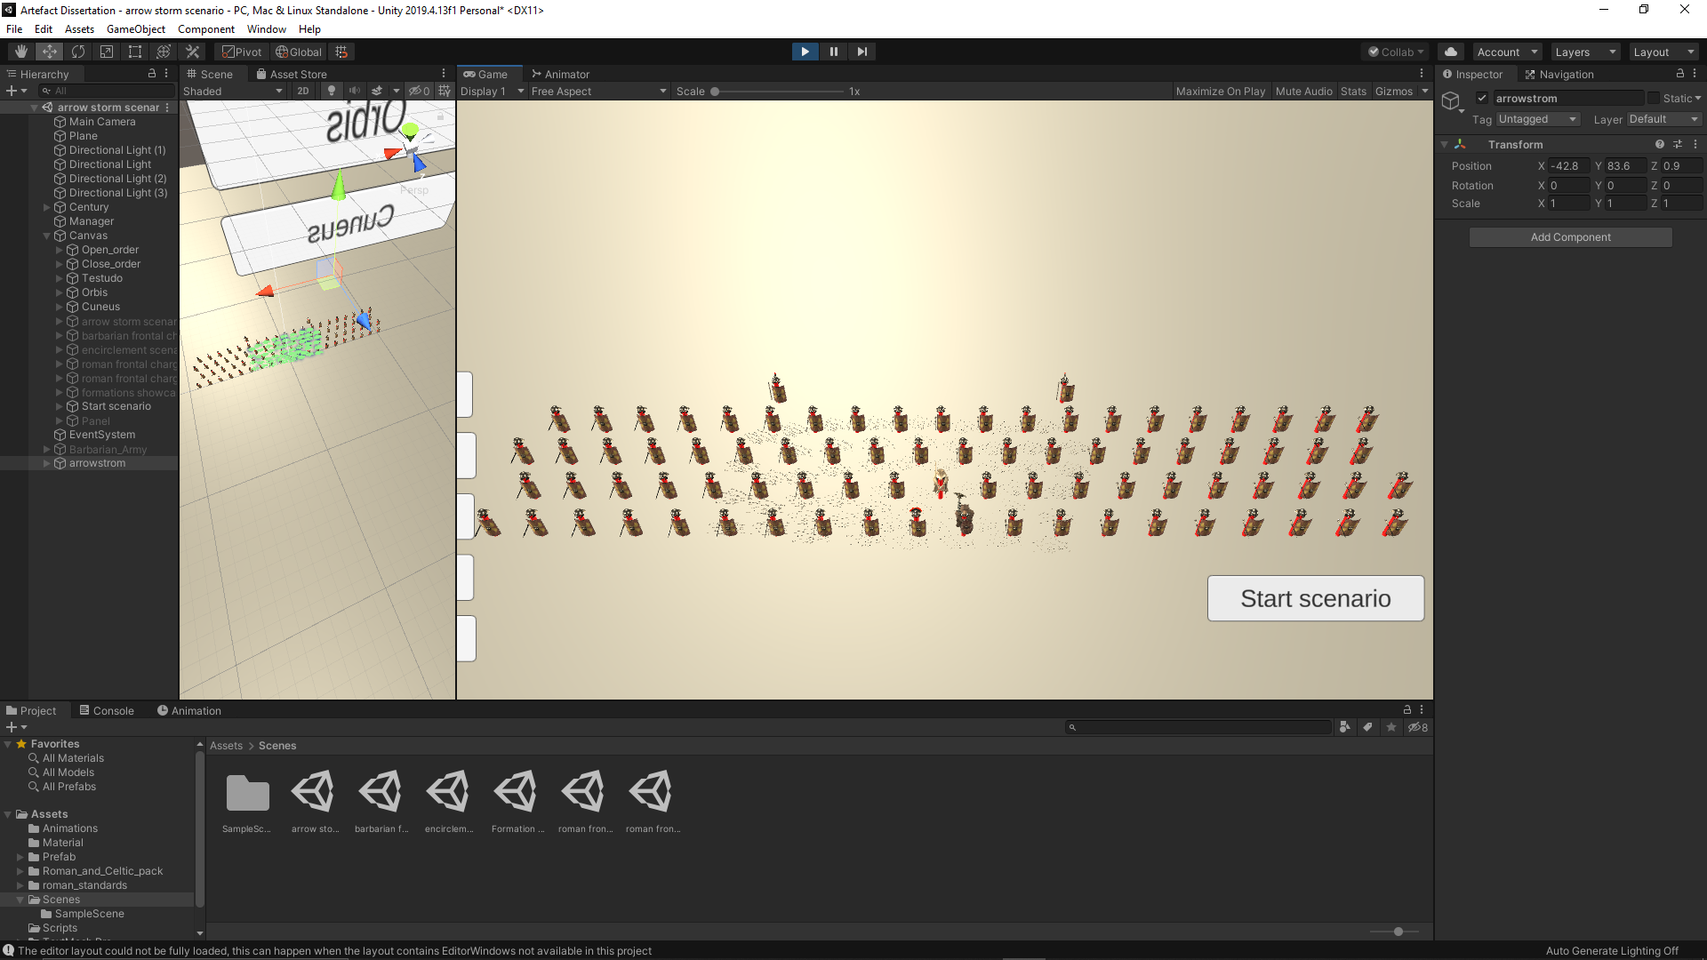

Open order during scenario



Open order after scenario



Close order before scenario

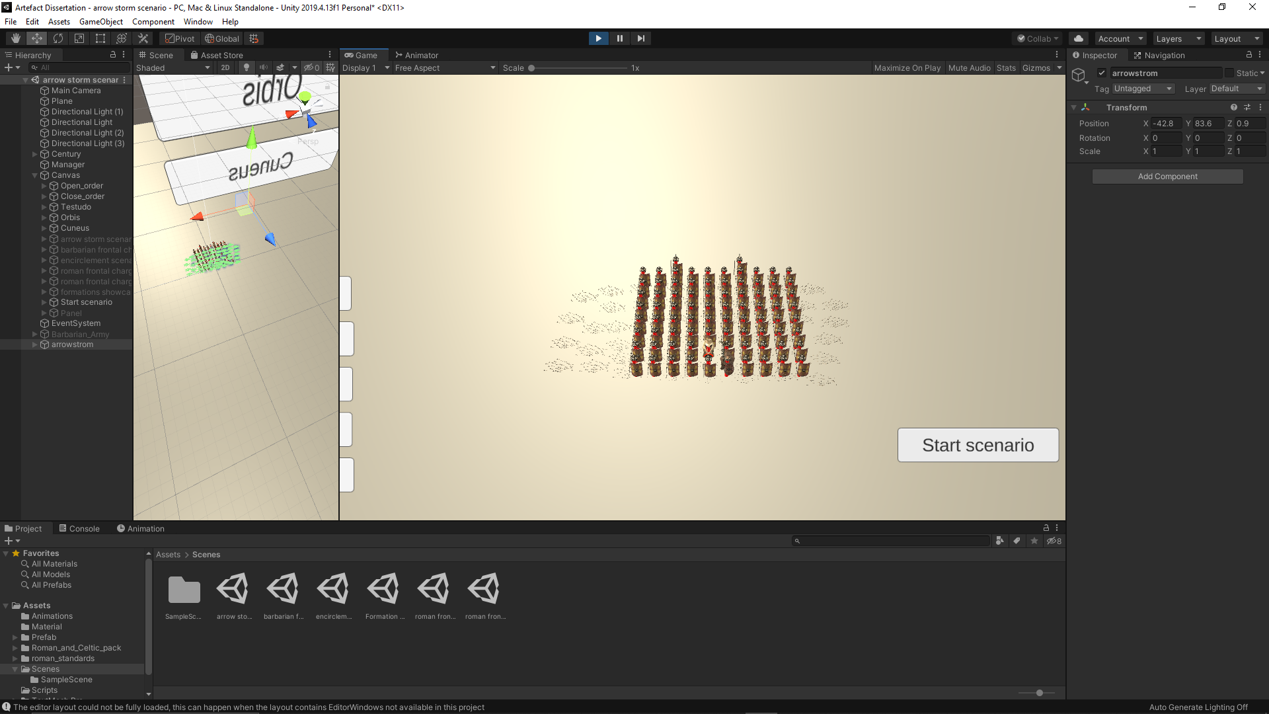

Close order during scenario



Close order after scenario



Testudo before scenario

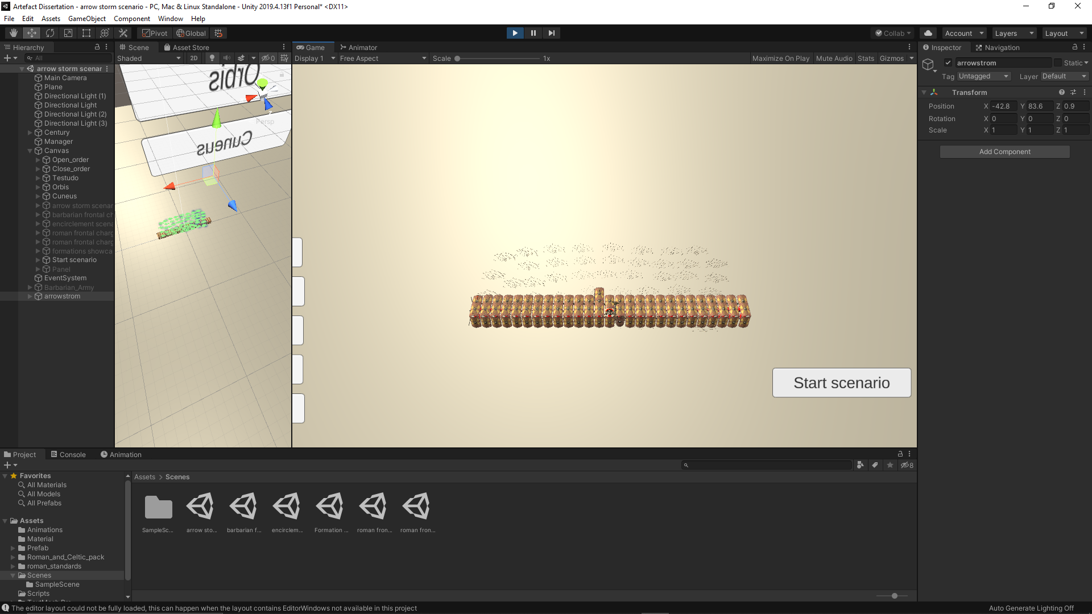

Testudo during scenario



Testudo after scenario



Orbis before scenario

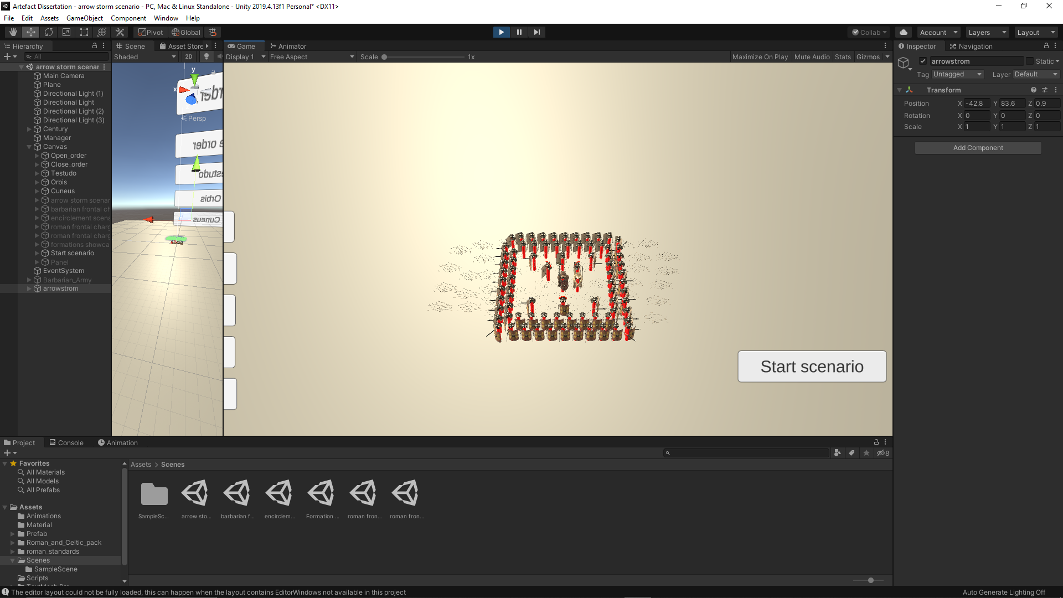

Orbis during scenario



Orbis after scenario



Cuneus before scenario

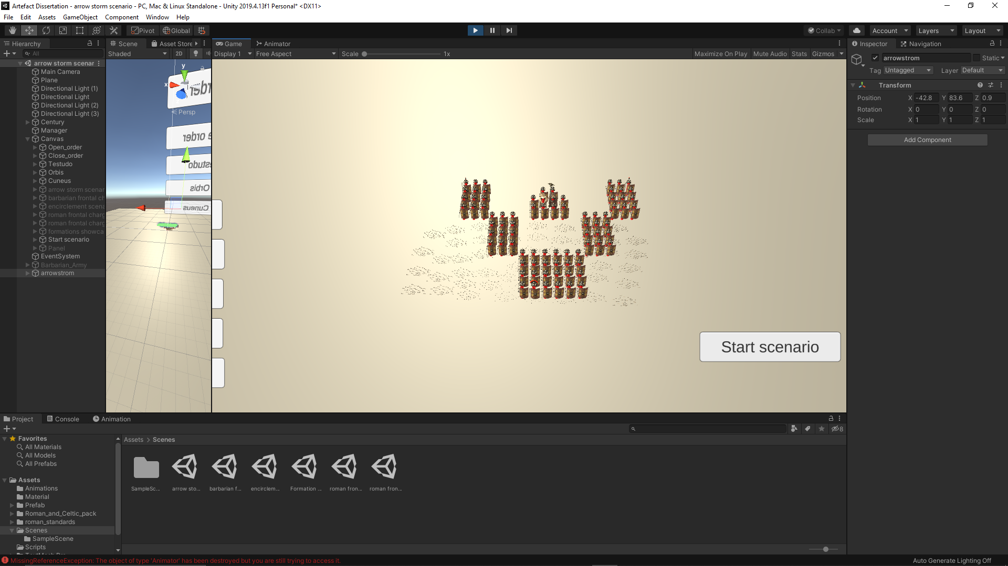

Cuneus during scenario



Cuneus after scenario

Barbarian frontal charge scenario



Open order before scenario

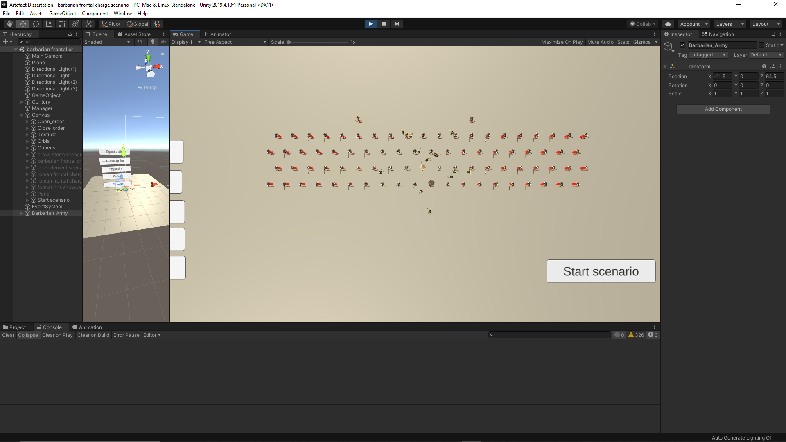

Open order during scenario



Open order after scenario



Close order before scenario

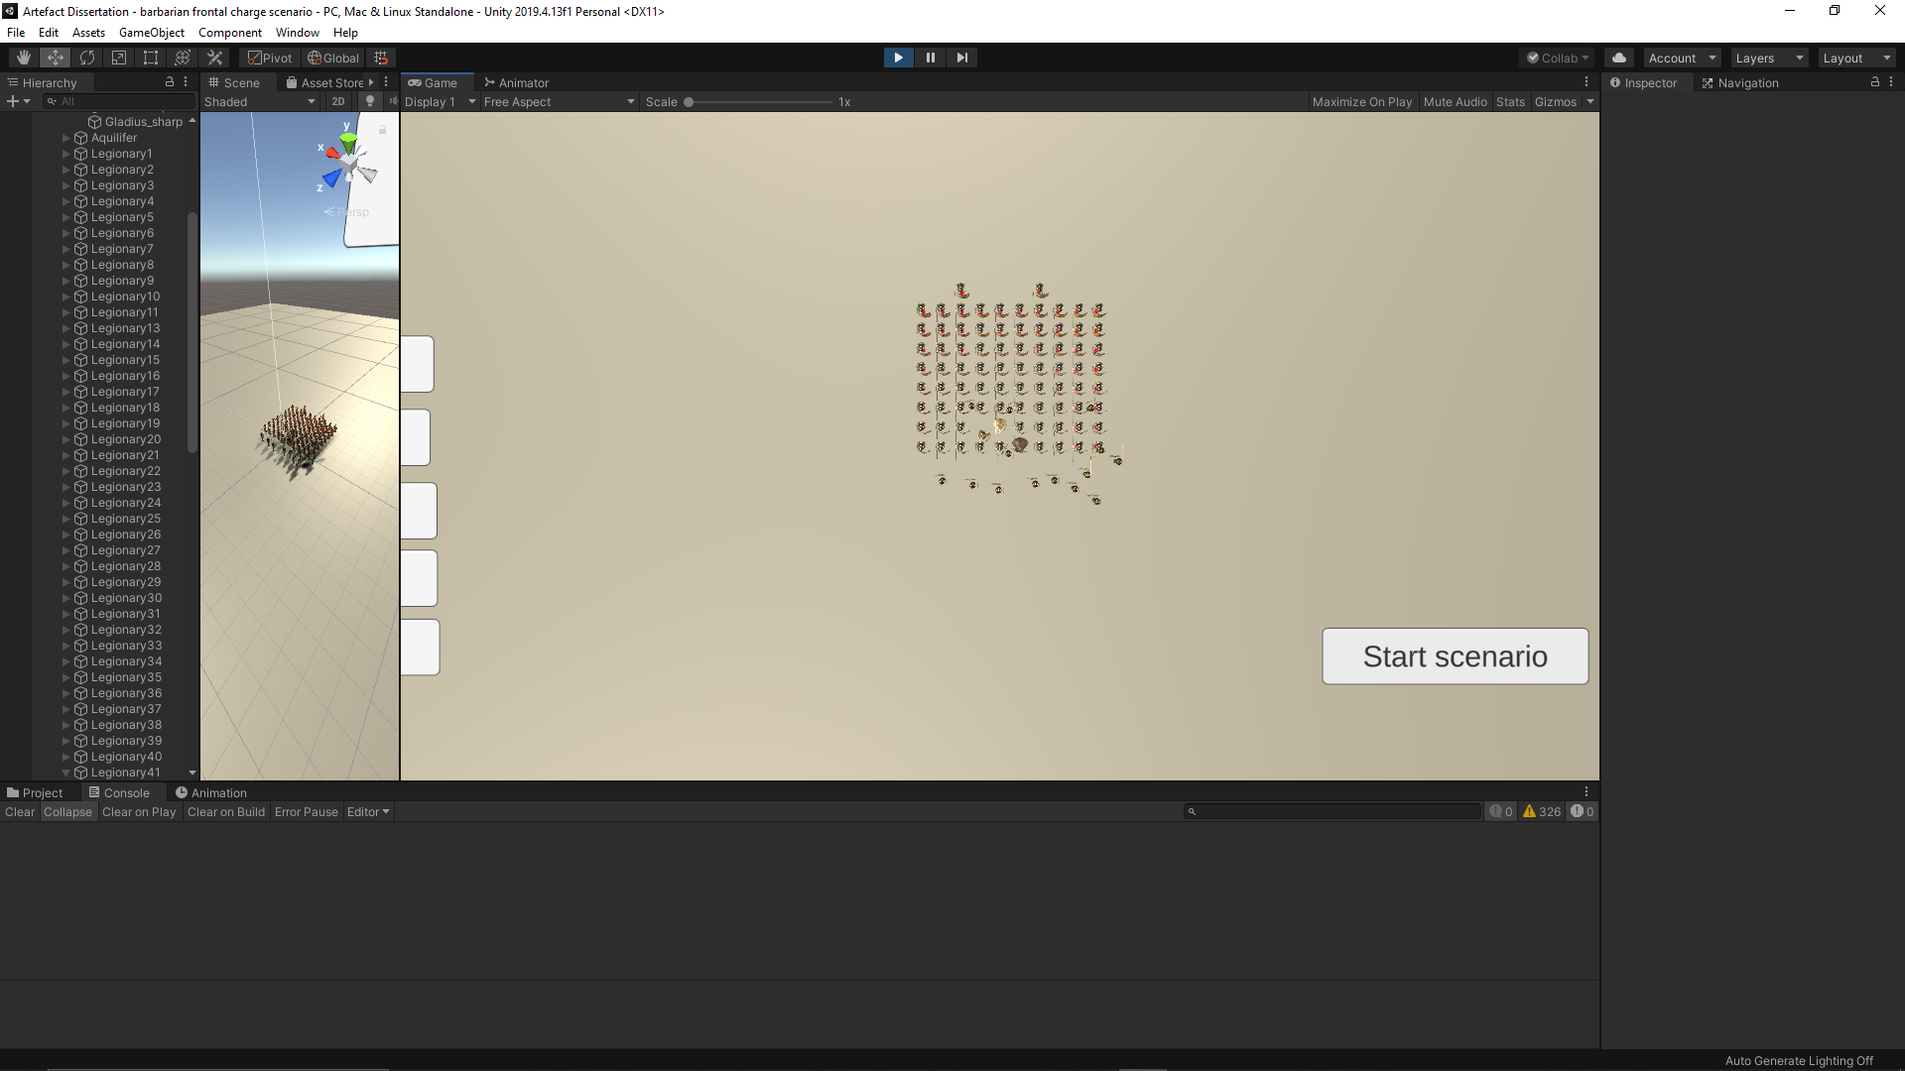

Close order during scenario



Close order after scenario



Testudo before scenario

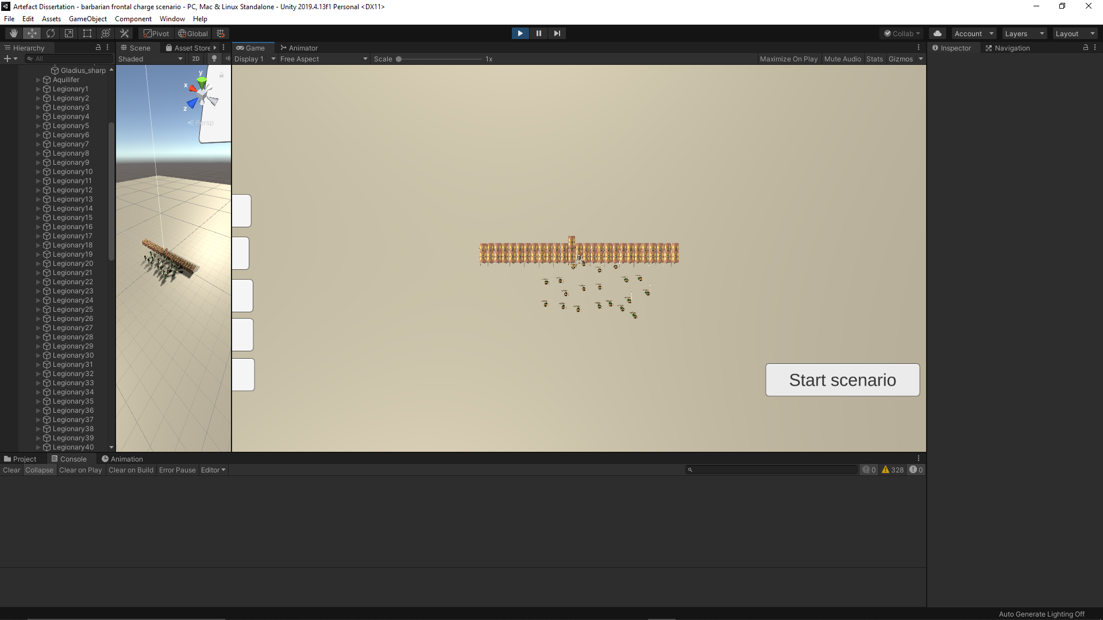

Testudo during scenario



Testudo after scenario



Orbis before scenario

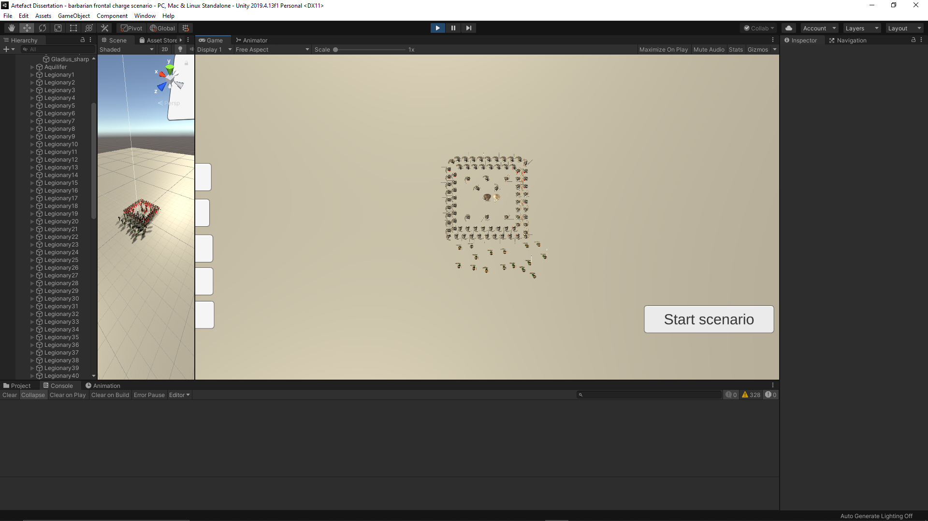

Orbis during scenario



Orbis after scenario



Cuneus before scenario

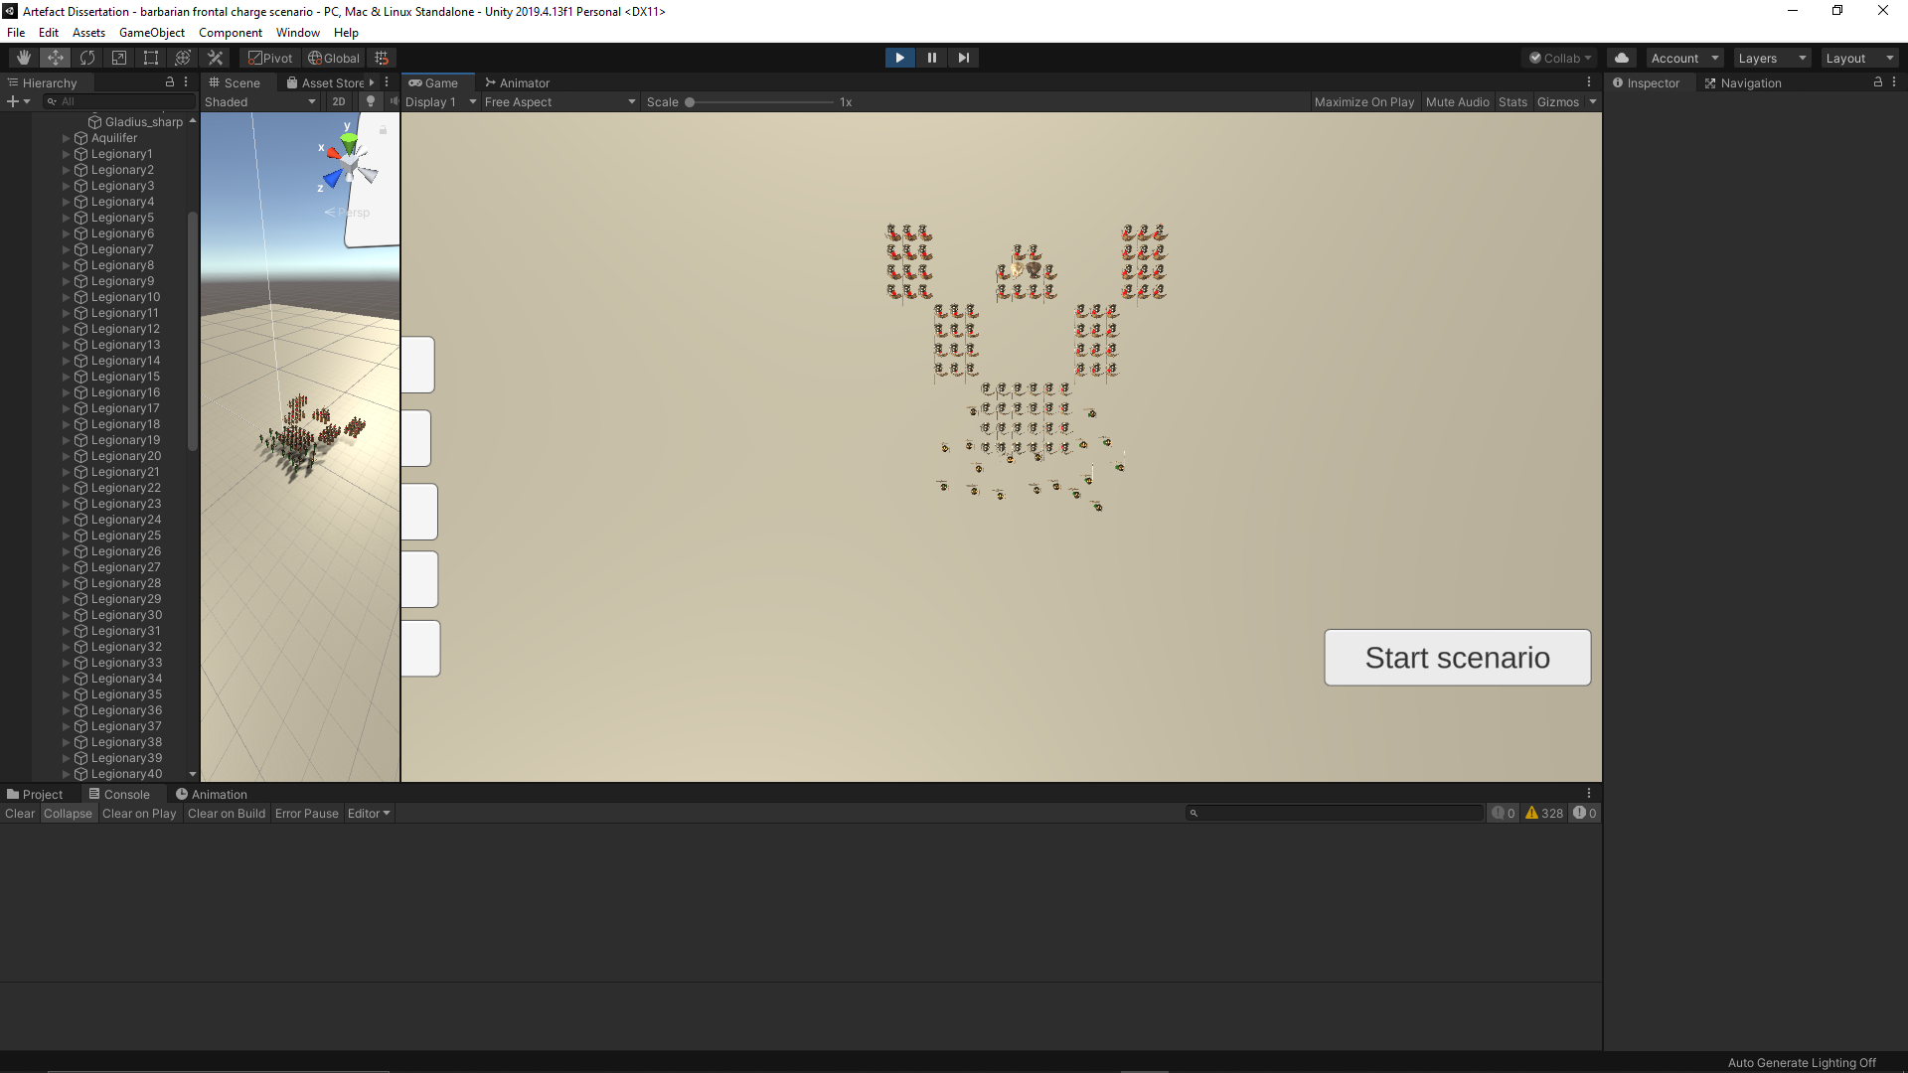

Cuneus during scenario



Cuneus after scenario

Encirclement scenario



Open order before scenario

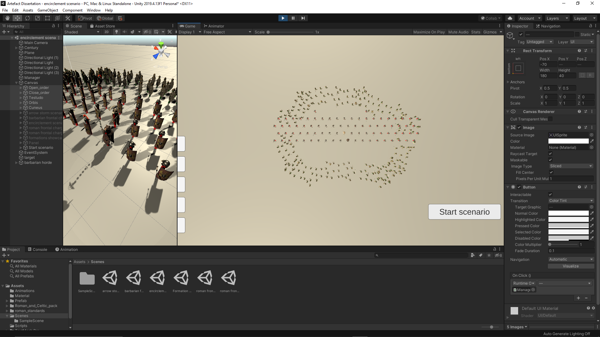

Open order during scenario



Open order after scenario



Close order before scenario

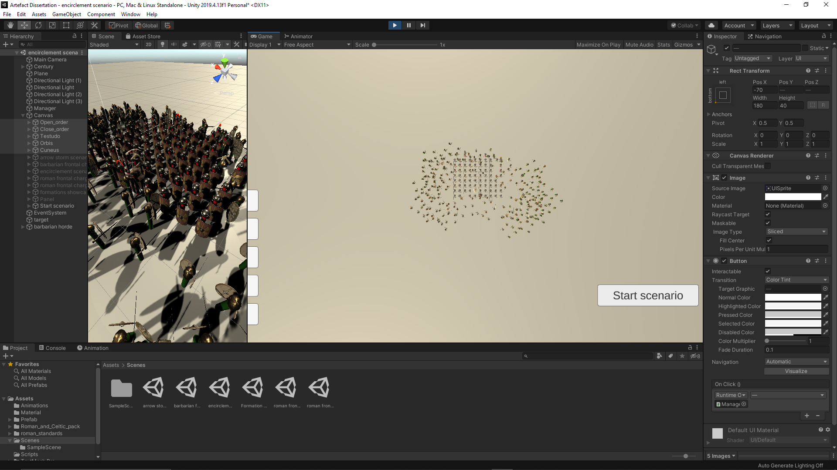

Close order during scenario



Close order after scenario



Testudo before scenario

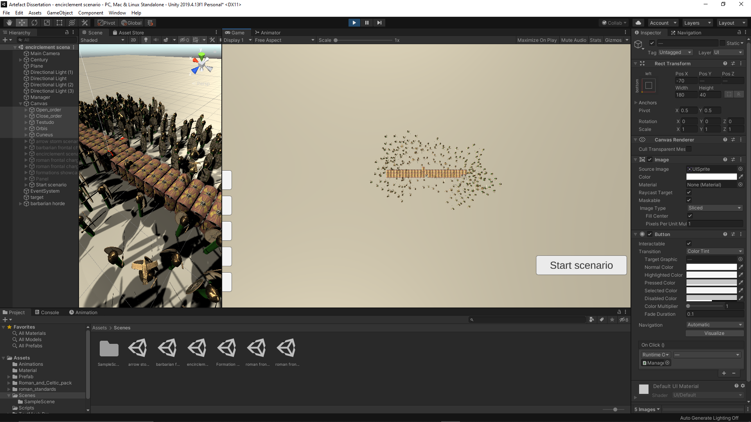

Testudo during scenario



Testudo during scenario



Orbis before scenario

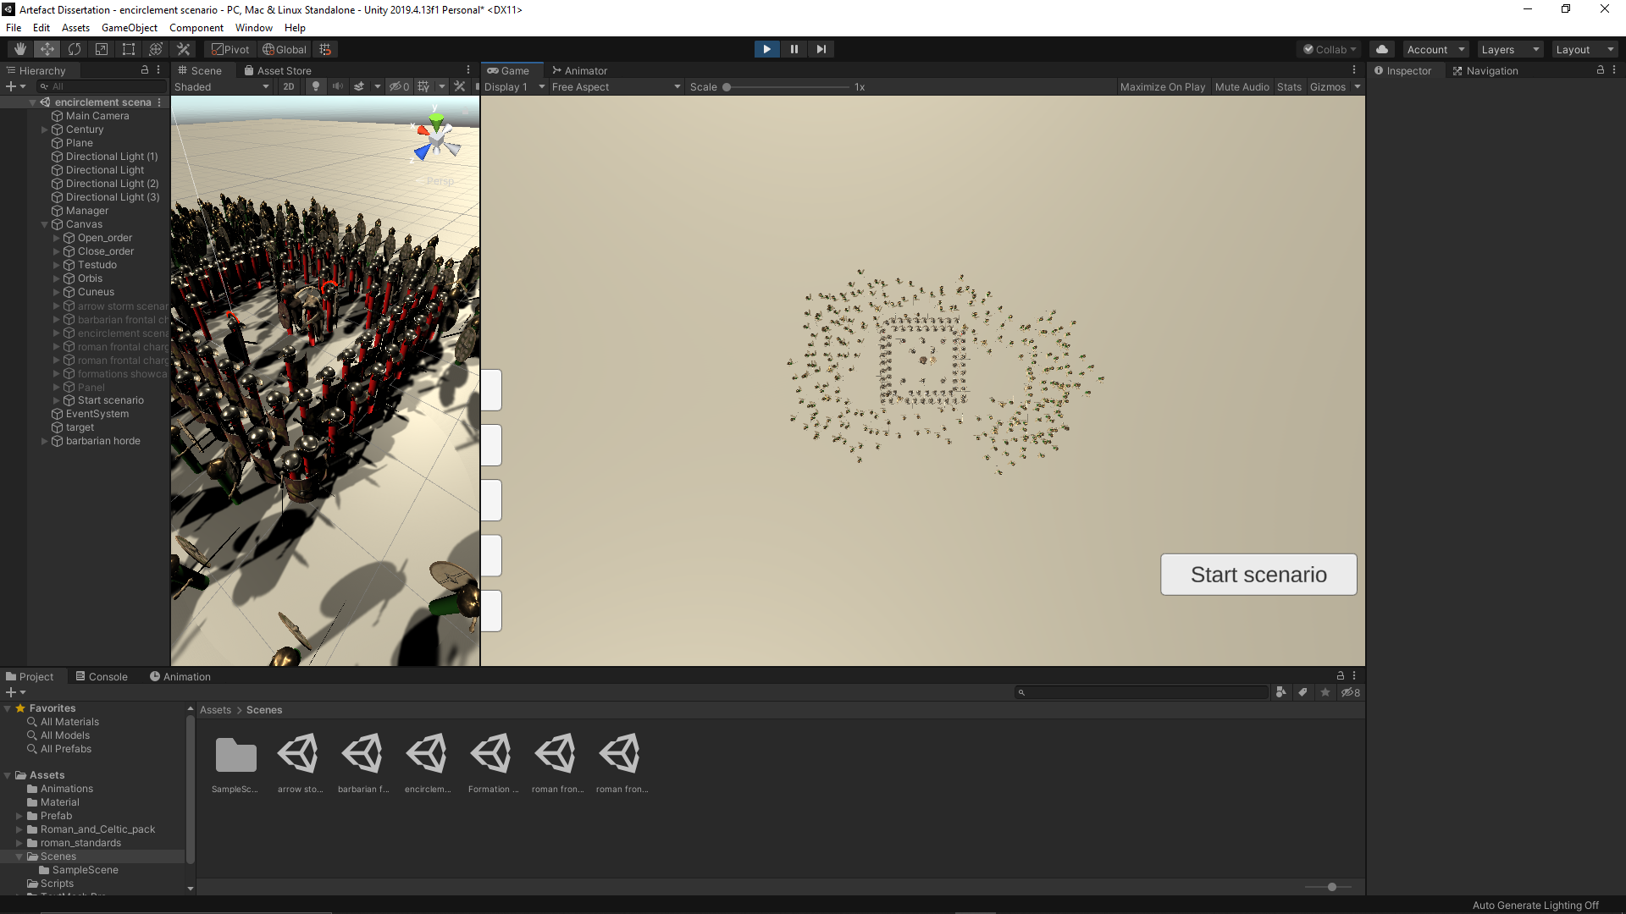

Orbis during scenario



Orbis after scenario



Cuneus before scenario

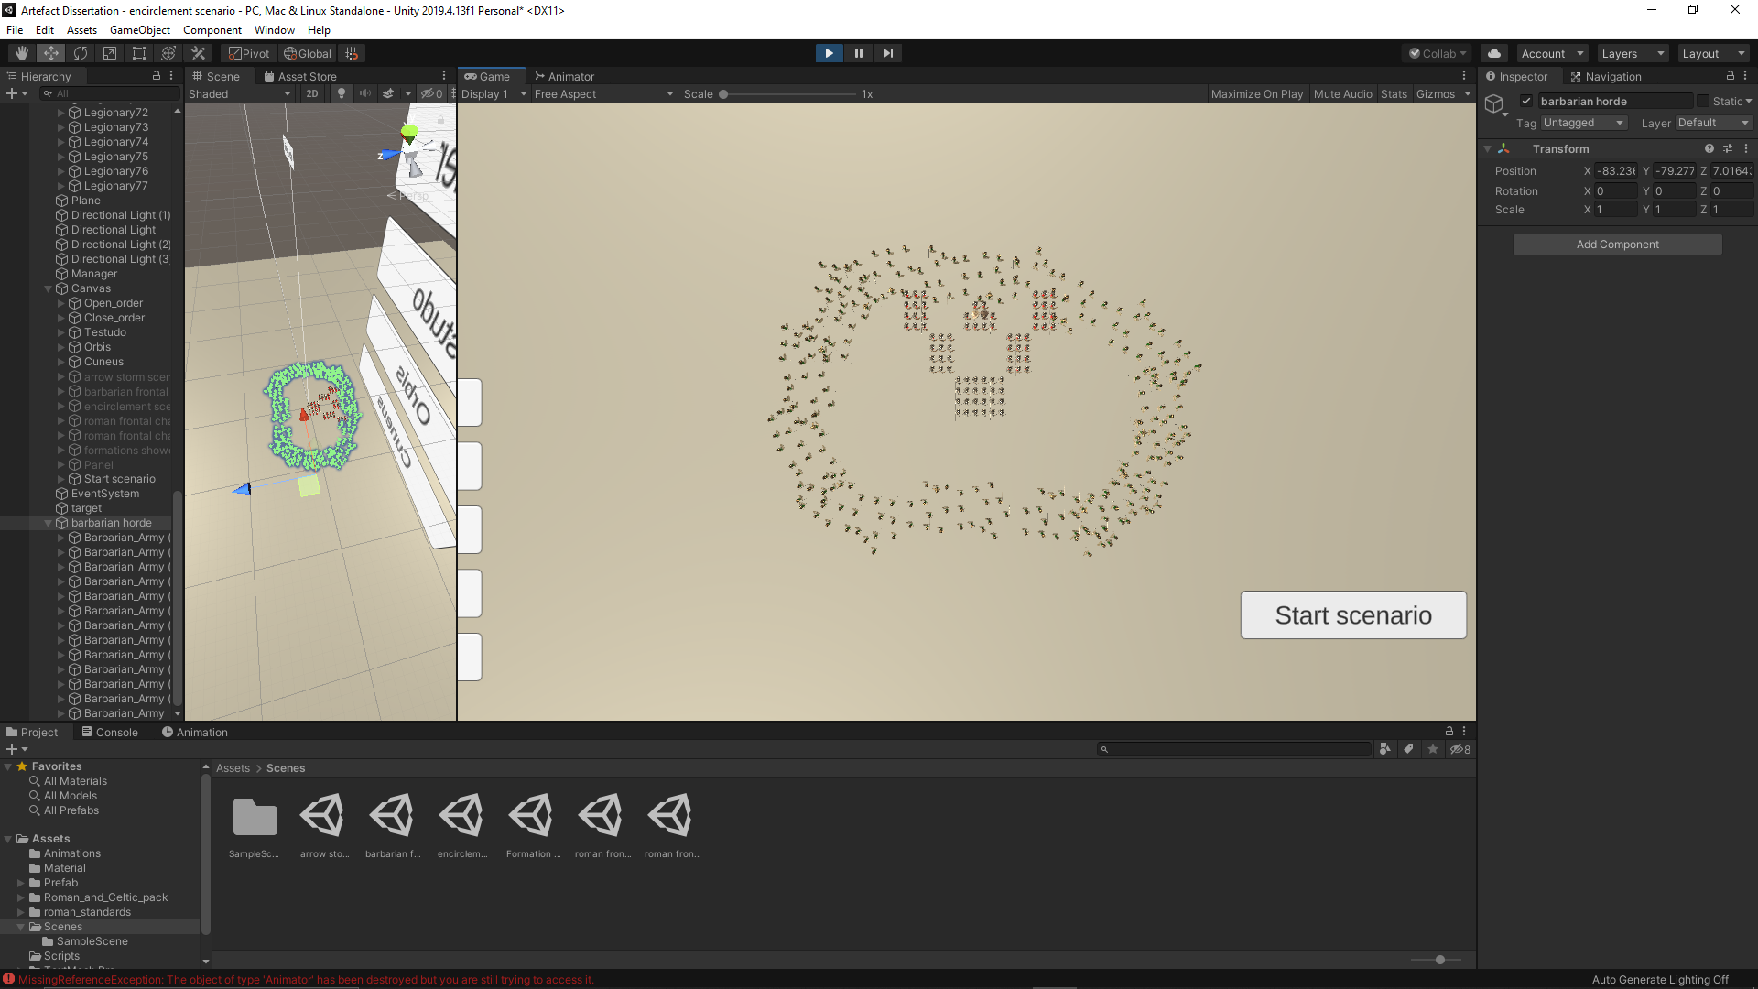

Cuneus during scenario



Cuneus after scenario

Roman frontal charge scenario



Open order before scenario

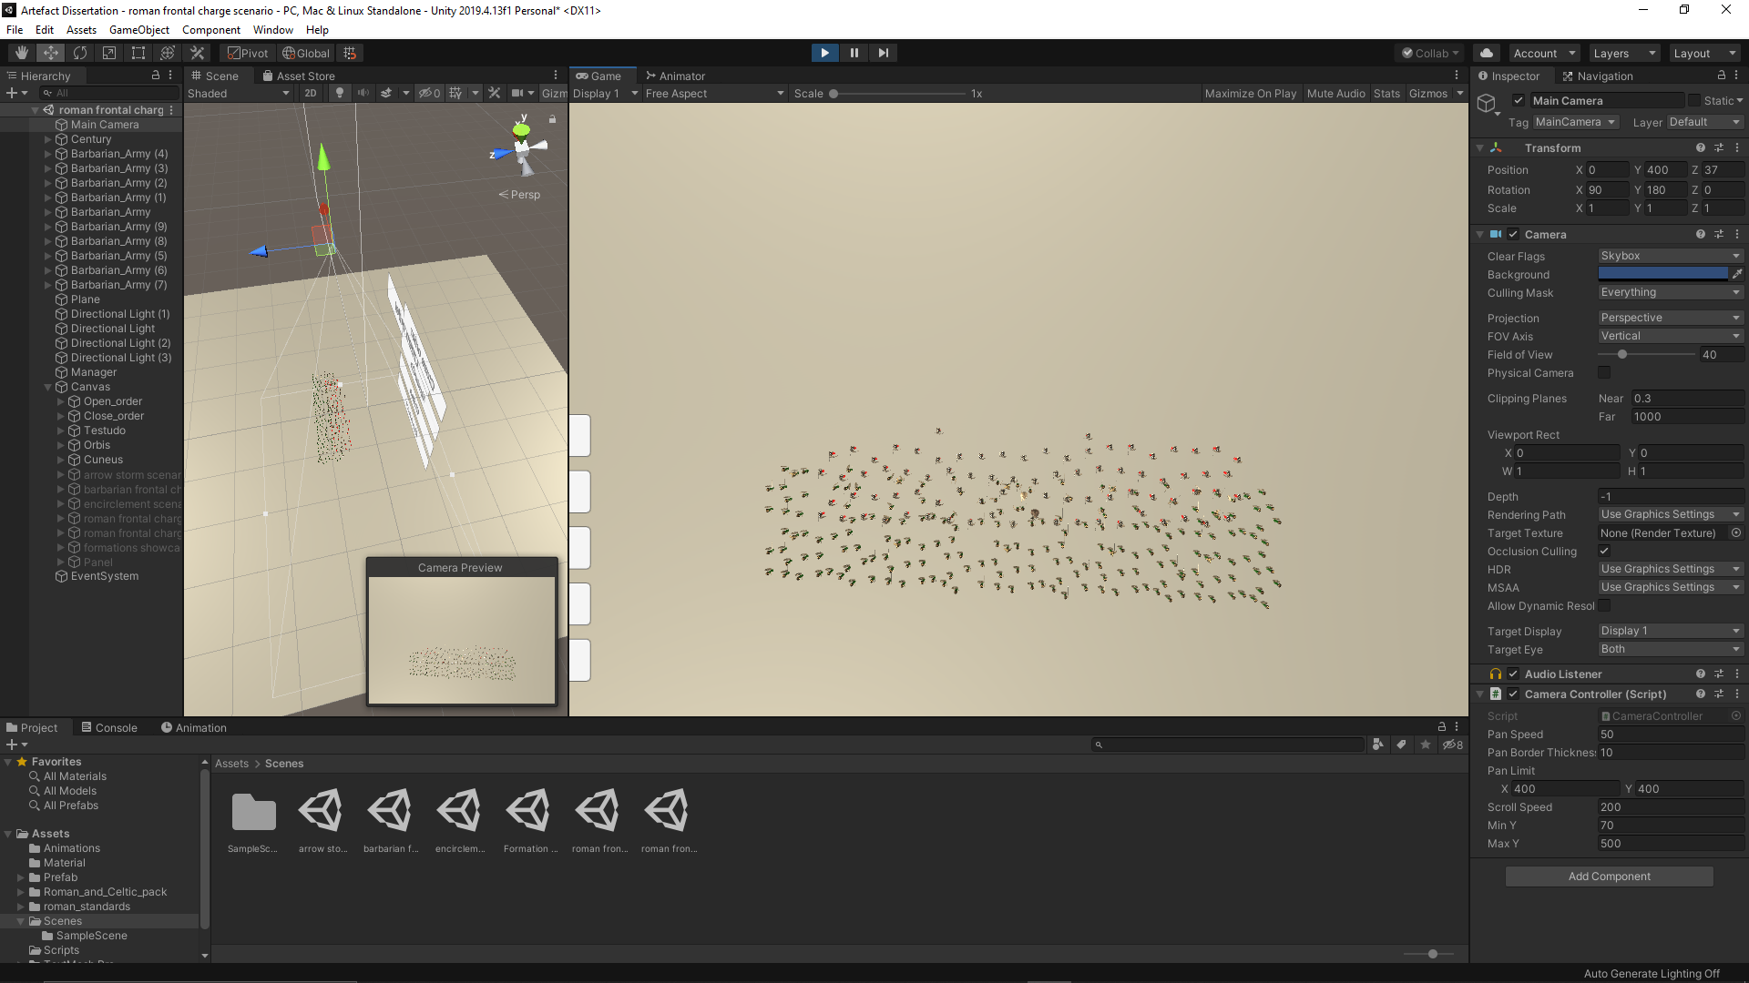

Open order during scenario



Open order after scenario



Close order before scenario

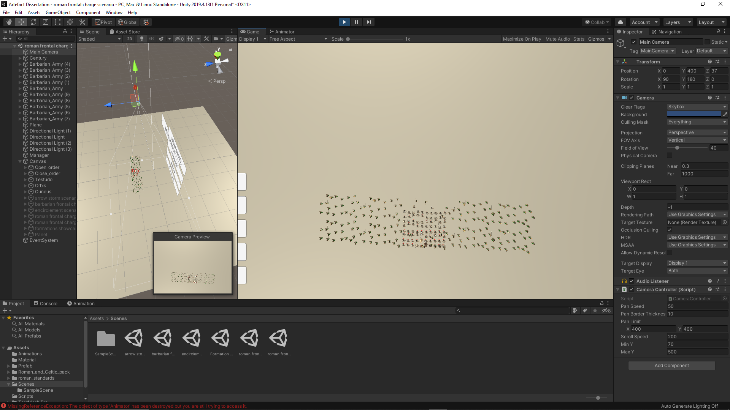

Close order during scenario



Close order after scenario



Testudo before scenario

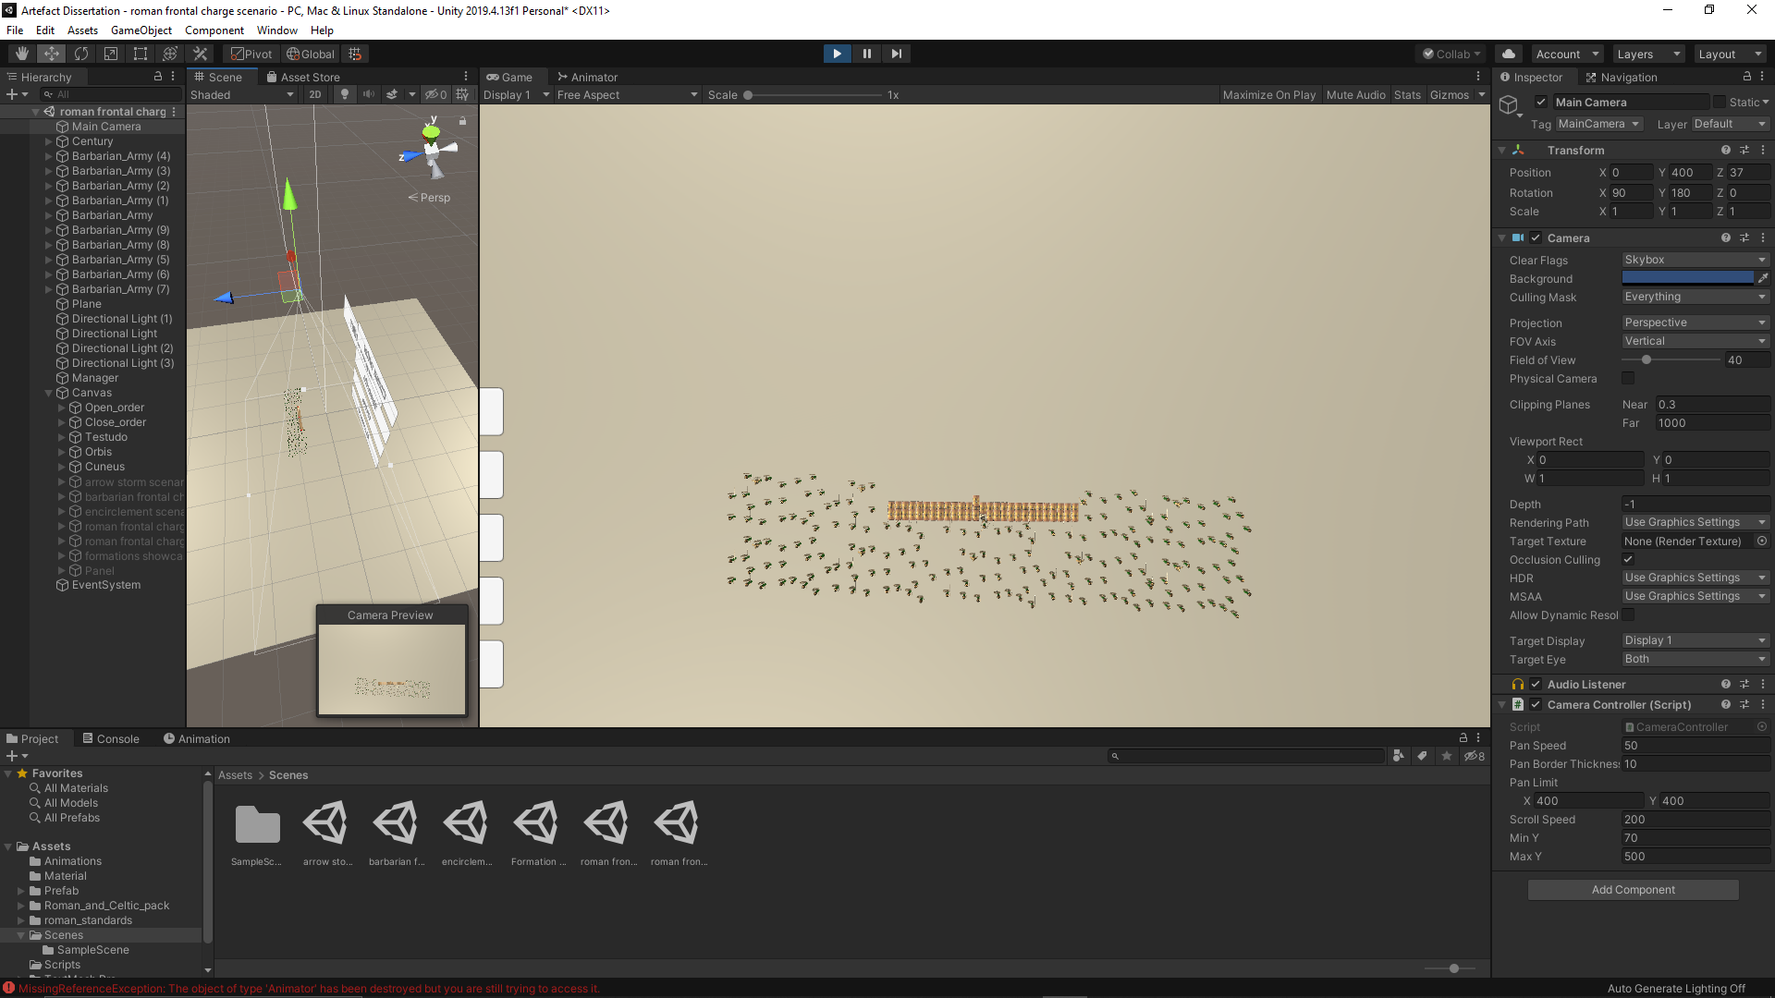

Testudo during scenario



Testudo during scenario



Orbis before scenario

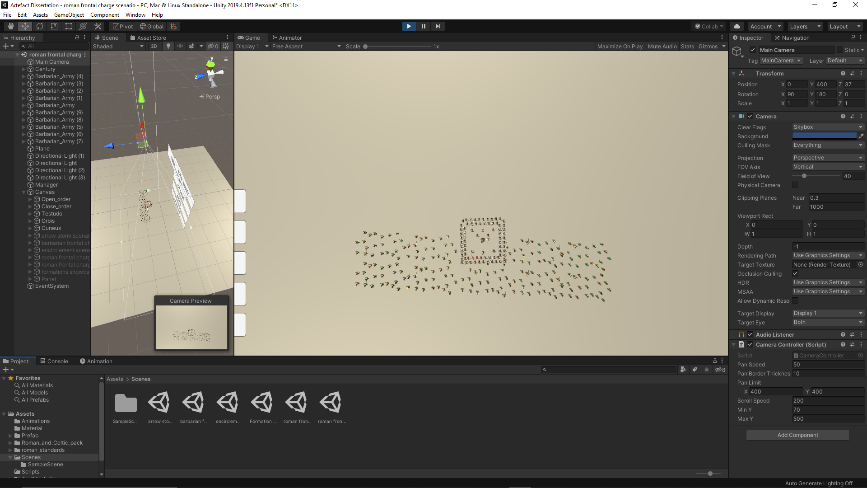

Orbis during scenario



Orbis after scenario



Cuneus before scenario

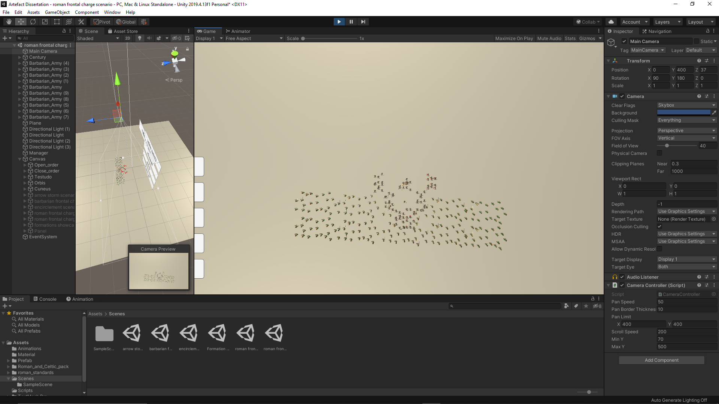

Cuneus during scenario



Cuneus after scenario

Roman frontal charge weak point scenario



Open order before scenario

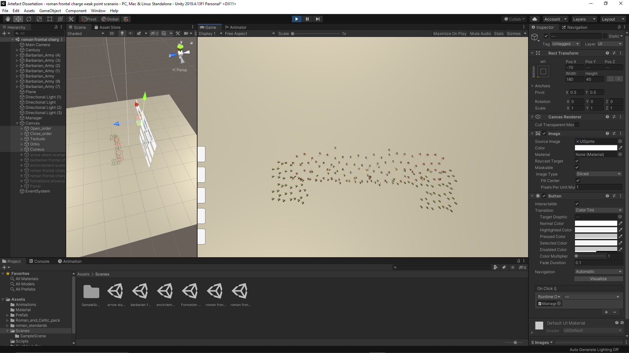

Open order during scenario



Open order after scenario



Close order before scenario

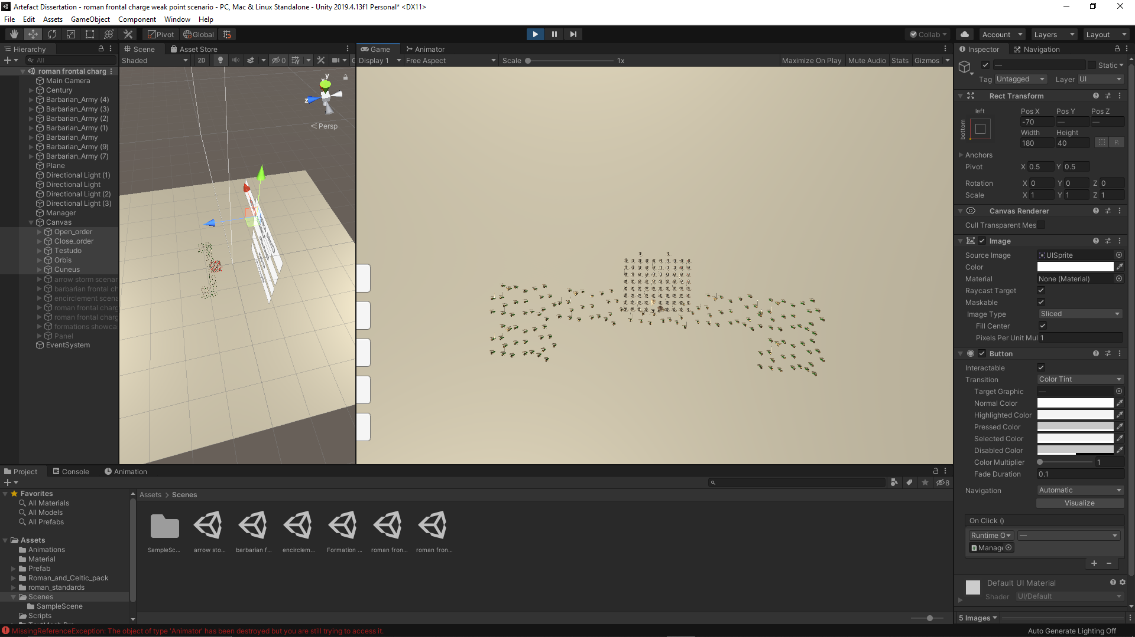

Close order during scenario



Close order after scenario



Close order after scenario

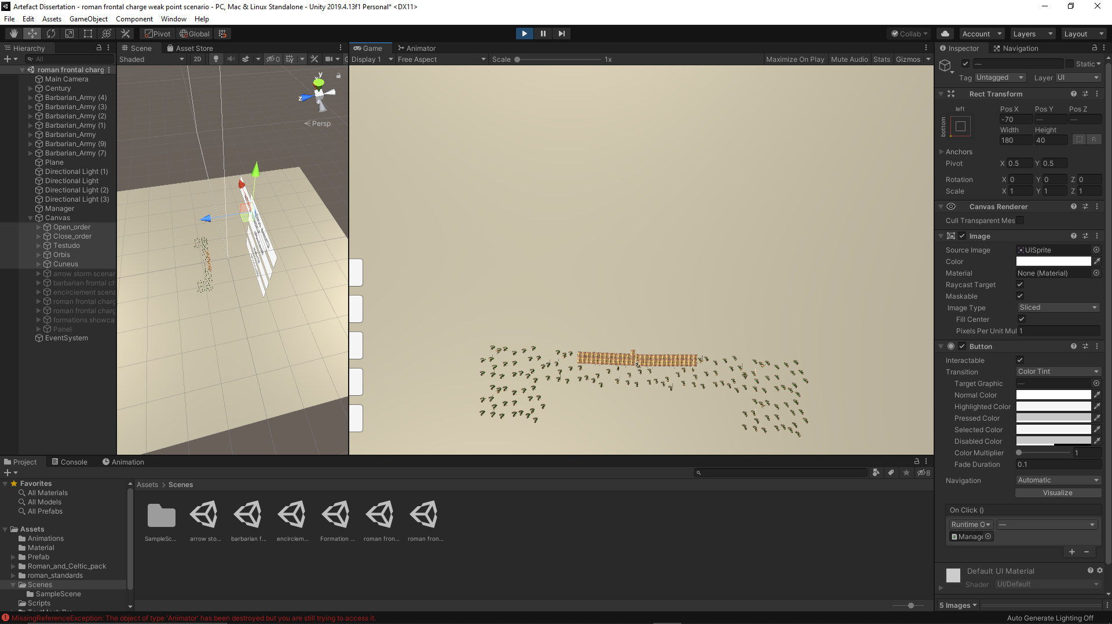

Testudo during scenario



Testudo during scenario



Orbis before scenario

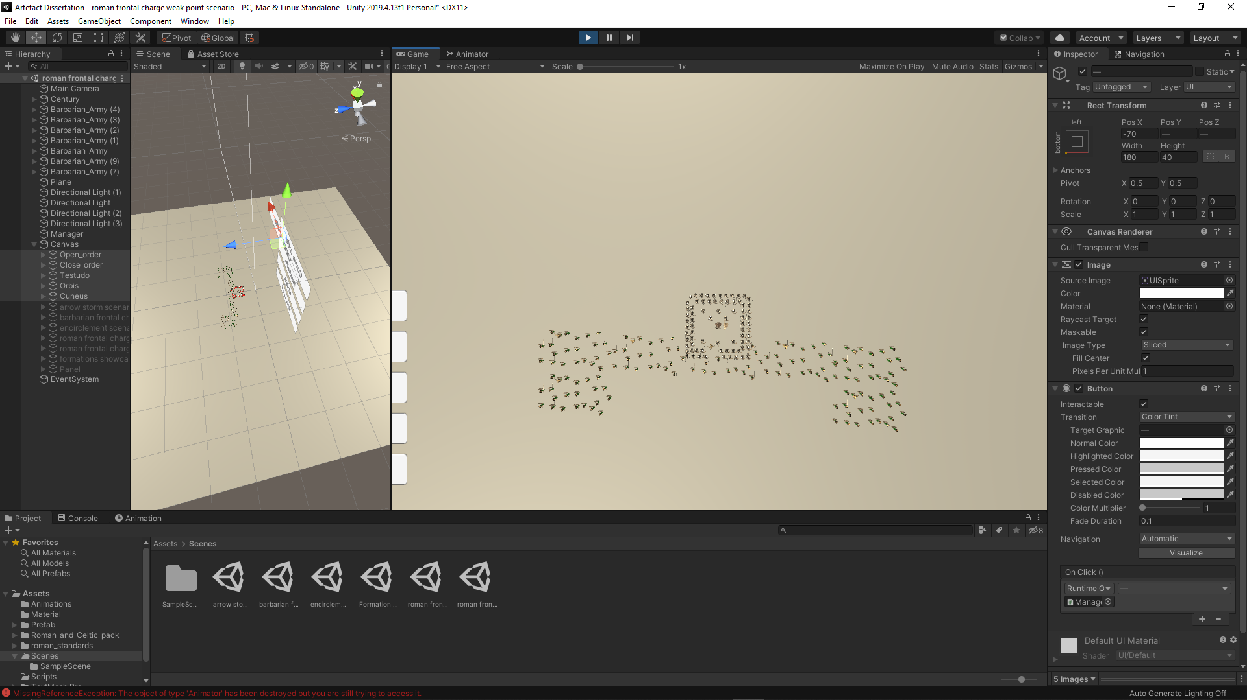

Orbis during scenario



Orbis after scenario



Cuneus before scenario

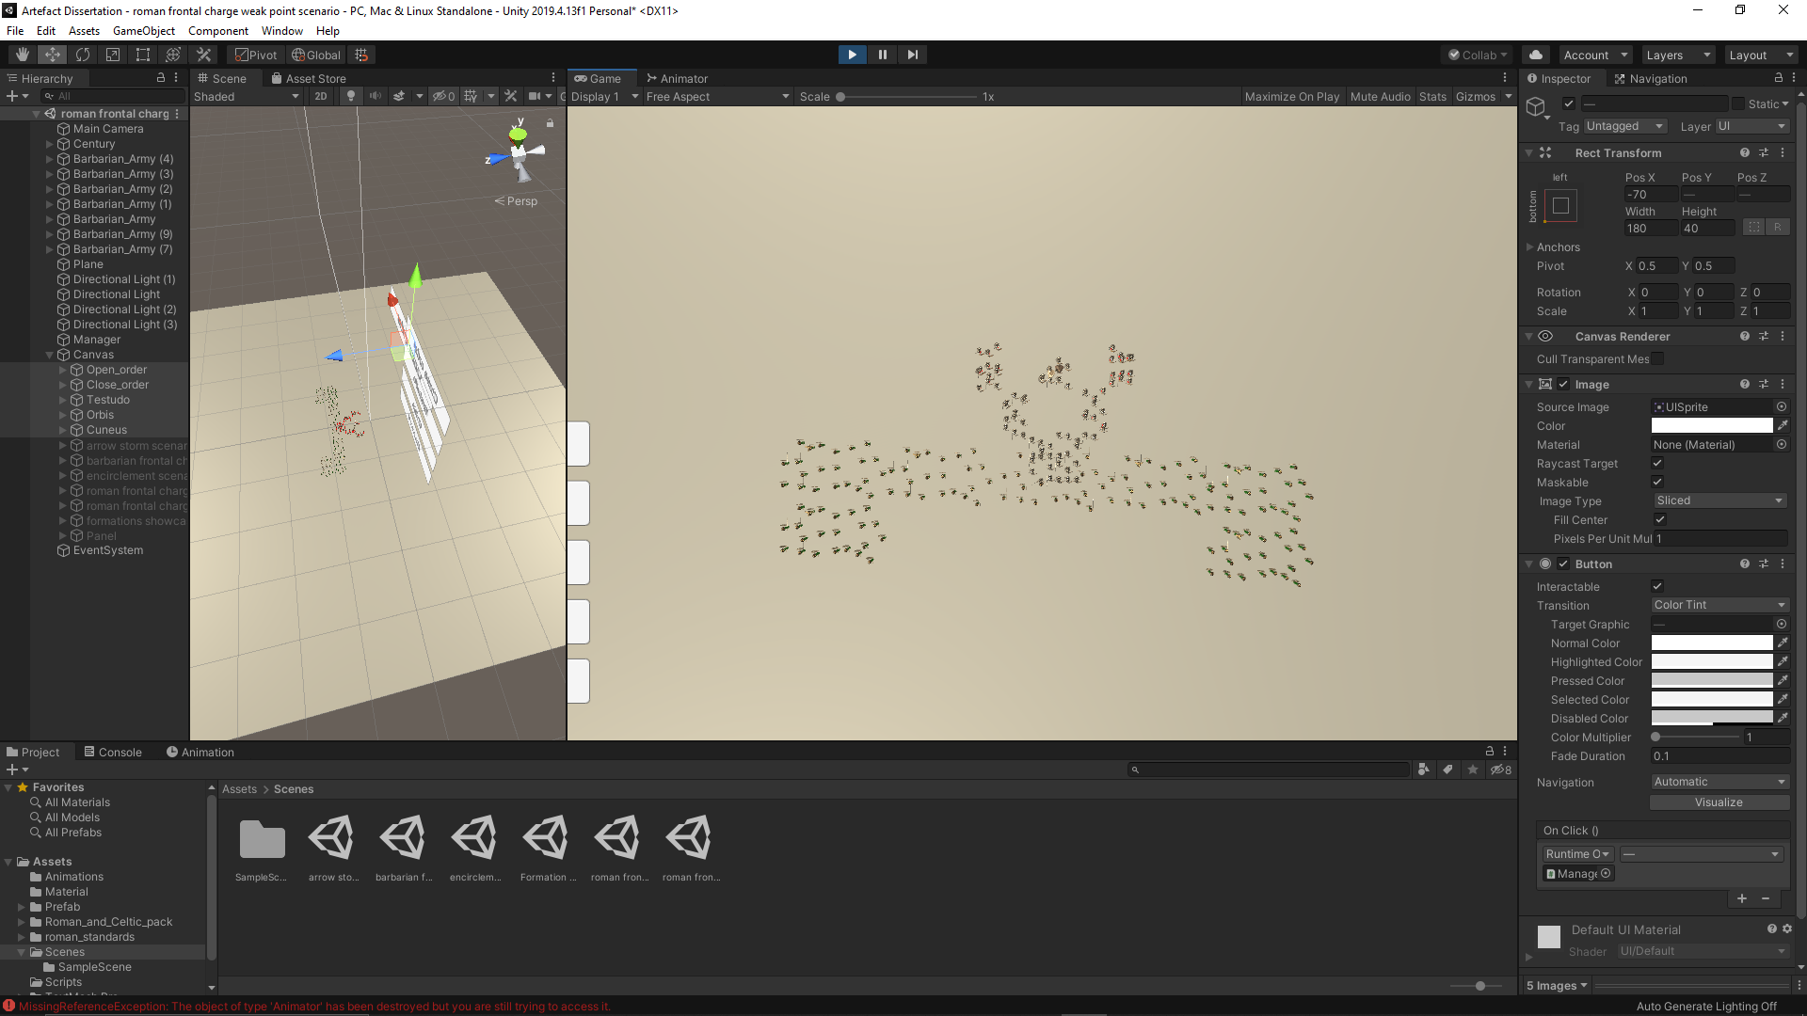

Cuneus during scenario



Cuneus after scenario